Friday 10th March 2023
KL: To be able to identify and label basic parts of a plant.

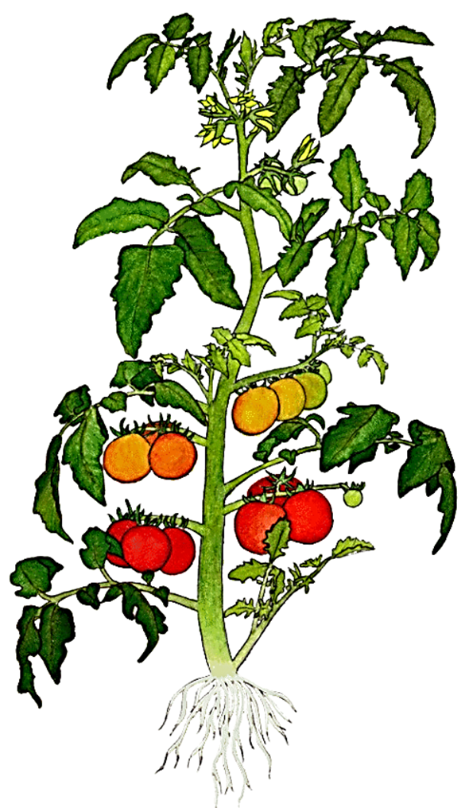
flower
leaf
roots
fruit
stem

Friday 10th March 2023
KL: To be able to identify and label basic parts of a plant.

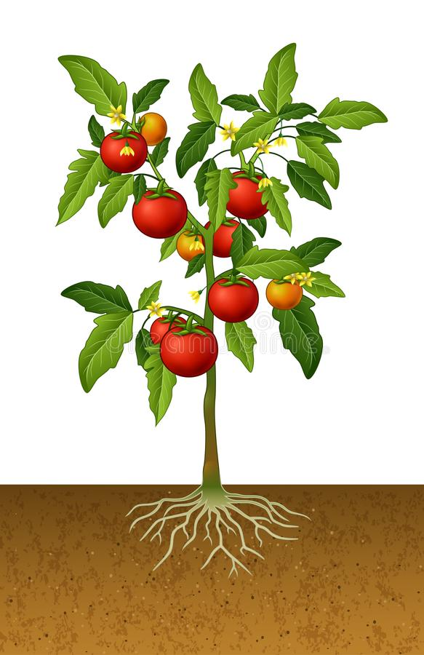

Try this:
Write a sentence about what each part of the plant does.

E.g. The petals are brightly coloured to attract bees and butterflies to their pollen.

