
Year 5 Homework

Date homework set: 23.02.23
To be returned to school by: 28.02.23

Talking Topic (10 minutes)
- To discuss the following topic:

- “What is a digital footprint?”
Tick when you have completed this task.
Maths (10 minutes)
Complete the following:

100 x 34.56 =
234 x 1000 =
7623.3 X 100 =
212 X _____ = 212000

Tick when you have completed these tasks.
Writing (10 minutes)
Write a story about this picture.
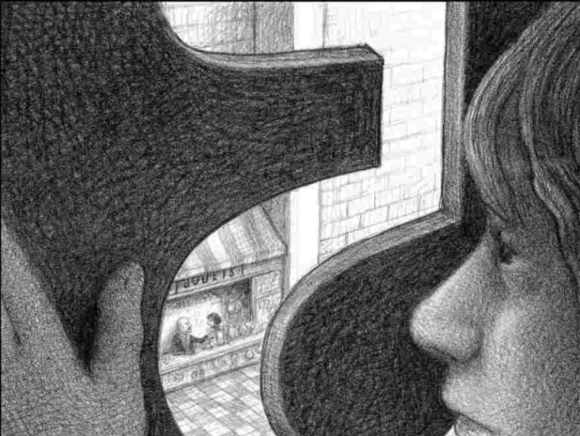

Spellings:
Learn these spellings:
Horrible
Legible
Reliably
Forgivable
Possible

Tick when you have completed this task.

