Friday, 23 May 2025
Dear Parents/Carers,
Half Term School Closure
School will be closed for half term for one week from Monday 26th May.
School will reopen on Monday 2nd June.

Attendance

Whole school attendance this week is 90.08%.
These four classes met the target of 96% this week.
Y5T Dragonfly | 98.52
Y6H Phantom Midge Larva | 97.78
Y2S Swan | 97.53
Y2C Coot | 96.16

Overall this half term, the Y2S Swan class have won the attendance award and will have a non-uniform day on Thursday 12th June.


Punctuality
In three of our classes, all children arrived on time this week.
Well done to five classes that only had one child arrive late this week.
Y2C, Y3E, Y4P and both our Year 6 classes.

Overall this half term, the Y2 Swan class have won the punctuality award and will have a non-uniform day on Friday 13th June.

Recent Events
Year 4 Egyptian Day
Year 4 took part in a Egyptian Day. Children are invited to dressed and learnt about Tutankhamun, mummification and the tomb that Howard Carter discovered in 1922. Mrs Phillip’s class recreated the River Nile on the school field earlier in the week.
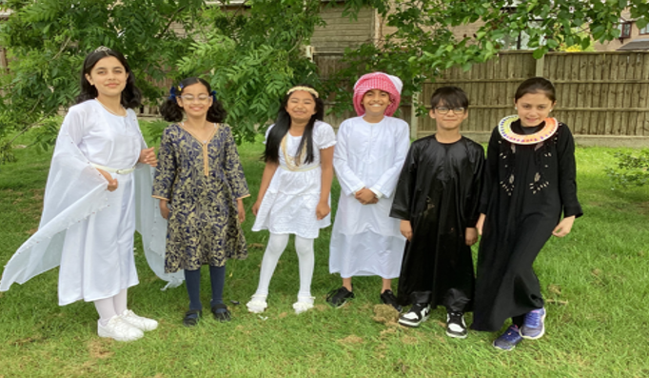
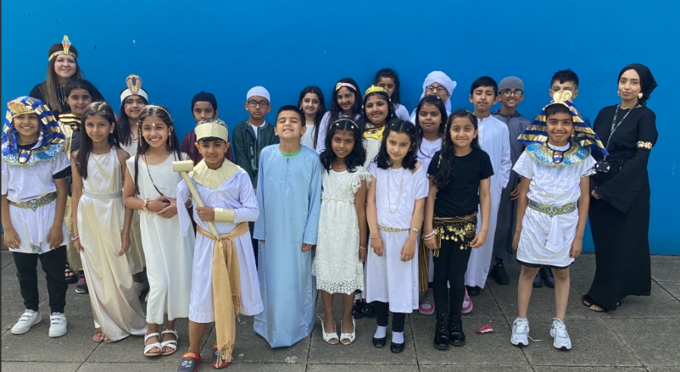

Our two Year 2 classes had their trip to St Anne’s this week as part of their geography and history topic about the seaside. They visited the lifeboat station to learn about their important work, built sandcastles and learnt about the features of a seaside location.

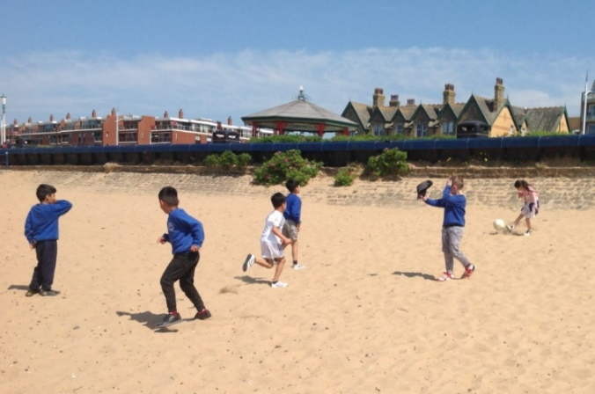
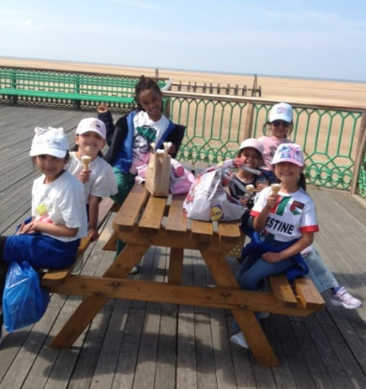

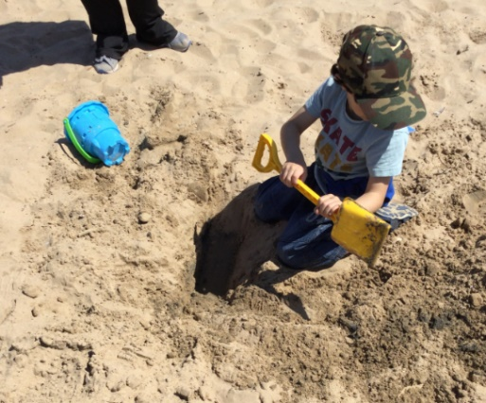
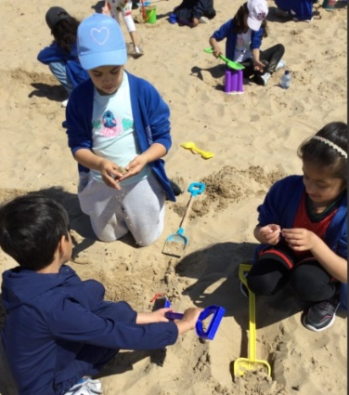

Mini Cops
10 of our children are part of a mini cop project with the police. Last Friday afternoon three of the children were able to attend a Community Policing Launch at the Leisure Box where they were able to talk to members of the public about their project.
They were also able to look around the police riot van and various pieces of equipment that the police use. We all had a turn with the riot shield, with each of us throwing bean bags at the shield. Well done Gabriel, Rabia and Zachariah, you represented Reedley School really well.
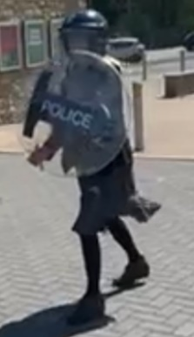

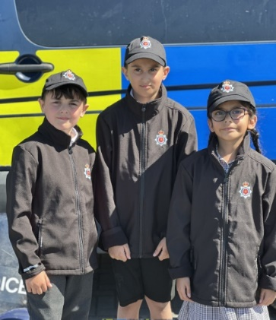

Air Ambulance
The children had an assembly about the Air Ambulance this week, learning about the important life-saving work that this organisation does. It is a charity close to my heart as I was air-lifted to hospital 17 years ago following an accident.
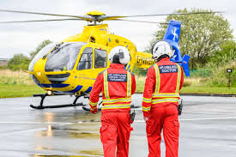
Today we have asked the children to come to school dressed in blue and yellow to raise money for the Air Ambulance as they rely purely on donations. Ask your children can tell you some facts about the Air Ambulance Service that they learnt from the assembly.

Key Dates
- Half term – school will be closed from 26th May and will reopen on Monday 2nd June.
- Reception Trip to the Farm – Wednesday 4th June
- Eid. The current position is that school will be closed on Monday 9th and Tuesday 10th June. This may change to school being closed on Friday 6th June. We will update you all on 28th May.
- Sports Day - (subject to weather)– families are welcome to come and watch

Sports Day - Monday 16th June
9.15am | Year 3 and Year 4
10.15am | Year 5 and Year 6
1.10pm | Reception
2.00pm | Year 1 and Year 2

- Y4 Times Table Check will take place between Monday 2nd June to Friday 13th June
- Y4 Eid Assembly - Families of children in Y4 invited to the assembly at 2.30pm on 18th June
- Eid Fair – Thursday 19th June from 3.40 – 4.40pm
- Phonics Screening Check for Y1 and some Y2 children to take place from Wednesday 11th June to Friday 13th June.
- Sporting Event – All classes to take part in a fun physical activity
- Y6 Residential trip to Whitehough - Monday 7th July to Wednesday 9th July
- Summer Holiday School will close at 1.30pm on Wednesday 23rd July. School will reopen to pupils on Tuesday 2nd September.

Thank you for your support, Mrs Sarah Bell, Headteacher





