Useful Information for the Crane Class

Hello and welcome to the Crane class information page. Our names are Mrs Collins and Miss McNulty we are your child’s class teachers. Mrs Latif is your child’s teaching assistant.
Below you will find lots of useful information to support your child during the year.
We are looking forward to teaching your child this year and having lots of fun learning together.
We have lots of exciting learning planned in Year 2 and we are sure your child will have a wonderful time taking part in all the different activities.
Other staff that work with us are:
Mrs Latif the class Teaching Assistant
Mrs Jaleel will teach the class on Tuesday afternoon.
UNIFORM
Boys - Black or grey trousers, white polo shirt and a royal blue sweatshirt
Girls – Black or navy dress or skirt, white polo shirt, blue checked dress, blue sweatshirt or cardigan. Girls can wear leggings or trousers.
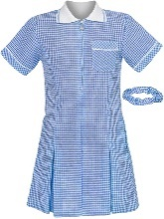
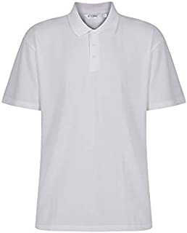
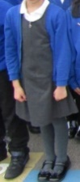
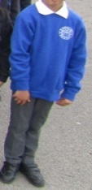

The children need to wear black school shoes with no logos. Trainers are not part of the school uniform.
HEADSCARVES
Girls can choose to wear a headscarf if they wish to. These should be plain black, blue or white and should have no decorations, and must not be fastened by pins. They should not be longer than shoulder length and must be removed for PE.
PE
Our PE day will be on a Thursday
Children need to have a red polo t shirt, black shorts and black pumps. Kits and PE bags (not pumps) can be bought from the school office.
Children can have plain black tracksuit bottoms for outside PE when the weather is colder.
The PE kit should be brought into school and remain here until the end of each term, when it can be taken home for washing.
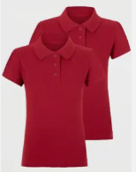
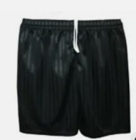
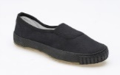

JEWELLERY
Jewellery is not allowed in school expect for a small pair of stud earrings and a watch. For PE lessons, the earrings must be covered over with plasters (provided by the parent) or removed. The children must be able to remove them themselves. Please keep all other jewellery at home at all times for safety purposes. If I have to take it from your child, it could get lost.
READING BOOK AND BOOK BAG
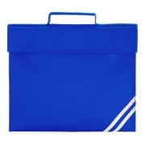
Children need a school bookbag – not a rucksack as we do not have the space to store these in the day.
They need to bring this to school every day.
Books are changed on a Friday morning.
We ask that all children read with an adult at home for around 10 minutes every day. Please make sure you sign the reading record when you have listened to your child read.
Library
Year 2 library time is on a Thursday.
Your child can bring home one book at a time. When you have finished it you can return it and choose a new book. You do not have to bring the book back every week you can enjoy sharing the book for as long as you like.
WATER
Children should bring a clear, plastic water bottle everyday with their name on. This should not have juice in.
- In our class we put our bottles in the water tray. Children are welcome to have a drink after playtimes and during independent learning time. Water should be drunk at the water station and not at tables.
HOMEWORK
- Homework books are sent home on a Thursday and the work should be completed by the following Tuesday.
- Homework is usually to consolidate something we have already learnt in class and it is really important that it is completed. Passwords are stuck at the front of the homework book.
- Your child has access to Numbots, TTRS, Spag.com and Purple Mash
- If your child is not able to complete the work, please let me know
- If the work is not done, we will chat to you on the playground
Your child may have access to Nessy which is a language based programme. If your child has a log in, they can access this at home and in school. We recommend that they try to do around 10 minutes each day on this at home to support their work in school.
STATUTORY ASSESSMENTS
Year 2 Phonics Screening Check
Any children who have not passed the Phonics Screening Check in
Year 1 will take the check again at the end of Year 2.
KNOWLEDGE ORGANISER
We will send home knowledge organisers throughout the year so that you can be aware of what your child will be learning and you can start to discuss the topic and key vocabulary with your child.
READING FOR PLEASURE
There is a Reading For Pleasure Scheme that takes place each year. The children are asked to complete tasks related to different animals, working their way through the alphabet.
We expect them to complete one per fortnight on average. There are certificates for those children who complete them and the opportunity to enter a prize draw.
TIMES TABLES
Each week the children will be able to take a written test to achieve different times table awards in school. They have to answer different questions at random, both multiplication and division. If they are close to passing but get a few wrong, we will write these facts down for the children to practise at home. The first test is platinum and is the 2,5,10 times tables.

Red Rose Phonics
We use Red Rose Phonics to teach phonics. There will be workshops to support you to help your child at home during the year.
HANDWRITING
In school we use the following handwriting formations. It would be really helpful if you ask you child to help you do some writing at home. Maybe they can write the shopping list or a list of jobs that you need to do in town.
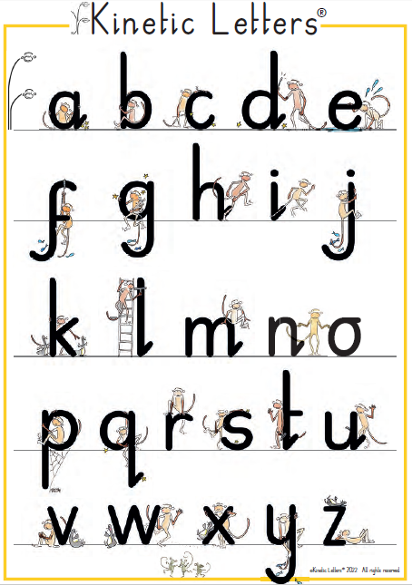
CLASS TRIP
Our class trip this year is to St. Annes beach at the end of May. The cost for the trip will be £15. This will include an ice cream.

You are welcome to pay in instalments via school spider.
PLEASE BE ON TIME
It is important that children arrive at school on time as learning in my class starts at 8.50am
We have phonics everyday first thing in the morning. This is important as it provides the building blocks to develop good reading. If your child is late they miss this vital learning.

CONCERNS
If you have any concerns or questions at any time, we are happy to chat to you. You can catch us on the playground at the end of the day or you can book an appointment or telephone call with us.
Call Mrs Iqbal on 01282 693688 if you require an appointment.

