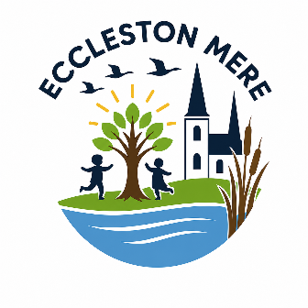
Year 6
Suggested Reading List

Books to share and enjoy with an adult
Modern Fiction
The Hobbit | JRR Tolkien
The Wolves of Willoughby Chase | Joan Aiken
The Midnight Fox | Betsy Byars
Wonder | RJ Palacio
Northern Lights | Philip Pullman

Poetry and Rhyme
I Don’t Like Poetry | Joshua Seigal
The Works | Paul Cookson
Bright Bursts of Colour | Matt Goodfellow

Traditional / Classic Tales
The Lost Happy Endings | Carol Ann Duffy
Greek Myths | Marcia Williams
Beowulf | Michael Morpurgo

Information / Non-Fiction
On The Origin of Species | Charles Darwin
A Really Short History of Nearly Everything | Bill Bryson
Ancient Egypt: Tales of Gods and Pharaohs | Marcia Williams

