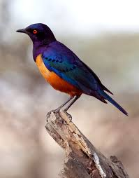

Autumn Newsletter

Hello and welcome back to school. We hope you have all had a lovely summer break.

We are really looking forward to the children being back in class and welcoming Annabelle in to Starlings.

In the Starlings class we provide a supportive environment for the children to ensure they thrive in all aspects of their learning and development. To achieve this, we follow a practical experiential curriculum with an emphasis on developing skills in the following areas;

* Communication
* Cognition
* Physical Development and
* Personal Care and Independence.

This term our topic is toys, so please feel free to send in favourite toys, or photos/videos of your children playing with them via Class Dojo.

Home / School Communication

We aim to report to you daily via Class Dojo about your child’s daily activity and any other relevant information. We may also include important letters and photographs. It would also be helpful for you to make us aware of any wow moments, changes in routine or any information that would help us to further support your child at school.

As we will be learning through doing it would be very useful to have spare clothes, including

socks in school and we will return soiled & wet/messy items to you bagged up and ready to

wash.

Class Fund

We ask for a voluntary contribution of £1 a week to make it possible for us to buy cookery ingredients, sensory play materials and resources for class sessions and activities. Please you can send in £1 every week or for the whole term if you prefer.

If you have any further questions please speak to a member of the team.

Thanks, The Starlings Team.