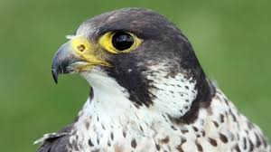 **Falcons Class**

** Autumn Term 2025**

This term our topic is my, myself and I. During the topic we will be thinking about the different attributes that make a good friend and what we think makes a good friend. We will be exploring different emotions and strategies to use when things become overwhelming. We will also be celebrating our differences and looking into what makes us individual.

**Me, myself and I**

**Welcome**

We hope you all had a nice Summer break.

I would like to welcome all parents/carers to the Falcons class team.

The team consists of:

**Teacher:** Tom Livingston

**Teaching Assistants**: Emma Spragg(TA3), Elaine Ford(TA1) Leanne Goddard(TA1) & Alex Pearce(Mon & Tue)

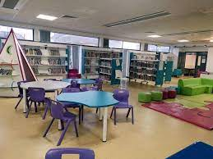

**Communication**

We use class dojo to communicate about your child’s day and you can use this to communicate back to the class team. Feel free to write anything that you feel might impact their day at school or anything else that is important for us to know E.g./Sleep, eating etc. Please make sure that messages are in the personal message option and not group message on dojo.

You can also speak to us by calling the school on 0161 359 5322. If we are not available, you can leave a message or ask us to call you back.

You can contact me on the email address below [**T.livingston@ashgate.manchester.sch.uk**](mailto:T.livingston@ashgate.manchester.sch.uk)

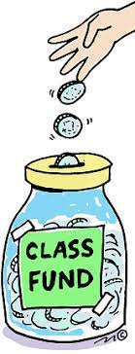 **Class fund, snack and water**

We have a class fund which supports snack, cooking and any other items we may need for class. We are asking for a contribution of £**1** a week to the class fund. A range of healthy snacks are offered to the children every morning including raisins, toast crackers and cereal. Please inform the Falcons team of any dietary requirements. We also have class water bottles for the children to access throughout the day. These bottles are refilled regularly with fresh water ensuring all children are hydrated.

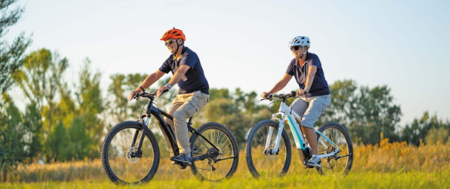

**Wythenshawe Wheelers**

This term the Falcons will be accessing Wythenshawe wheelers and given the opportunity to access a variety of different bikes. This is a chance for all pupils to build confidence around riding a bike and learning some key life skills.

**Forest Schools** 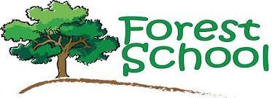

Every Tuesday afternoon the Falcons will take part in a forest school session lead by myself (Tom Class Teacher). I am a fully trained Forest School Lead and will look to link sessions with the class topic and also build confidence as well as independence. The children will be in the forest in all weather conditions so if you could send a set of wellies and waterproofs that would be great.