 | 9.00-9.45 | 9.45-10.15 | 10.15-10.30 | 10.30-10.50 | 10.50-11.45 | 11.45-12.00 | 12.00-12.30 | 12.30-1.00 | 1.00-2.30 | 2.30-3.15
Mon | Morning routines  Sign in, Hello & morning activities  Reading  (6 Pupils to read per day) | Numeracy/Happy Café  (Use and Apply- Money recognition and exchange) | Numeracy/Happy Café  (Use and Apply- Money recognition and exchange) | Outside Play  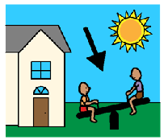 | Cooking  (Use and Apply- Mass and Volume of ingredients) | Undirected time 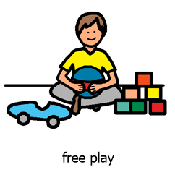 | Outside Play  PSHE | Lunch  Toileting  Independence skills | Tooth Brushing  Meditation  Circle time  Literacy Weekend New, letter formation & fine motor  Swings 1.30-2.30pm | Story Time  Home time routine  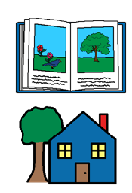
Tues | Morning routines  Sign in, Hello & morning activities  Reading  (6 Pupils to read per day) | Phonics & SPAG  Little Wandle phase 2,3 and 4  SPAG task for pupils above phase 5 | Snack  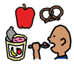 | Outside Play | Numeracy  Number & place value | Undirected time | Outside Play  PSHE | Lunch  Toileting  Independence skills | Tooth Brushing  Meditation  Circle time  Forest | Story Time  Home time routine
Wed | Morning routines  Sign in, Hello & morning activities  Reading  (6 Pupils to read per day) | Phonics & SPAG  Little Wandle phase 2, 3 and 4  SPAG task for pupils above phase 5 | Snack | Outside Play | Literacy, mark marking, letter formation & fine motor | Undirected time | Outside Play  PSHE | Lunch  Toileting  Independence skills | Tooth Brushing  Mediation  Circle time  Geography/history/ KUW | Story Time  Home time routine
Thurs | Morning routines  Sign in, Hello & morning activities  Reading  (6 Pupils to read per day) | Phonics & SPAG  Little Wandle phase 2,3 and 4  SPAG task for pupils above phase 5 | Snack | Outside Play | Numeracy  Shape, space & measure | Undirected time | Outside Play  PSHE | Lunch  Toileting  Independence skills | Tooth Brushing  Meditation  Circle time  Art/Design technology  Sensory room 2.00-3.00pm | Story Time  Home time routine
Fri | Morning routines  Sign in, Hello & morning activities | Snack | Wythenshawe Wheelers | Wythenshawe Wheelers | Wythenshawe Wheelers | Undirected time | Outside Play  PSHE | Lunch  Toileting  Independence skills | Soft play 1.00-1.45  Tooth Brushing  Golden Time | Story Time  Home time routine

