
Queensgate Primary School
Home Learning

Below you will find the areas to focus on with your child this week. The children will have already been taught the sounds, tricky words and numbers below so this is an opportunity for them to consolidate and apply their learning. Please also remember to read regularly with your child at home and access the suggested websites for more activities for you to do at home.

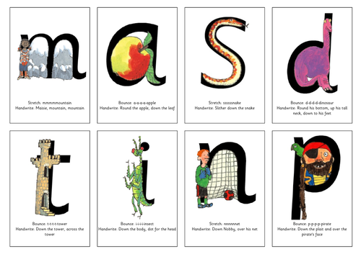
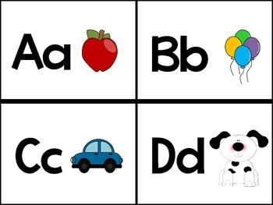
Sounds of the week
Pp (pig)
Ii (Igloo)

Can you child think of any words that begin with these sounds? What about words that end with these sounds? Can they use these sounds in blending and segmenting activities? For example, if you say the sounds ‘p-i-p’, can they reply with ‘pip’? If you give them the word ‘tap’, can they reply by sound talking ‘t-a-p’? In blending and segmenting activities we only work with 2 or 3 letter words that are all phonetically decodable. Have a go at writing these sounds using the rhymes, ‘down the plait and over the pirate’s face’’ and ‘down the body, dot for the head’.

Tricky word

go

Can your child read this tricky word from our Tricky Word Train? Can they tell you what is tricky about the word? Can they say a sentence containing this tricky word? Perhaps they could have a go at writing it? (Remember that nice pencil grip) Can they spot the tricky word in books, stories online or in print in the environment?

Number of the week
4 four

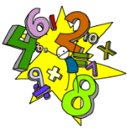

Can your child identify this number? Can they count out the correct number of objects? Can they count on and back from this number? Can they tell you what comes before or after this number on a number line? Can they find this number in the environment? What else can they tell you about this number? How many different ways can they find to make this total using two separate groups?

ILD task


This week our area of learning is….

Understanding the World: Signs of Spring

Explore your outdoor area and garden – can you spot any signs of spring? Look for buds, flowers, birds and minibeasts. What can you spot? What’s happening to trees and flowers? What are the birds doing? How many new plant or animal names can you learn? What’s the weather like? How is the season of spring different to winter? Maybe you could draw and colour your favourite flower, or make a bird feeder (with the help of a grown up), or start to grow your own plant. You could even learn about the butterfly lifecycle or animals and their young. Just make sure you have lots of fun exploring spring!

Please take a picture of your child completing the task above and upload it onto the ILD. It would be great if you could please write a comment explaining what they were able to do and, especially note down any comments that they said during the activity.

Useful Websites

Just click on the images below to take you to the following websites…


Fun Maths activities to try at home accompanied by explanatory videos.
A fantastic range of resources to support all areas of learning and they are currently free. PowerPoints can be downloaded and many resources can be printed for use at home.

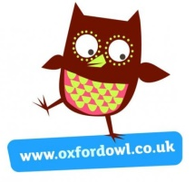
Free eBooks for your child to read at home.
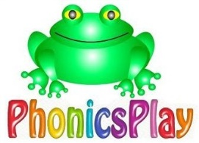
Fun, interactive, online phonics games to help your child review the sounds and tricky words that they have learnt. This is also currently free.

A variety of online activities and games for all age groups.
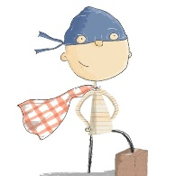
A collection of fun activities / ideas to do at home to give you some inspiration if needed!

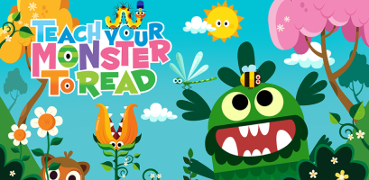
A fun, interactive phonics game! The children create their own monster who they then teach to read whilst adventuring around a magical world. The game is free on a computer and there is an app available to purchase.

If you are on Instagram or Facebook the Play Hooray account does a live play-a-long every weekday at 10am for children aged 1 – 5 and has lots of ideas to get you playing with things you can find around the house!

