Power for Good means
Everyone is worthy of friendship
We can choose to make good choices
Instead of being mean
We all have feelings, we all matter
We should all be seen

Power for Good means
Knowing that our actions have consequences
We can use our voice to defend others,
And to spread understanding
Don’t get stuck in a loophole of fear
Ask for help because adults are here

Power for Good means
Standing up for ourselves
And knowing that we matter
You never know what other people are going through
Our power can fix our worries
And make people feel safe
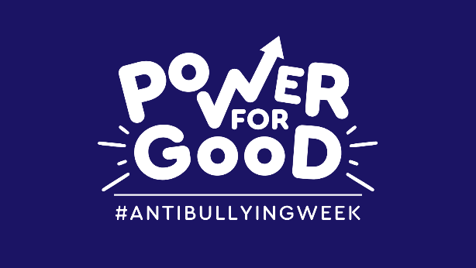
By Y4L

