Tuesday 1st September, 2026

Dear Parents and Carers,

Welcome back to a new school year at Mount Carmel. I hope you and your families have had a wonderful summer holiday and enjoyed time together.

The school has been a hive of activity over the last week with staff busy preparing classrooms, organising resources and completing important statutory training. Everything is now ready, and we are so excited to welcome all our children back tomorrow! We are particularly looking forward to seeing our new children and families joining us and beginning another happy and successful year together.

A few reminders for tomorrow:
Mobile Phones
Mobile phones are not permitted in school.
We understand that some children in Year 6 who walk to and from school independently may need to carry a phone for their journey. In these circumstances, phones must be handed into the school office each morning and will be safely stored during the school day. At the end of the day, children can collect their phone from the class teacher's phone box as they leave.
If your child is dropped off and collected from school, they will not need to bring a mobile phone.

Year 6 Walking Home Permission
If you would like your Year 6 child to walk home from school independently at the end of the school day, please complete the permission on Arbor.

Start and Finish Times
Infants (Nursery, Reception, Year 1 and Year 2)
• Gates open at 8:40am
• Gates close at 8:50am
• The school day begins at 8:50am
• School finishes at 3:20pm

Juniors (Years 3–6)
• Gates open at 8:45am
• Gates close at 9:00am
• The school day begins at 9:00am
• School finishes at 3:30pm
Tomorrow morning, members of staff will be available to welcome our Year 3 children into the building and help them settle into their new surroundings.
Thank you, as always, for your continued support. We are looking forward to another wonderful year filled with learning, friendship, faith and lots of happy memories.

We can't wait to see you all tomorrow!

With very best wishes,

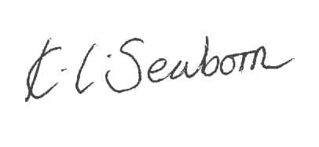
Mrs Seaborn
Headteacher

