
This Photo by Unknown Author is licensed under CC BY-SA-NC

23rd October, 2025
YEARS 3 To 6 CHRISTMAS PANTOMIME

Dear Parents/Carers,

On Wednesday 10th December, we are planning to take the children in Years 3-6 to Middleton Arena to see the Pantomime “Aladdin”.

The performance has been booked for the morning so it will require that all the children are in school at 8.45am in order to leave on the coach promptly at 9am. They will return to school at lunchtime and will have their dinner as normal, children who are on packed lunch will bring one in as usual. School will finish at the normal time.

To cover the cost of the Pantomime and transport, we are asking for a contribution of £15.55 per child. Please send your payment by using Parent pay for your child by Monday 1st December if you wish your child to go.

We appreciate that we are sending the letter out early, but Middleton Arena requires full payment for the booking by the beginning of December. If this presents any problem for you, please do not hesitate to contact Mrs Seaborn
through the school office.
If you would like your child to go, please confirm this by payment of £15.55 through Parentpay and this will also act as your consent. Please note that if we do not have your consent your child will be unable to go.

This Photo by Unknown Author is licensed under CC BY-NC-ND
Yours sincerely,
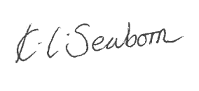
Kirsty Seaborn
Headteacher

