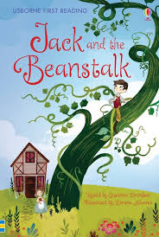
13th November, 2025

INFANT CHRISTMAS PANTOMIME

‘JACK and the BEANSTALK’

Dear Parents/Carers,

On Tuesday 9th December, we have a Theatre group coming in to school to perform the pantomime “Jack and the Beanstalk” to our Infant and Nursery Department children.

The performance has been booked for the morning and the children will be given a treat also.

To cover the cost of the Pantomime and refreshments, we are asking for a contribution of £5.00 per child. Please make your payment by using Parent pay for your child by Wednesday 3rd December.

If you feel you may have difficulty in making this payment, please do not hesitate to contact the school office.

Yours sincerely

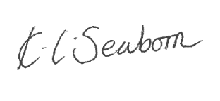

Mrs K. Seaborn
Headteacher

