Mount Carmel Attainment and Progress Information 2022- 2023
EYFS- GLD
 | Mount Carmel | Manchester | National
GLD  Good Level of Development | 56% | 59% | 67%

Phonics Screening Data Year 1
 | Mount Carmel | Manchester | National
Phonics | 82% | 74% | 79%

Key Stage 1 Data Achieving Expected Standard
 | Mount Carmel | Manchester | National
Reading | 58% | 62% | 68%
Writing | 50% | 52% | 60%
Maths | 63% | 64% | 70%
RWM | 43% | 49%

Key Stage 1 Data Achieving Greater Depth
 | Mount Carmel | Manchester | National
Reading | 10% | 13% | 19%
Writing | 3% | 4% | 8%
Maths | 8% | 12% | 16%
RWM | 2% | 3%

Key Stage 2 Data Achieving Expected Standard
 | Mount Carmel | Manchester | National
Reading | 80% | 68% | 73%
Writing | 75% | 61% | 71%
GPS | 85% | 69% | 72%
Maths | 82% | 68% | 73%
RWM | 65% | 51% | 59%

Key Stage 2 Data Achieving Greater Depth
 | Mount Carmel | Manchester | National
Reading | 30% | 24% | 29%
Writing | 12% | 7% | 13%
GPS | 45% | 29% | 30%
Maths | 25% | 21% | 24%
RWM | 7% | 4% | 8%

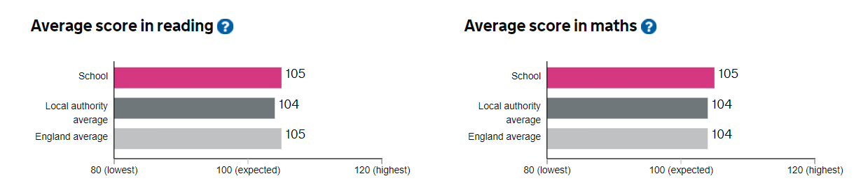
To compare the performance of Mount Carmel to other schools locally please click the link below
https://www.gov.uk/school-performance-tables

