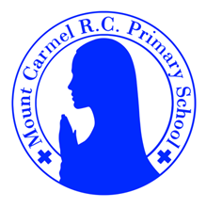
Year 4 Newsletter
Autumn Term 1
Welcome to Year 4
Welcome back! We hope you have all had a wonderful summer and a good rest, ready for a new, exciting year! There are so many interesting topics to cover this year, which we know all of you will thoroughly enjoy. We can’t wait to begin what promises to be a year of fulfilment, happiness and learning.
PE Days | Homework |  | Important Dates
Our P.E. days are Tuesday and Friday. On a Thursday morning, we will be going swimming. A letter has been sent home regarding the correct/appropriate attire for swimming.  For P.E, Children need the following kit in school.    White T-Shirt    Navy blue or black shorts    Trainers or pumps  Please make sure that earrings are removed for P.E and swimming days. |   Spellings are given out on a Monday ready for a test on Friday. Children are to complete one column at a time, in order to maximise their recall.  Maths homework is set on MyMaths on Friday and is due on the following Thursday. If children cannot complete the homework online, we would encourage you to ask for a paper copy.  Reading books are changed weekly. Children are expected to read at home for 20 minutes. Reading Diaries must be signed each day.  TT Rockstars should be used at least weekly to help the children with their learning of the times tables. This is particularly important in Year 4 with the national times tables check in the summer term. |  | 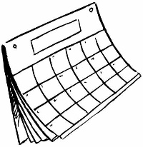  Electricity Topic Launch – Creative Builders Workshop 15th and 16th Sept.  Harvest Festival Thursday 22nd October.
What we are learning about this half term.
English |  | Maths
Using texts to write dialogue, setting and character descriptions, alternative endings and persuasive writing. The texts we will be using are:  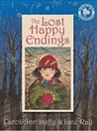 |  | The children will be building on existing knowledge of place value, rounding numbers, number bonds and the four key operations. (addition, subtraction, division and multiplication). There will also be a focus on telling the time and measurement including converting units of measurement. The children will be working particularly hard throughout the year, on their times tables recall in preparation for the national MTC in June.
Science |  | RE
The children will be learning all about electricity, building simple circuits and getting a firm grip on what makes a good conductor and a great insulator. Creative Builders will be delivering an exciting workshop using Lego, to secure our understanding.  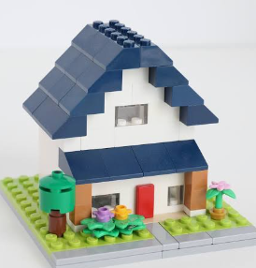 |  |   In our RE lesson, we will be focusing on the idea of creation and covenant, looking specifically at Abraham and his life after hearing the voice of God. In doing so, we will look in detail at the virtues of faith, love and hope, which help Christians to be good people.
Geography |  | D&T
The children will learn about the major world mountain ranges, as well as their key features.   |  | Children will use their knowledge of circuits to create a model house with working electricity.  
Music |  | PHSE
To perform a piece of music surrounding the topic of electricity. The children will work together, using expression to create their final performance. |  | The children will be looking at the key quality of resilience, understanding the importance of diversity, managing risks and recognising the rights of the child.
Computing |  | German
The children will learn about programming and coding, looking at key concepts such as sequencing, loops and algorithms. |  | The children will be looking at months of the year, days of the week, numbers, classroom items, as well as comparing both German and English schools.

