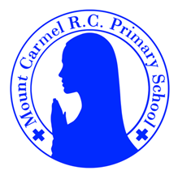
Y5R Newsletter
Autumn Term 1
Welcome to Y5B!
Welcome to Year 5R. I hope you all had a wonderful summer holiday and a well-deserved rest. Mrs Donnelly and I are really looking forward to our fantastic year ahead with you. We are going to be learning so many new things with some fun, exciting trips and visits along the way. Happy new school year!
From Miss Ratcliffe.
PE Days | Homework |  | Important Dates
Our P.E. days are Thursday and Friday.  Children need the following P.E. kit in school.  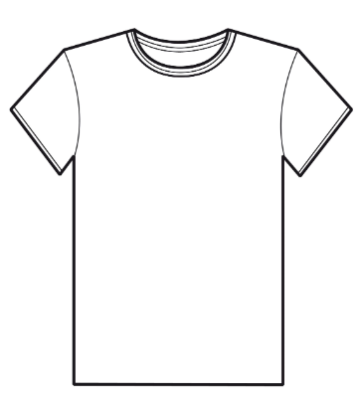  White T-Shirt  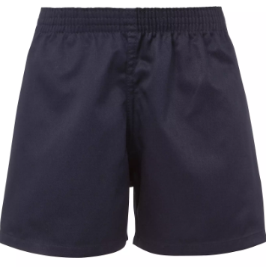  Navy blue or black shorts  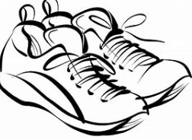  Trainers or pumps  Please make sure that earrings are removed for P.E. days. |   Spellings are given out on a Monday ready for a test on Friday. One column should be completed each night.  Maths homework is set on MyMaths on Friday and is due on the following Thursday. If children cannot complete the homework online, they can ask for a paper copy.  Reading books are changed weekly. Children are expected to read at home for 20 minutes every day. Reading diaries must be signed each day by a parent/carer. Book Club runs each break time for children who haven’t read or if their reading diaries have not been signed.  TT Rockstars should be used at least weekly to help the children with their learning of the times tables. |  | 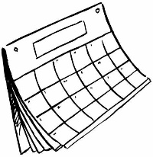  Date to be confirmed  Y5 Manchester Carnival  22/10/26  Harvest Festival  22/10/26  3:30pm finish for half term
What we are learning this half term!
English |  | Maths
We will be reading the following texts:  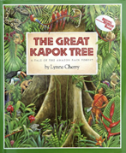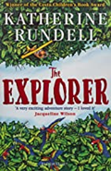  We will be using these texts to write persuasive letters, dialogue, postcards and an adventure story. These texts are linked to our geography topic (Brazil) this term. |  | This term, there will be a focus mainly on number work. The main topics we will be working on are place value in 5-digit numbers including decimal numbers and using < and > signs. We will be practising formal addition, subtraction, multiplication and division. We will revise time, length and perimeter. For more details, please see the overview on our class page on the school website.
Science: Living Things and Their Habitats |  | RE: Branch 1 – Creation and Covenant
We will be looking at our local environment throughout the year and studying the life cycles of a mammal, an amphibian, an insect and a bird. We will also be researching the work of the animal behaviourist Jane Goodall.  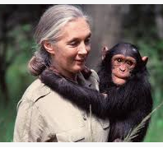 |  | We will be learning about Abraham, Moses and the Commandments. We will be thinking about our virtues, values and our Catholic Social Teaching and how we can be good neighbours.  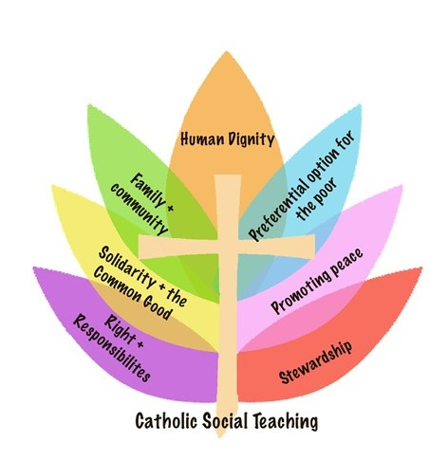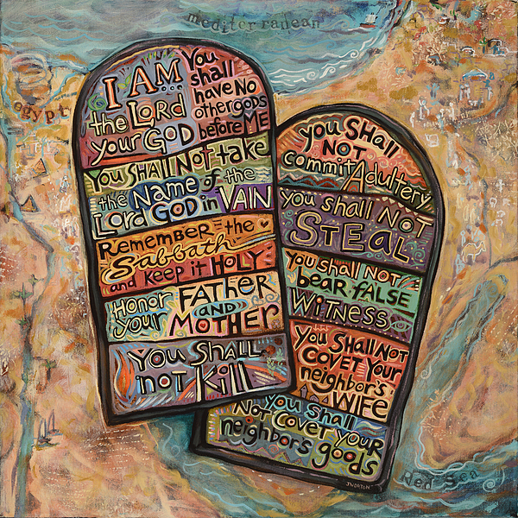
Geography: Brazil |  | Art: Pottery
We will learn about the physical and human geography of Brazil, urbanization, explore Rio de Janeiro as a tourist destination and compare the culture of Brazil to the UK.  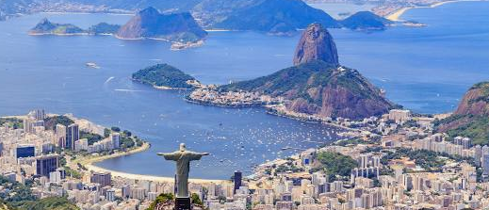 |  | We will learn about Clarice Cliff and Josiah Wedgwood. We will design and make our own piece of pottery inspired by these famous potters.  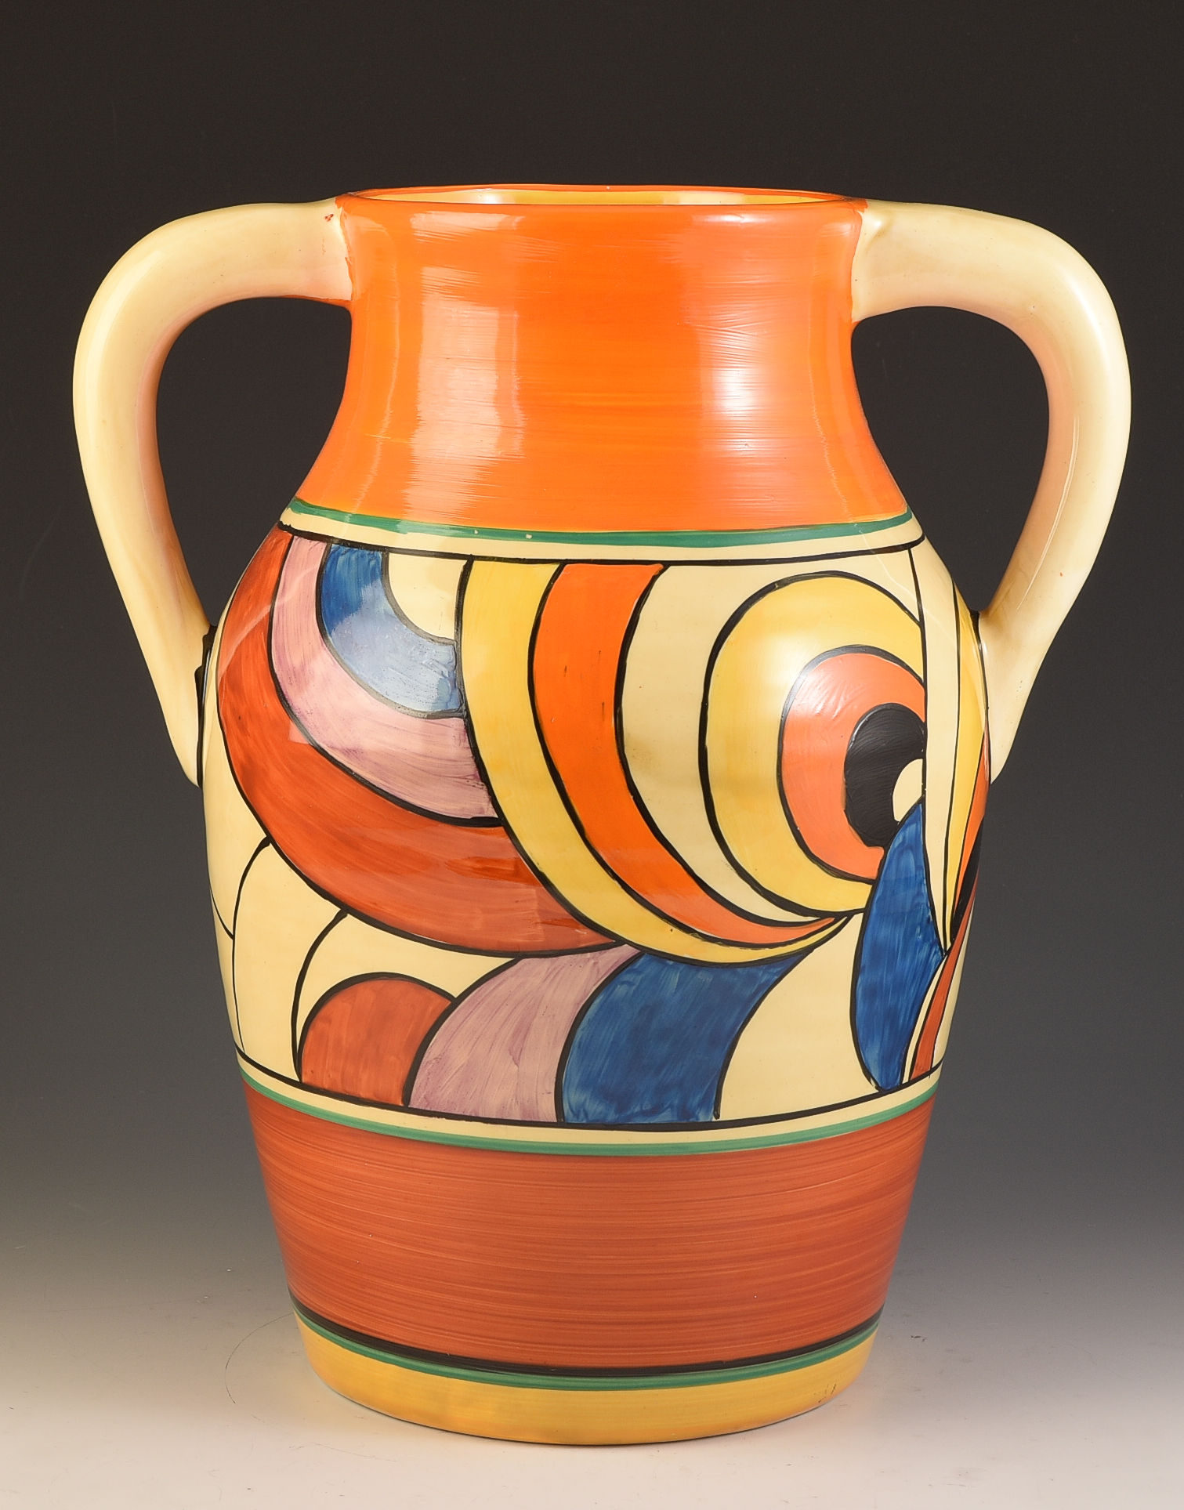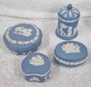
Music: Hey Dumba |  | PHSE: Calming the storm
We will be creating rhythm patterns and listening to the composer Florence Price. |  | Through the story of Jesus calming the storm, we will be learning about our faith and that God is always there for us.
PE: Dance and Fitness |  | German: My school, my subject
We will be learning about different styles of dance and how to perform them along with developing our strength and agility. |  | We will be revising feelings, school subjects and looking at word order when giving reasons.

