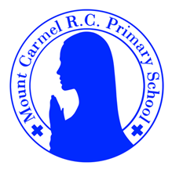
2W Newsletter
Autumn Term 1
Welcome to 2W!
Welcome back to school, everybody! We hope you had a lovely summer break and are now ready and raring to go in Year 2! We have been so excited to see you all and can’t wait to get started!

Below you will find lots of important information about this half term, so please read it carefully and if you have any questions then please speak to Mrs Warnes or Miss Comberbach. You will also find lots more information about what we will be learning about this year on our class page on the school website. You will receive a new newsletter each half term with updated information.
PE Days | Homework |  | Important Dates
Our P.E. days are Monday and Thursday.  Children need the following P.E. kit in school.  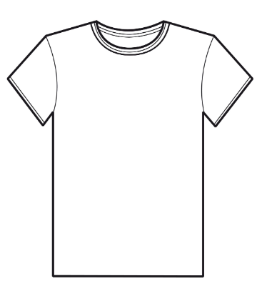  White T-Shirt  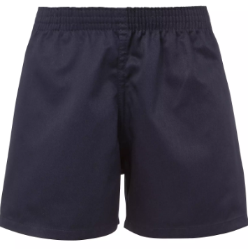  Navy blue or black shorts  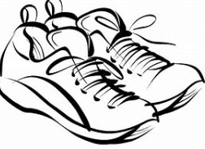  Trainers or pumps  Please make sure that earrings are removed for P.E. days. |   Spellings are given out on a Monday ready for a test on Friday. One column should be completed each night.  Maths homework is set on MyMaths on Tuesday and is due on the following Tuesday. If children cannot complete the homework online, they can use a paper copy.  Reading books are changed every Monday. Children are expected to read at home for 10 minutes every day! Reading Diaries must be signed each day.  TT Rockstars or Numbots should be used at least weekly to help the children with their learning of the times tables and number fluency. |  | 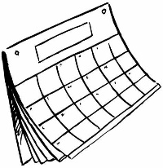  Tuesday 8th September  Our Lady’s Birthday  Wednesday 22nd October  Harvest Festival  Friday 23rd October  INSET day. School will finish for the term on Thursday 22nd October.
What we are learning this half term!
English |  | Maths
Children will be reviewing their phase 5 sounds.  We will be reading  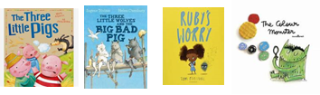  We will be writing character descriptions, letters, poems and stories. |  | -Counting from 0-100  -Comparing numbers using < and > and ordering numbers  -Using a number square to find 10 more/less and 1 more/less  -Number bonds to 10 and the relating number facts  -Doubling numbers to 15  -Sorting and classifying 2D shapes
Science |  | RE
Living Things and Their Habitats  Children will learn to classify living things and find out where they live. They will learn about what they eat and about food chains. |  | Branch 1:  Creation and Covenant
Geography |  | Art
Continents and Oceans  Children will learn about the seven continents and five oceans of the world and locate them on the map. |  | Portraits  Children will looks at some portraits by famous artists and draw and paint their own portrait using watercolours.
Music |  | PHSE
We will be finding the pulse and creating rhythm patterns, listening to music by Ravel and learning Harvest Songs. |  | Let the Children Come  We will learn that we have been created individually by God.
Computing |  | PE
IT around us  We will be learning how IT is being used for good in our lives and how to make smart choices when using it. |  | Fundamentals and team building.

