Hi, I’m Miss Ratcliffe!

I will be your teacher in Year 5 and I can’t wait to meet you.

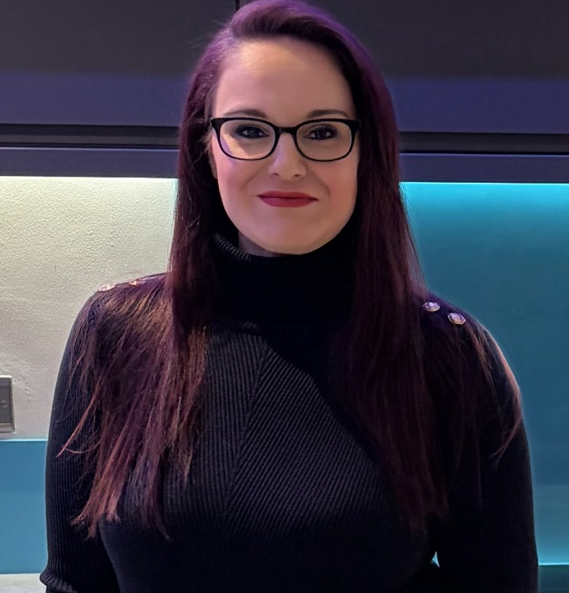

A little bit about me…
  My Birthday is in July. |   I have one dog called Denzil & two children. |   One of my favourite subjects is Maths.
  My favourite colour is blue. |   I love going to the seaside. |   I enjoy watching films.

Have a look at our classroom…
Our classroom  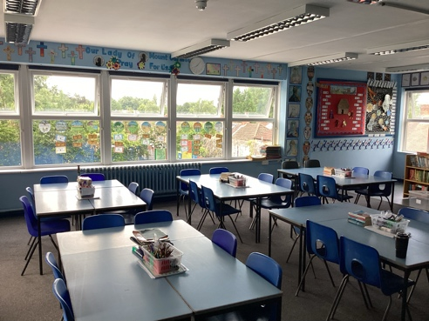 | 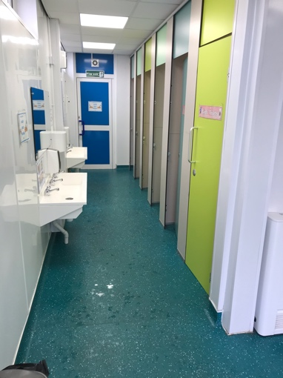  Our Toilets | 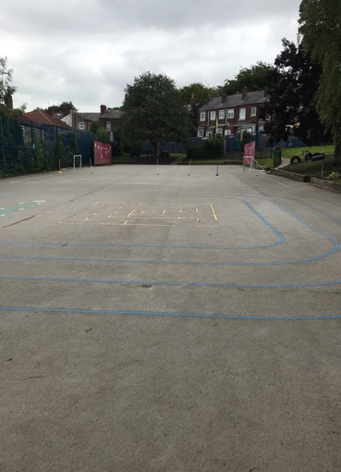  Our Playground

Other adults that work in our classroom are…
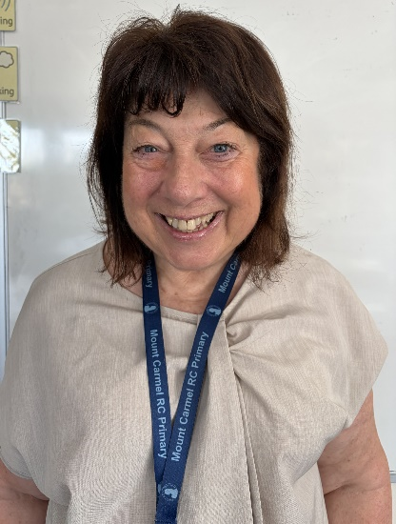
Mrs Donnelly

See you all in September. I can’t wait to meet you.
Love Miss Ratcliffe

