
Hi, I’m Mr Sloan!

I will be your teacher in Year 4 and I can’t wait to meet you! We are going to have such an amazing year together.

A little bit about me…
  My Birthday is in August |   I live with my wife, Emily, who is a high school teacher. | My favourite food is lasagne  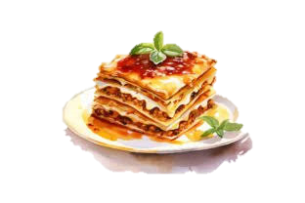
My favourite colour is  Blue   |   I play semi-professional cricket |   I have a degree in classical civilisation

Have a look at our classroom…
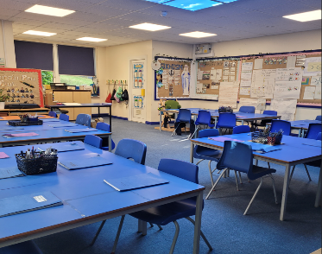  This is our classroom.  This year we will be working hard to learn all of our times Tables.  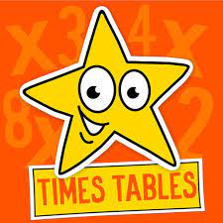 | 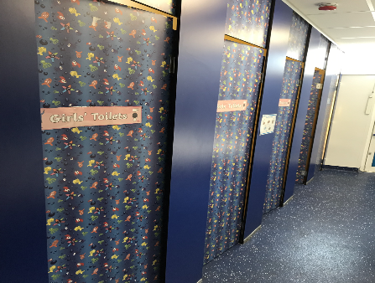  These are our toilets.  We will be inviting visitors to talk to us about science.   | 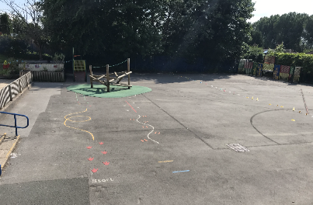  This is our playground.  Thursday is our day to go swimming.  

Other adults who work with us…
Mrs Mcardle

See you all in September. We can’t wait to meet you.
From Mr Sloan and Mrs Mcardle

