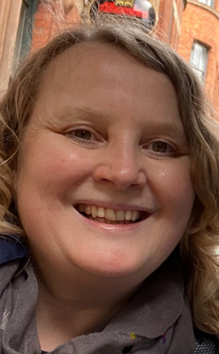
Hi, I’m Mrs Dennis!

I will be your teacher in Year 3 and it was lovely
to meet you this morning.

A little bit about me…
  My Birthday is in November. | 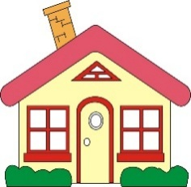  I live with my husband and my daughter. | 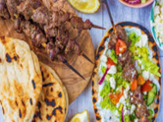  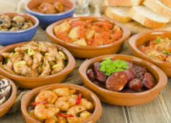  My favourite food is Greek and Spanish.
  My favourite colour is blue. |   I love travelling and visiting new places, especially near the sea. |   I enjoy reading, watching football and eating out.

Other adults that work in our classroom are…
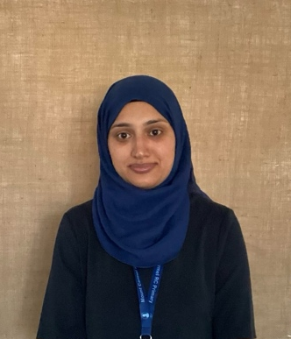
Miss Yasin

Have a look at our classroom…
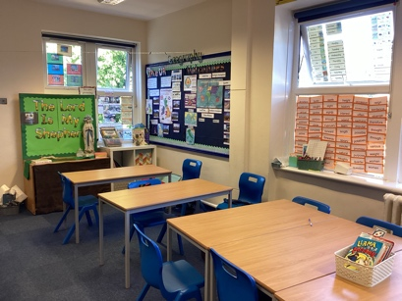  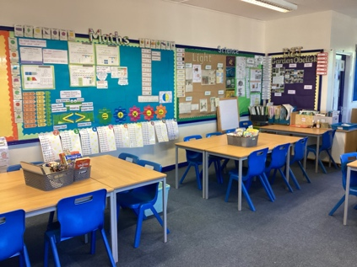  Our classroom | 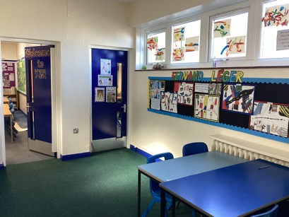  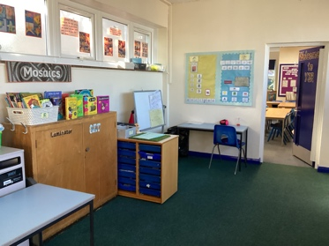  Outside our classroom | 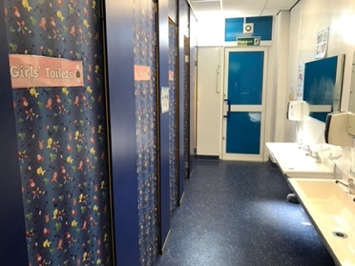  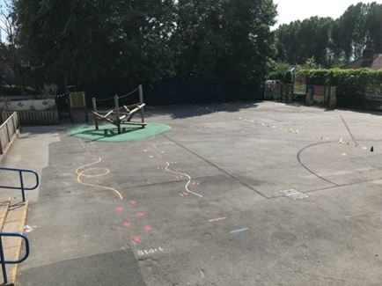  Our Toilets  Our Playground

See you all in September. I can’t wait to see you all again. Have a fantastic summer!
Love Mrs Dennis

