Hi, I’m Mrs Grayson!

I will be your teacher in Year 2 on a Monday, Tuesday and Wednesday.
I can’t wait to meet you.
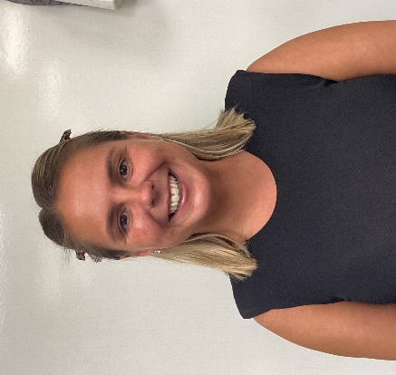

A little bit about me…

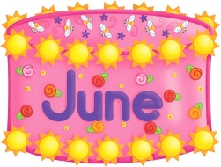  My Birthday is in June. |   I live with my husband and my little girl. |   My favourite food is  pizza
My favourite colour is purple. |   I love travelling and visiting new places. | 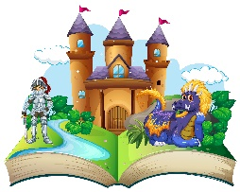  I enjoy reading stories and singing songs.

Have a look at our areas…
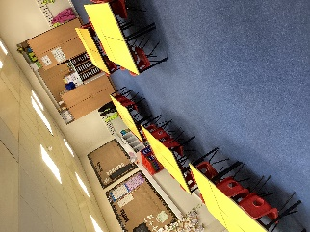  Our classroom | 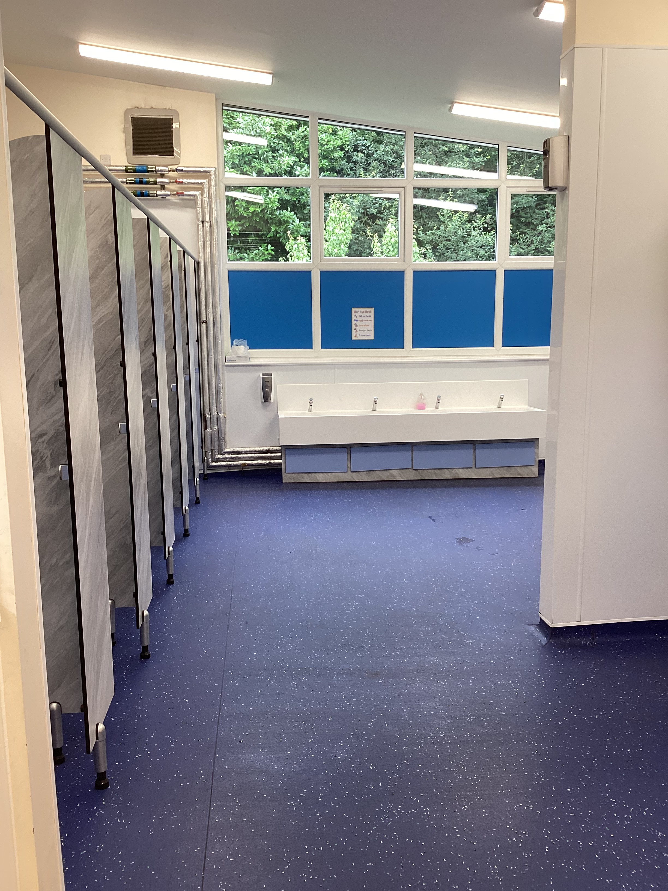  Our toilets | 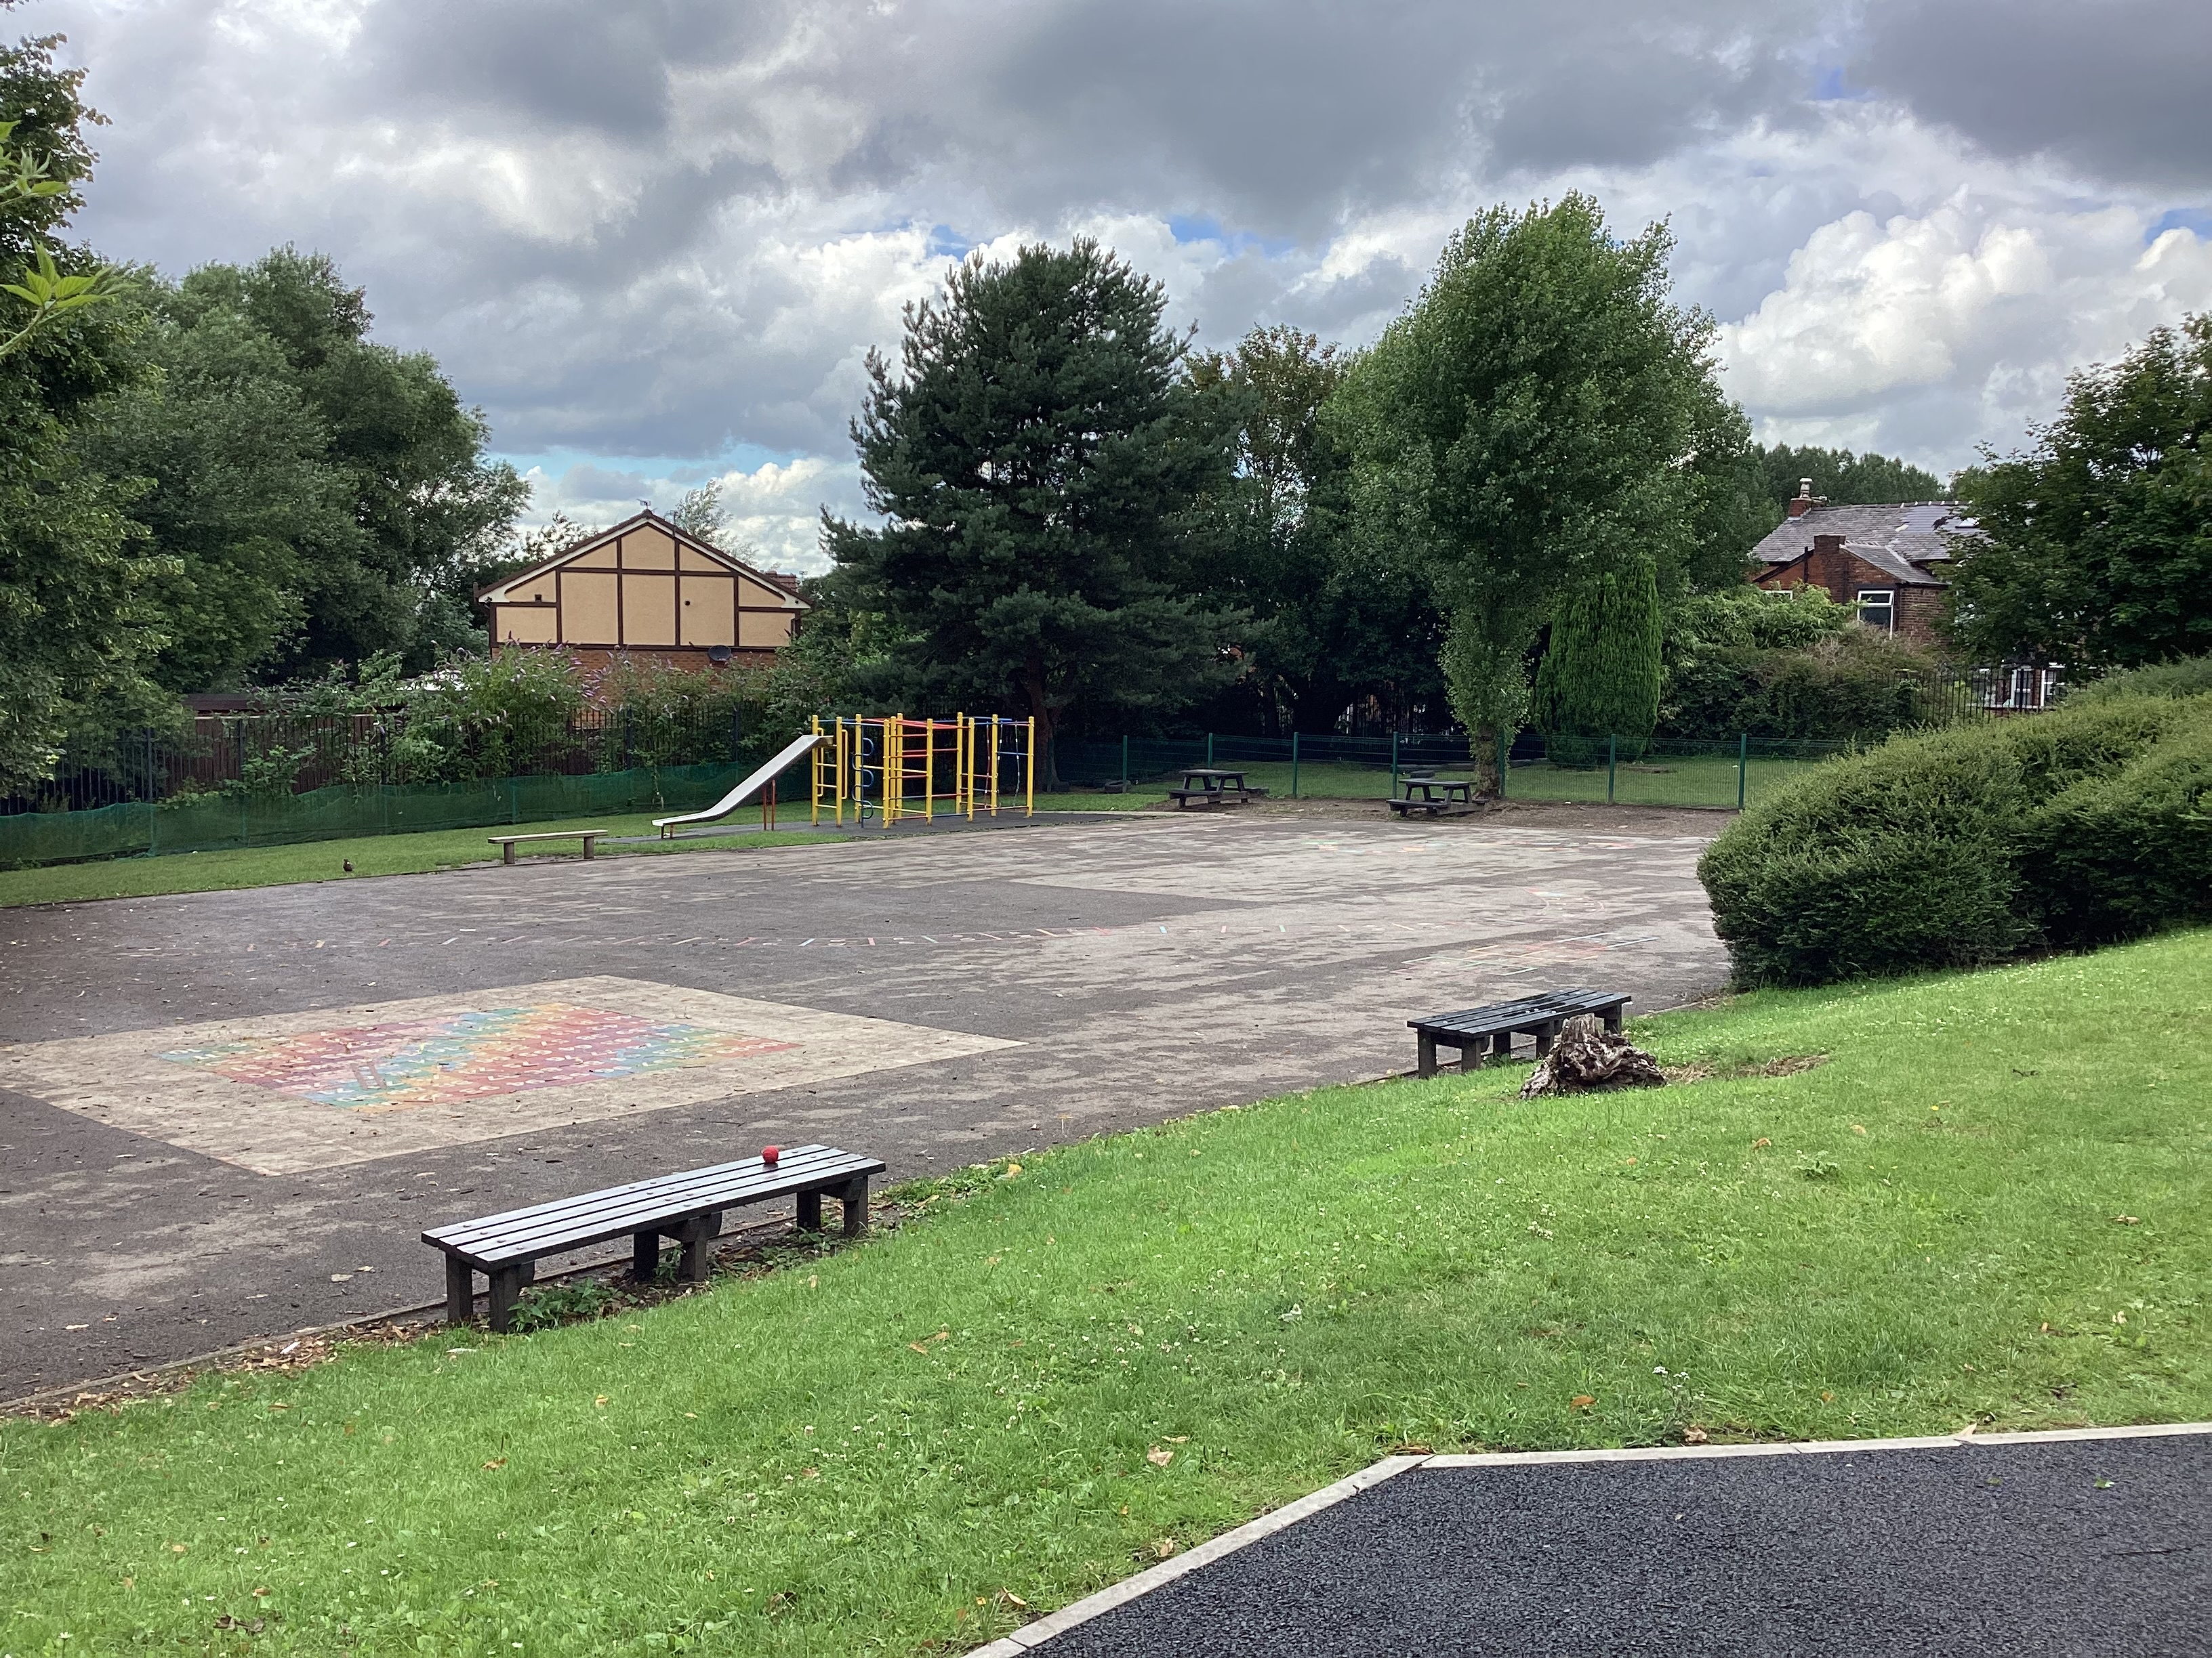  Our playground

Other adults that work in our classroom are…
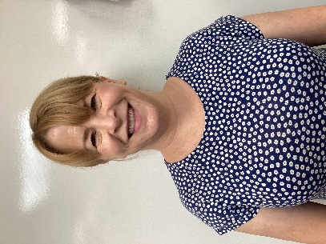  Mrs Liversage | 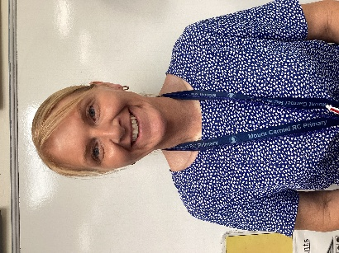  Miss Marsh | 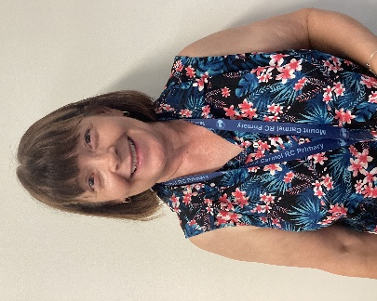  Mrs Goode | 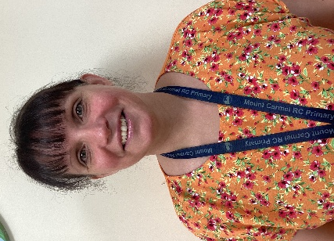  Mrs Harris

I hope you all have a wonderful summer holiday. See you all in September.
Mrs Grayson


