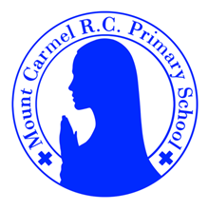
Y1 Newsletter
Summer Term 2
Welcome to Y1
Please find information below about what your child will be learning this half term. There are also some important dates for your diary.
Mrs Liversage - Year 1L
Mrs Birnie - Year 1B
PE Days | Homework |  | Important Dates
Our P.E. days are Wednesday & Thursday Y1L.  Wednesday & Friday Y1B.  Please make sure that earrings are removed for P.E. days.  Please bring in Velcro trainers or pumps for P.E. this term. | Spellings are given out on a Monday ready for a test on Friday. One column should be completed each night with the final column completed in class on Friday morning.  Maths homework is set on MyMaths on Friday and is due on the following Thursday. If children cannot complete the homework online, they can use a paper copy.  Reading books are changed every Tuesday. Children are expected to read at home for 10 minutes every day. Reading Diaries must be signed each day. |  | 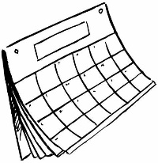  Phonics screening check – week beg. 8th June  Sports day – Wednesday 24th June  School trip to Blackpool Circus – Thursday 9th July  Friday 17th July – school closes for summer at 1.30
What we are learning this half term!
English  We will be reading these texts:  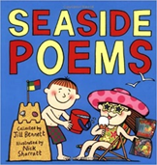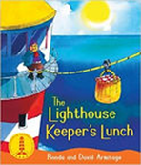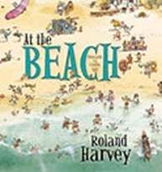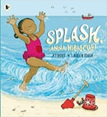  Using these texts we will be writing postcards, letters and poems. |  | Maths  *Locate 2-digit numbers on a beaded line and 100-square; compare and order 2-digit numbers up to 100 and say a number between two numbers; identify 10s and 1s in 2-digit numbers and solve place-value additions  *Recognise odd and even numbers; count in 2s, 5s and 10s, look for patterns; multiply by 2, 5, 10 by counting in groups/sets; find doubles to double 10 and related halves; halve odd numbers up to 10  *Tell the time to the half hour and quarter hour on analogue clocks and begin to read these times on digital clocks; revise months of the year; read, interpret and create a pictogram; begin to recognise and read block graphs; measure lengths using non-standard, uniform units; recognise and name simple 2D shapes and continue repeating patterns  *Use number facts to add and subtract 1-digit numbers to and from 2-digit numbers; find change from 10p and from 20p  *Locate 2-digit numbers on a bead string and a 1-100 square; order numbers to 100; identify 10s and 1s in 2-digit numbers; say or write 1 more and 1 less and 10 more and 10 less than any number to 100; explore patterns in 10s, 5s and 2s on a 9×9 grid; count in tens from any given number
Science |  | History
Revision of the units covered this year |  | 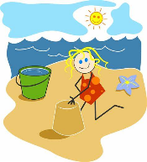  The Seaside (Victorians)  Children will learn about holidays in the past. They will learn how holidays have changed over time.
RE |  | Music
Y1 Branch 6 –dialogue & encounter.  We will be learning about the Catholic Church & the cross as a Christian symbol. We will also be learning about the Jewish and Muslim faiths. |  | We will be using all our knowledge and skills in our final performance, listening to music by Stephen Sondheim and learning songs about the seaside.
PE |  | PHSE
Target games and Invasion Games |  | The communities we live in  Who Will I Be?  Gifts, talents, jobs and vocations.
Art |  | D & T
Artist Study- Seaside pictures inspired by Renoir  Children will learn how to draw water, sea, beach and boats. Children will create their own seaside artwork using chalk. |  | Moving Pictures  Children will explore and learn about inventive ways to bring their pictures to life through a variety of moving mechanisms. They will explore sliders, levers, pivots and wheel mechanisms and how they can be used to make different parts of a picture move.

