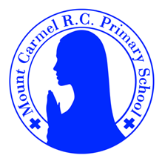
3D Newsletter
Summer Term 1

Welcome Back!
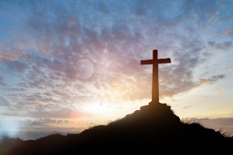
We hope that you all had a lovely Easter.
“He is not here, for He has risen, as he said he would. Come, see the place where He lay.” Matthew 28:6.
We have lots exciting learning to get through this half term in such a short amount of time – we hope you’re up for the challenge!
Our school Gospel Value this half term is grateful and generous.
Mrs Dennis,.
PE Days | Homework |  | Important Dates
Our P.E. days are Wednesday and Thursday.  Children need the following P.E. kit in school.  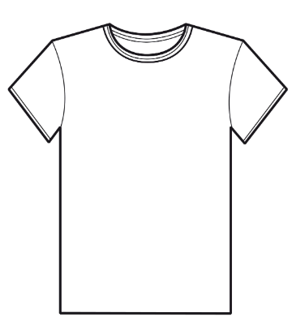  White T-Shirt  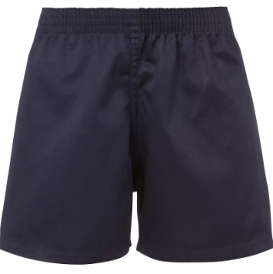  Navy blue or black shorts  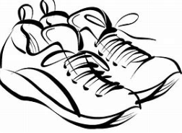  Trainers or pumps  Please make sure that earrings are removed for P.E. days . |   Spellings are given out on a Monday ready for a test on Friday. One column should be completed each night with the final column completed in class on Friday morning.  Maths homework is set on MyMaths on Friday and is due on the following Thursday. If children cannot complete the homework online, they can use a paper copy.  Reading books are changed each week on a daily rota. Children are expected to read at home for 20 minutes every day. Reading Diaries must be signed each day.  TT Rockstars and Numbots should be used at least weekly to help the children with their learning of the times tables. The logins are in the front of the Reading Diary. |  | 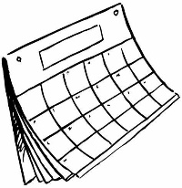  13/4/25  School opens for Summer Term 1  5/5/26  Pizza Express trip  22/5/25  Finish for half term.
What we are learning this half term!
English |  | Maths
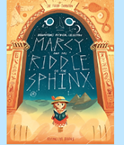  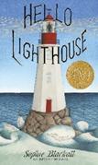  We will be reading the book Hello Lighthouse to create a diary entry and a letter from the lighthouse owner to his wife back on land. We will then read Marcy and the Riddle of the Sphinx where we will revisit dialogue and then create our own adventure story! |  | We will begin by revisiting our learning of adding and subtracting numbers mentally and building on this knowledge using our number facts. We will then move onto fractions where we will compare, find equivalences and add and subtract. We will build on our multiplication knowledge and use this to understand the inverse.
Science |  | RE
  We will learn that we need light in order to see things and that dark is the absence of light. We will notice that light is reflected from surfaces and explore what happens when light reflects off a mirror or other reflective surfaces. |  | 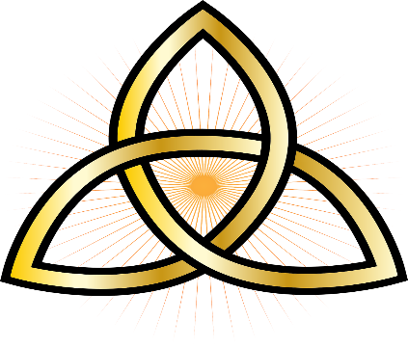  Our R.E. topic this half term is called “To the Ends of the Earth”. We will think about the resurrection of Jesus and the events after this, including The Ascension. We will then look at the Trinity and how it is represented.
Geography |  | Art
  We will learn how volcanoes are formed and know what happens when a volcano erupts. We will look at the location of volcanos using a world map and investigate why people would live near a volcano. |  | We will look at the mosaics preserved in the House of Faun and learn that mosaics are made up of an assemblage of small pieces of marble, ceramics etc. We will learn that mosaics come in different styles and will then create our own.
Music |  | PHSE
  The children will be using instruments to create different sounds, thinking about tempo, listening to music from Argentina and learning The Plant Song. |  | We will be learning the importance of First Aid and how staying calm in an emergency situation can make a huge difference. We will also be discussing our Rights and Responsibilities.
Computing |  | German
We will use a range of techniques to create a stop-frame animation using iPads. Then we will apply those skills to create a story-based animation. adding other types of media, such as music and text. |  |   In German, we will be learning how to say different fruits and vegetables and using this to request food. We will also be doing work around The Hungry Giant.
Snacks
In the Juniors, the children are not provided with a piece of fruit at breaktime. If you would like your child to have a snack, please send in a piece of fruit and they will be able to take it out with them. Thanks.

