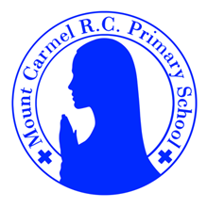
Y1 Newsletter
Summer Term 1
Welcome to Y1
Please find information below about what your child will be learning this half term. There are also some important dates for your diary.
Mrs Liversage - Year 1L
Mrs Birnie - Year 1B
PE Days | Homework |  | Important Dates
Our P.E. days are Wednesday & Thursday Y1L.  Wednesday & Friday Y1B.  Please make sure that earrings are removed for P.E. days.  Please bring in Velcro trainers or pumps for P.E. this term. | Spellings are given out on a Monday ready for a test on Friday. One column should be completed each night with the final column completed in class on Friday morning.  Maths homework is set on MyMaths on Tuesday and is due on the following Tuesday. If children cannot complete the homework online, they can use a paper copy.  Reading books are changed every Tuesday. Children are expected to read at home for 10 minutes every day. Reading Diaries must be signed each day. |  | 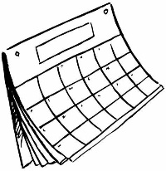  Monday 4th May Bank holiday.  School closed.  Friday 22nd May 3.20pm – break up for half term
What we are learning this half term!
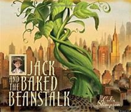  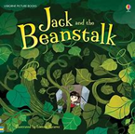  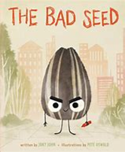  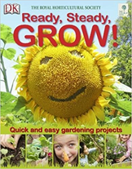  Using these texts we will be writing instructions, letters, poems, retelling stories and alternative stories. |  | - Find 1 more, 1 less, 10 more, 10 less than any 2-digit number  -Understand place value in 2-digit numbers and identify 10s and 1s  -Use number facts to add and subtract 1-digit numbers to/from 2-digit numbers  - Add pairs of 1-digit numbers with totals above 10  -Add three small numbers, spotting pairs to 10 and doubles  - Add and subtract 10 to and from 2-digit numbers  - Compare weights and capacities  - Complete tables and block graphs  - Find half of all numbers to 10 and then to 20  - Identify even numbers and begin to learn halves  - Recognise halves and quarters of shapes and begin to know 2/2=1, 4/4=1 and 2/4=1/2  - Recognise, name and know value of coins 1p–£2 and £5 and £10 notes  - Solve repeated addition problems using coins and make equivalent amounts using coins.
Science |  | Geography
Plants- Children will explore and answer questions about plants growing in the local habitat. They will identify and name a variety of common wild and garden plants and flowers, including deciduous and evergreen trees. They will identify and describe the basic structure of a variety of common flowering plants and trees. |  | 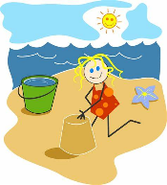  The Seaside-Children will learn about UK seaside destinations and recognise the human and physical features of the seaside. They will learn that daily weather patterns may be different in coastal areas.
RE |  | Music
To the ends of the Earth.  Pentecost: feast of the Holy Spirit  Sharing God’s good news  Share the Glory Be prayer  Value & Virtue – grateful & generous |  | Children will be thinking about and creating musical structures, listening to music by Michael Giacchino and learning songs about plants and growing.
PE |  | PHSE
Athletics & Striking and Fielding |  | Three in One (Father, Son and Holy Spirit)  Who Is My Neighbour?
Computing |  | Art
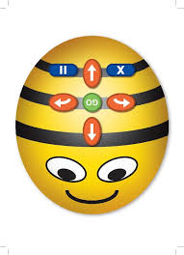  Programming /Moving a robot-Children will identify what each floor robot command does and use that knowledge to start predicting the outcome of programs. Learners are introduced to the early stages of program design through the introduction of algorithms |  | 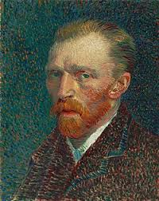  Van Gough -Children will become familiar with the work of Van Gogh. They will use pencil to make an observational drawing of sunflowers and learn how to use pastels to blend colours together to create a sunflower picture in Van Gough style.

