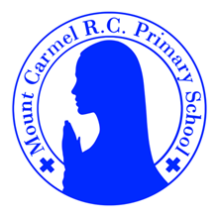
2GG Newsletter
Summer Term 1
Welcome back to 2GG!
Welcome back to school, everybody! We hope you have had a lovely Easter break!

Below you will find lots of important information about this half term, so please read it carefully and if you have any questions then please speak to Mrs Grayson or Miss Gee. You will also find lots more information about what we will be learning about this year on our class page on the school website. You will receive a new newsletter each half term with updated information.
PE Days | Homework |  | Important Dates
Our P.E. days are Monday and Thursday.  Children need the following P.E. kit in school.  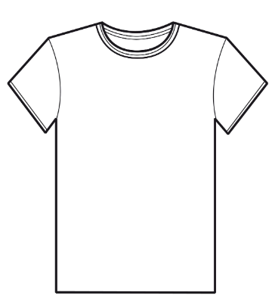  White T-Shirt  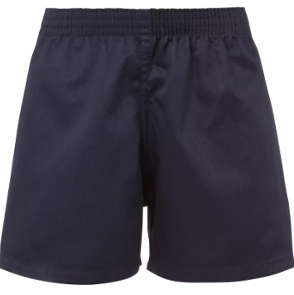  Navy blue or black shorts  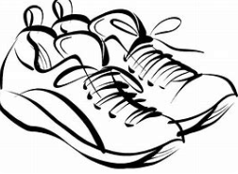  Trainers or pumps  Please make sure that earrings are removed for P.E. days. |   Spellings are given out on a Monday ready for a test on Friday. One column should be completed each night.  Maths homework is set on MyMaths on Tuesday and is due on the following Monday. If children cannot complete the homework online, they can use a paper copy. Please speak to Mrs Grayson or Miss Gee about this.  Reading books are changed every Monday. Children are expected to read at home for 10 minutes every day! Reading Diaries must be signed each day. Children may also be assigned a book on Collins Hub. This is the same book the children will access in their guided reading sessions in school.  TT Rockstars or Numbots should be used at least weekly to help the children with their learning of the times tables and number fluency. |  | 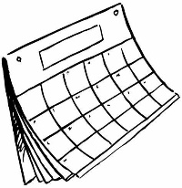  School re-opens Monday 13th April  May Bank Holiday  School Closed  Monday 4th May  Break up for the half term holidays: 3:20pm  Friday 22nd May
What we are learning this half term!
English |  | Maths
In spellings, we will be learning Why do some longer words have the spelling ‘ti’ for /sh/?  How to use possessive apostrophes for singular possession. When to swap, drop or double? (-ing, -er, -est, -y, -ed)  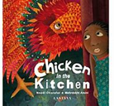  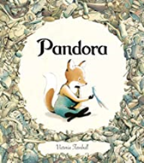  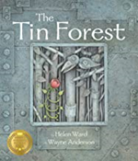  We will be reading:  We will use these texts to write diaries, letters of persuasion and alternative endings. |  | *Locate, order and compare 2-digit numbers on 0-100 landmarked lines and on the 1-100 square; use < and > signs; locate numbers on an empty 0-100 line; introduce numbers 101 to 200 and count in 100s to 1000; add 2-digit numbers by counting on in 10s and 1s; subtract 2-digit numbers by counting back in 10s and 1s  *Use doubles and number bonds to add three 1-digit numbers; use number facts to 10 and 20 in number stories; find complements to multiples of 10; understand subtraction as difference and find this by counting up; find small differences either side of a multiple of 10  *Add and subtract 1-digit numbers to and from 2-digit numbers; subtract 2-digit numbers by counting back in tens and ones; add two 2-digit numbers by counting in 10s, then adding 1s; add 2-digit numbers using 10p and 1p coins (partitioning, answers less than 100); add 2-digit numbers using place-value cards (partitioning, answers more than 100)  *Measure weight using standard or uniform non-standard units; draw a block graph where one square represents two units; weigh items using 100g weights using scales marked in multiples of 1kg or 100g; measure capacity using uniform non-standard units; measure capacity in litres and in multiples of 100ml  *Double multiples of 10 and 5 (answers less than 100); double 2-digit numbers ending in 1, 2, 3 or 4 (answers less than 100); find a quarter of numbers up to 40 by halving twice; begin to find 3/4 of numbers; find 1/2 1/4 and 1/3 of amounts (sharing); spot patterns and make predictions when finding a third of numbers
P.E.
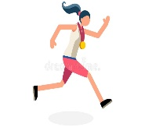
Athletics
Striking and Fielding
Science |  | RE
Plants (part 2)  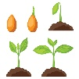  Children will learn about the requirements of plants for germination, growth and survival, as well as the processes of reproduction and growth in plants. Children will also learn that seeds and bulbs need water to grow but most do not need light; seeds and bulbs have a store of food inside them. |  | Branch 5:  To the ends of the earth – In this branch, children come to a simple understanding of what happened after the Resurrection. The events conclude the life of Jesus and begin the life of the earliest community which would become the church.
Geography |  | Computing
Geography: Nigeria in Africa    Children will revise their knowledge of continents and oceans. They will locate Nigeria on a world map and use an atlas to find the capital city and rivers in Nigeria. They will look at the capital city, Abuja, and compare it to our capital city in London. Children will learn about the weather in Nigeria and compare life in Nigeria to life in the UK. |  | Creating media/Digital photography    Children will learn to recognise that different devices can be used to capture photographs and will gain experience capturing, editing, and improving photos. Finally, they will use this knowledge to recognise that images they see may not be real.
 |  | Music

We will be thinking about and creating musical structures, listening to music by Kristen Anderson-Lopez and learning songs about fairy tales.

Art
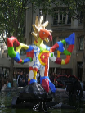
Sculpture – Fairy Tale Animals
Children will look at a piece of public sculpture BY Niki de Saint Phalle (Firebird) and learn how the inspiration for it was a Russian story. Children will create their own fairy tale animals out of clay.
 |  | PHSE
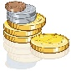
The cycle of life
Financial Capability- value of coins/ keeping money safe.

