
Year 4 Newsletter
Summer 1
Welcome to Year 4
What a busy term Spring was! We have been so busy covering so many interesting topics, produced wonderful pieces of work and lots of fun. This half term promises to be just as exciting and we cannot wait to get started on our new topics. Mrs Lyon and Mr Sloan would like to say a very big well done to everyone in year 4, especially for their hard work in our production of The Three Trees. You were all amazing!! But we still have lots of work to do…

PE Days | Homework |  | Important Dates
Our P.E. days are Wednesdays for Mr Sloan’s class and Thursdays for Mrs Lyon’s class, however on a Monday we will be going swimming. A letter has been sent home regarding the correct/appropriate attire for swimming.  For P.E, Children need the following kit in school.  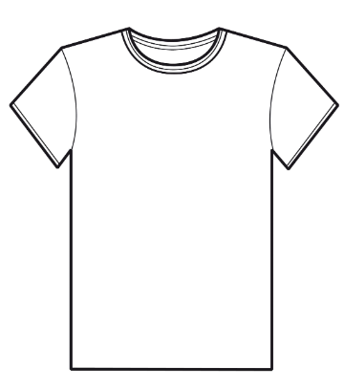  White T-Shirt  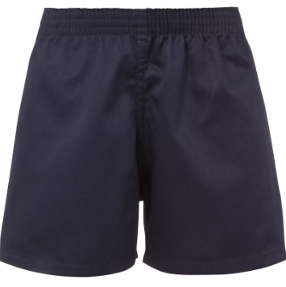  Navy blue or black shorts    Trainers or pumps  Please make sure that earrings are removed for P.E. days . |   Spellings are given out on a Monday ready for a test on Friday. Children are to complete one column at a time, in order to maximise their learning.  Maths homework is set on MyMaths on Friday and is due on the following Thursday. If children cannot complete the homework online, we would encourage you to ask for a paper copy.  Reading books are changed twice a week. Children are expected to read at home for 20 minutes. Reading Diaries must be signed each day.  TT Rockstars should be used at least weekly to help the children with their learning of the times tables. |  | 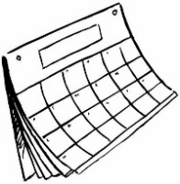  End of half term – Friday 22nd May  (New term starts Monday 8th June)
What we are learning this half term!
English |  | Maths
This half term, we are going to be writing poems and scripts, advertisements, speeches and diary entries. As always, we will be encouraging the children to use all of their grammatical knowledge too. |  | 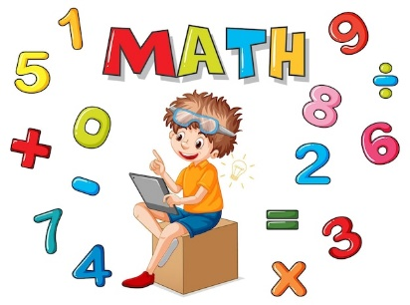  The children will be multiplying and dividing numbers by 10 and 100 including decimals. We will be learning our 11 and 12 times tables and recognising and reading roman numerals. We will also be identifying 3d shapes, and exploring numbers with 2 decimal places.
Science |  | RE
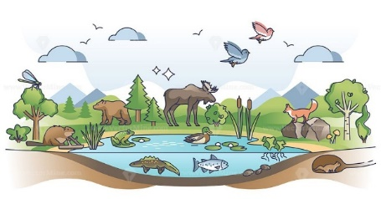  The children will be exploring animals, including humans, looking at the body parts associated with digestion. We will learn to identify different types of teeth and also construct a variety of food chains, identifying producers, predators and prey. |  | 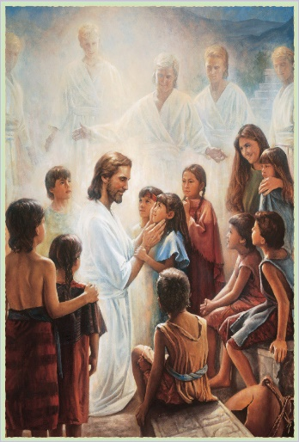  To the Ends of the Earth – We will be looking at the road to Emmaus, our belief in Trinity, what happened after the Ascension. We will also be looking more closely at the Eucharist and Mass.
History |  | Art
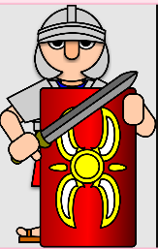  We will be looking at Ancient Rome and learning about its impact on Britain at the time. We will learn all about Boudica and the similarities and differences between Roman and Celtic tribes. To start this topic, we have planned an exciting Roman Day where we will explore Roman life and look at real objects from that time. |  | 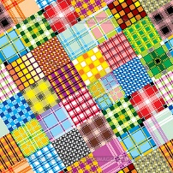  We will experiment with wax resist designs and create different patterns using tie-dye techniques.
Music |  | PHSE
  The children will be using structure and texture in compositions and listening to the composer, John Williams. |  | We will be looking at the community of Love and what the church is.  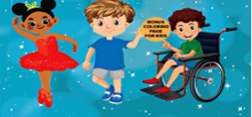
German

This half term, the children will be revising parts of the body, as well as ‘Feeling unwell’ and ‘Jungle animals’.

