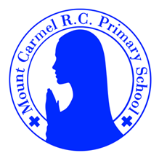
Y6 Newsletter
Summer Term 1
Welcome to Year 6!
Summer term is upon us, and the weather is really brightening up. The children have done a fantastic job preparing for their SATS so far this year, and one final push now brings us towards the end. Well done everybody and thank you for all your support. As ever, please speak to us if you need anything.

PE Days | Homework |  | Important Dates
Our P.E. days are either: Tuesday and Friday (Y6C) Monday and Friday (Y6S)  Children need the following P.E. kit in school.  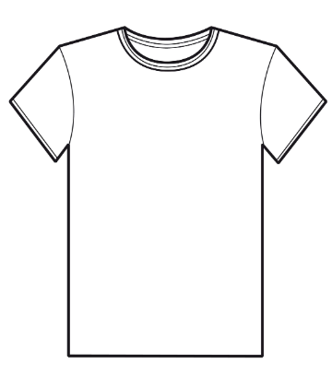  White T-Shirt  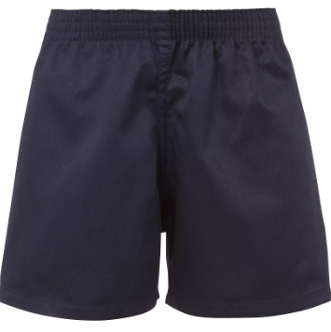  Navy blue or black shorts  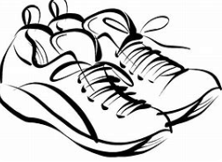  Trainers or pumps  Please make sure that earrings are removed and hair tied back for P.E. days . |   Spellings are given out on a Friday ready for a test on the following Friday. One column should be completed each night with the final column completed in class on Friday morning.  Maths homework is set on MyMaths on Friday and is due on the following Thursday. If children cannot complete the homework online, they can use a paper copy.  Reading books are changed by the children once they have finished their book. Children are expected to read at home for 20 minutes every day. Reading Diaries must be signed and brought to school each day.  Reading comprehension homework is given out on a Friday to be completed by the following Thursday.  TT Rockstars should be used at least three times a week to help the children with their learning of their times tables. |  | Throughout next term we are really focussing on preparing for SATS, which are the fourth week back after the holidays.  Please ensure your child is in school every day, on time and ready to learn.  Remember, Maths club is on Monday – Thursday from 8am too. Even if your child has not attended this year so far, please ensure they are in school from 8am.  SATS week:  Monday 11th May to  Thursday 14th May  Writing SATS assessments will continue until the beginning of July.
What we are learning this half term!
English |  | RE
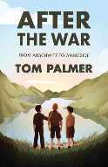  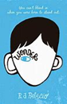  We will be reading the following texts:  Using these books, we will write a new chapter and rewrite a story from the perspective of a character using flashbacks. |  | Topic 7: Witnesses  The Holy spirit enables people to become witnesses  Topic 8: Healing  Sacrament of the Sick
Maths |  | Science – Light
*Revise:  - reading, writing, comparing and ordering numbers  - adding and subtracting whole numbers and decimal numbers  - finding percentages of numbers  - converting fractions, decimals and percentages  - how brackets can be used in calculation problems  - solving missing number problems using inverse operations  - missing lengths and angles  - multiplying 3-digit and 4-digit numbers including decimals  - a systematic approach to solve problems involving multiplication and division  - short division to find unit fractions of amounts  - using long division to divide 4-digit by 2-digit numbers, giving remainders as a fraction  - revise reading and marking coordinates in all four quadrants and drawing simple polygons |  | Build on previous learning exploring the way that light behaves, including light sources, reflection and shadows.  Recognise that light appears to travel in straight lines.  Apply the concept that light travels in straight lines to explain that objects are seen because they give out or reflect light into the eye.  Explain that we see things because light travels from light sources to our eyes or from light sources to objects and then to our eyes. Discuss what happens and make predictions. Apply the idea that light travels in straight lines to explain why shadows have the same shape as the objects that cast them.
Geography: Energy and Sustainability |  | D&T-Making a Leavers Cushion
Learn how energy is produced, what it means to be sustainable and practices that can be used to improve sustainability such as a circular economy. Through case studies of Curitiba (Brazil) and Freiburg (Germany), they will learn about the impact sustainable practice can have on an area and identify ways in which they can make more sustainable decisions and respond to Pope Francis’ message of Laudato Si. |  | Children will think about the user’s needs/wants and aesthetics when choosing textiles to make a memory/leavers cushion. They will use a range of joining techniques to make a patchwork leavers cushion and begin to use cross stitch to add detail. Children will think carefully about what would improve their product.
Music |  | German– Café Culture and Restaurants
- creating compositions with structure and texture, listening to Hans Zimmer and learning Feel the Light. |  | *Revise and practice food items and phrases from previous units.
PE |  | PSHE
Handball and Rounders |  | *Hope Beyond Death, Coping with Change and  Building Others Up.

