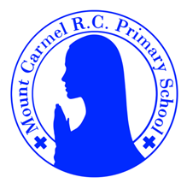
2C Newsletter
Spring Term 2
Welcome back to 2C!
Welcome back to school, everybody! We hope you have had a lovely half term break!

Below you will find lots of important information about this half term, so please read it carefully and if you have any questions then please speak to Mr Conwell. You will also find lots more information about what we will be learning about this year on our class page on the school website. You will receive a new newsletter each half term with updated information.
PE Days | Homework |  | Important Dates
Our P.E. days are Monday and Friday.  Children need the following P.E. kit in school.    White T-Shirt    Navy blue or black shorts  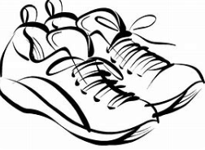  Trainers or pumps  Please make sure that earrings are removed for P.E. days. |   Spellings are given out on a Monday ready for a test on Friday. One column should be completed each night.  Maths homework is set on MyMaths on Tuesday and is due on the following Tuesday. If children cannot complete the homework online, they can use a paper copy. Please speak to Mr Conwel about this.  Reading books are changed every Monday. Children are expected to read at home for 10 minutes every day! Reading Diaries must be signed each day. Children will also be assigned a book on Collins Hub. This is the same book children access in their guided reading sessions in school.  TT Rockstars or Numbots should be used at least weekly to help the children with their learning of the times tables and number fluency. |  | 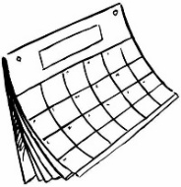  World Book Day:  Thursday 5th March  Children are welcome to dress up as a character from their favourite book.  Parents Evening:  Wednesday 25th March  You will be told closer to the time when slots are opened to make an appointment.  Year 2 Easter play performance:  Thursday 2nd April 2026 at 9:00am  All parents are welcome to attend.  Break up for the end of term holidays:  Thursday 2nd April 1:30pm pick up time.
What we are learning this half term!
English |  | Maths
In spellings, we will be learning the different rules to follow when we add suffixes to the end of root words.  We will be reading:  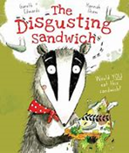  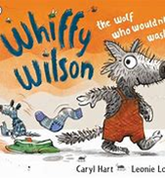  We will use these texts to write letters, instructions and explanations. |  | *Revise doubles and corresponding halves to 15; find half of odd and even numbers to 30; Revise and recognise 1/2s, 1/4s, 1/3s and 2/3s of shapes; place 1/2s on a number line; count in 1/2s and 1/4s; understand and write mixed numbers  *Count in 2s, 5s and 10s to solve multiplication problems and find specified multiples; introduce the × sign; record the 2, 5 and 10 times-tables; investigate multiplications with the same answer; write multiplications to go with arrays, rotate arrays to show they are commutative  *Tell the time to the nearest quarter of an hour using analogue and digital clocks; understand the relationship between seconds, minutes and hours and use a tally chart; interpret and complete a pictogram or block graph where one block or symbol represents one or two things  *Revise 2, 5 and 10 times-tables; revise arrays and hops on the number line; multiply by 2, 3, 4, 5 and 10; arrange objects into arrays and write the corresponding multiplications; make links between grouping and multiplication to begin to show division; write divisions as multiplications with holes in and use the ÷ sign  *Recognise all coins, know their value, and use them to make amounts; recognise £5, £10, £20 notes; make amounts using coins and £10 note; write amounts using £.p notation; order coins 1p – £2 and notes £5 – £20; add several coins writing totals in £.p notation (no zeros in 10p place); add two amounts of pence, using counting on in 10s and 1s; add two amounts of money, beginning to cross into £s
Science |  | RE
  Plants  Children will use the local environment to observe and describe how seeds and bulbs grow into mature plants. They will find out and describe how plants need water, light and a suitable temperature to grow and stay healthy. |  | 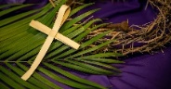  Branch 4:  Desert to Garden – In this branch,  children will revisit some scripture from the previous year to consolidate learning about the events of Holy Week and deepen their understanding about God’s forgiveness.
Computing |  | History
Course A: This first teaches learners how to use the basic skills of code writing including dragging and dropping. It then teaches learners to write basic instructional code using visual-based code to develop problem-solving skills, encourage persistence and promote creativity. |  | Florence Nightingale and Mary Seacole  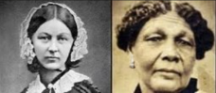  We will be learning about Mary Seacole and Florence Nightingale and their achievements. We will be making and using timelines and will compare their lives.
Music |  | PHSE
We will be creating different sounds, using fast and slow patterns, listening to music from Nigeria and learning Easter Songs. |  | The Cycle of Life  Beginnings and Endings  Change is All Around
D&T |  | PE
  Children will find out about where food comes from in the world, from plants or animals. They will know how to use techniques such as cutting, peeling and whisking. With adult support children will use the appropriate heat source. |  |   Ball Skills  Sending and Receiving

