
Y1 Newsletter
Spring 2
Welcome to Y1
Please find information below about what your child will be learning this half term. There are also some important dates for your diary.
Mrs Dale & Mrs Liversage - Year 1DL
Mrs Birnie - Year 1B
PE Days | Homework |  | Important Dates
Our P.E. days are Wednesday & Friday Y1B Wednesday & Thursday  Y1L.  Children need the following P.E. kit in school.  Please make sure that earrings are removed for P.E. days. | Spellings are given out on a Monday ready for a test on Friday. One column should be completed each night with the final column completed in class on Friday morning.  Maths homework is set on MyMaths on Friday and is due on the following Thursday. If children cannot complete the homework online, they can use a paper copy.  Reading books are changed every Tuesday. Children are expected to read at home for 10 minutes every day. Reading Diaries must be signed each day. |  | 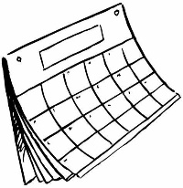  World Book Day  Thursday 5^{h} March  Children are welcome to dress up as a character from their favourite book or in their pyjamas.  Parent’s Evening  Wednesday 25th  March 3.30pm-6.00pm  Break up for the Easter holidays:  Thursday 2nd April at 1.30pm
What we are learning this half term!
English |  | Maths
The texts we will be reading this half term:  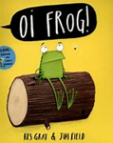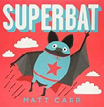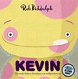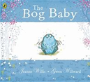  We will be writing poetry, instructions, descriptions, letters, diaries and comic strips. |  | Recognise odd and even numbers; count objects in 5s and 10s and begin to say 5 lots and 10 lots; find half, quarter and three quarters of shapes; begin to know that two halves and four quarters are a whole and that two quarters is a half  Find and begin to know doubles to double 10; revise pairs to 5, 6, 7, 8, 9 and 10 and derive related subtraction facts; use knowledge of pairs of 10 to make pairs to 20; use number facts to solve word problems  Relate units of time weeks, days, hours; divide the days up into parts; read and write times to the hour; begin to have a notion of how long an hour is and how long a minute is; tell the time (oʼclock and half past) on analogue and digital clocks; measure using uniform units (cubes and rulers)  Add a 1-digit number by counting on from a 2-digit number, not crossing 10s at first, then beginning to cross 10s; subtract a 1-digit number by counting back initially from numbers up to 30 (not crossing 10s) and then generally from a 2-digit number (not crossing 10s) and from multiples of 10
Science |  | History
Animals Including Humans Part 2.  They will be able to identify, name, draw and label the basic parts of the human body and know which part of the body is associated with each sense. |  | George Stephenson and the developments of the railway.  Children will learn about George Stephenson and the development of the railway . They will learn about his life and the impact he had locally, nationally and globally.
Religion |  | Computing
Lent time for change  The children will learn about Lent and the Easter story.   |  | Creating media/Digital painting  Children will explore the world of digital art and its exciting range of creative tools. Children will create their own paintings, while getting inspiration from a range of other artists.
Music |  | PHSE
We will be creating different sounds, using fast and slow patterns, listening to Calypso music from Trinidad and learning songs about Spring and Easter. |  | Can You Help Me? To understand what is and isn’t a medical emergency. To know to call 999 in an emergency. To know that if they require medical help but it is not an emergency basic first aid should be used.
Design & Technology |  | PE
Making a Sandwich  Children will learn that food can be  divided into different groups .Children will learn where sandwich fillings come from and will taste a variety of sandwich ingredients before designing and making their own sandwich. Children will use techniques such as spreading, cutting and grating.  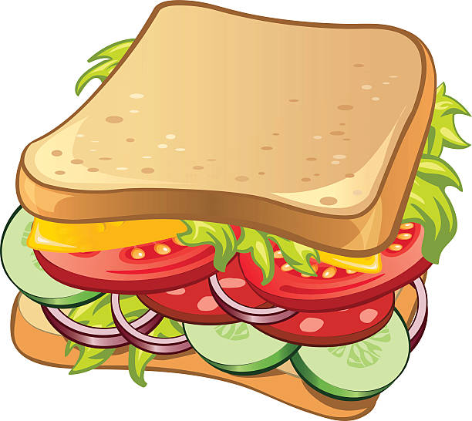 |  | Ball Skills &Sending and Receiving.  

