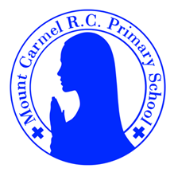
Y6 Newsletter
Spring Term 2
Welcome to Year 6!
Welcome back to hopefully lighter mornings and brighter evenings for our second spring half term. We just wanted as a year group team to express how amazing the children were last term at Robinwood, with all of them being a real credit to Mount Carmel. Well done! As ever, if you need to chat to us at any time about anything please grab us and we will be happy to help.
PE Days | Homework |  | Important Dates
Our P.E. days are either: Tuesday and Friday (Y6C) Monday and Friday (Y6S)  Children need the following P.E. kit in school.  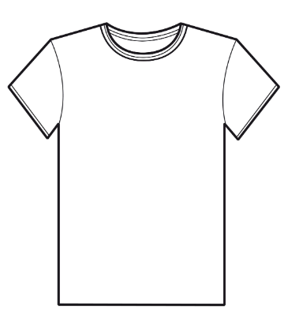  White T-Shirt  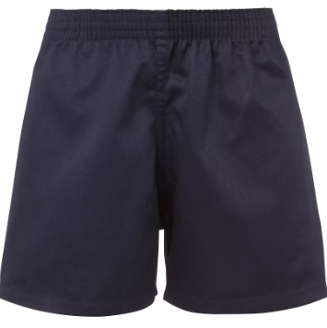  Navy blue or black shorts  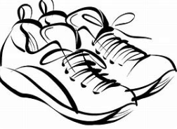  Trainers or pumps  Please make sure that earrings are removed and hair tied back for P.E. days . |   Spellings are given out on a Friday ready for a test on the following Friday. One column should be completed each night with the final column completed in class on Friday morning.  Maths homework is set on MyMaths on Friday and is due on the following Thursday. If children cannot complete the homework online, they can use a paper copy.  Reading books are changed by the children once they have finished their book. Children are expected to read at home for 20 minutes every day. Reading Diaries must be signed and brought to school each day.  Reading comprehension homework is given out on a Friday to be completed by the following Thursday.  TT Rockstars should be used at least three times a week to help the children with their learning of their times tables. |  | Thursday 5th March – World Book Day – children come to school dressed as book character or in pyjamas  Tuesday 24th March – Junior Parents Evening  Thursday 26th March – Rocksteady Concert – 2pm Junior Hall  Wednesday 1st April – Year 6 Stations of the Cross Assembly – 2:30pm  Thursday 2nd April – 1.30pm Break Up  Monday 13th April – School reopens after the Easter Holidays
What we are learning this half term!
English |  | RE
We will read the following texts:  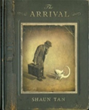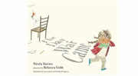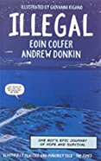  Using these texts we will write persuasive formal letters and a narrative with a flashback. |  | Topic 6: Death and new life  Celebrating Jesus’ death and resurrection  Judaism: Belonging and values  Yom Kipper
Maths |  | Science – Electricity
*Solve addition and subtraction multi-step problems; use reasoning to solve problems.  *Calculate and understand the mean; construct and interpret line graphs; interpret pie charts.  *Read and plot coordinates in all four quadrants, draw and translate simple polygons; find missing coordinates for a vertex on a polygon; draw and reflect simple polygons in both the x-axis and y-axis using coordinates; find unknown angles around a point, on a line, in a triangle or vertically opposite and in polygons where diagonals intersect.  *Multiply 4-digit numbers; revise short division; give remainders as a fraction; use long division  *Generalise a relationship between pairs of numbers; express simple formulae in words; generalise a term in a sequence using n to stand for the number of the term in a sequence; use ratio to solve problems. |  | Construct simple series circuits and answer questions about what happens using different components, e.g. switches, bulbs, buzzers and motors. Associate the brightness of a lamp or the volume of a buzzer with the number and voltage of cells used in the circuit. Compare and give reasons for variations in how components function, including the brightness of bulbs, the loudness of buzzers and the on/off position of switches. Represent a simple circuit in a diagram using recognised symbols.
Geography: Natural Resources |  | Art - Gustav Klimt
Understand what natural resources are; learn about those in the UK (fossil fuels for energy, crops for food; and livestock for food as well as clothes) and the distribution across the world. Study Russia, including its location, physical features and resources. |  | Learn about the history of Gustav Klimt’s artwork and explore elements of his Golden Period. Use photographic portraits to create different images inspired by Adele Bloch Bauer. Create a “Tree of Life” inspired by talents and interests.
Music |  | German - This is me, hobbies and fun
Explore timbre and tempo; listen to music by Sona Jobarteh; learn songs for Stations of the Cross. |  | * Revise sports * Introduce hobbies  * Lieblings Sachen
Computing |  | PSHE
Use spreadsheets to organise data |  | * Making Babies and Menstruation

