
3D Newsletter
Spring Term 2

Welcome Back!

We hope that you all enjoyed a lovely break – it went far too quickly didn’t it! We are looking forward to a new term with lots more exciting things to learn but most importantly, preparing ourselves to commemorate Jesus’ resurrection through prayer, penance and fasting.
We are waiting excitedly for news about Miss Foster’s baby!
Our school Gospel Value this half term eloquent and truthful.
Mrs Dennis and Miss Leonard.
PE Days | Homework |  | Important Dates
Our P.E. days are Wednesday and Thursday.  Children need the following P.E. kit in school.    White T-Shirt  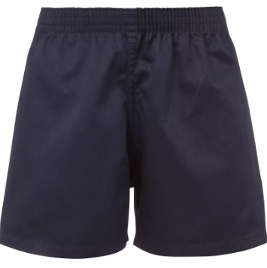  Navy blue or black shorts  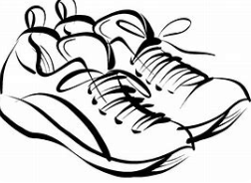  Trainers or pumps  Please make sure that earrings are removed for P.E. days. |   Spellings are given out on a Monday ready for a test on Friday. One column should be completed each night with the final column completed in class on Friday morning.  Maths homework is set on MyMaths on Friday and is due on the following Thursday. If children cannot complete the homework online, they can use a paper copy.  Reading books are changed each week on a daily rota. Children are expected to read at home for 20 minutes every day. Reading Diaries must be signed each day.  TT Rockstars and Numbots should be used at least weekly to help the children with their learning of the times tables. The logins are in the front of the Reading Diary. |  | 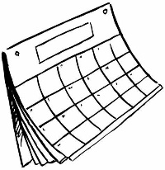  2/3/26  Global Food Stories with Michael Rosen and friends Zoom  5/3/26  World Book Day – Children can come to school dressed as a character from a book  19/3/26  Class Photographs  24/3/26  Parents evening  2/4/26  Break up for Easter 1:30pm
What we are learning this half term!
English |  | Maths
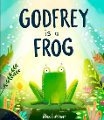    We will be reading the book Godfrey is a Frog – a book that follows Godfrey’s journey to find out who he truly is – to create a persuasive letter and a non-chronological report. We will then study the poem ‘Don’t’ by Michael Rosen and use this to create our own poem. |  | We will begin to add 3-digit numbers using the formal written method, add 2-digit numbers mentally, and add 2-digit and 3-digit numbers mentally using place value and rounding. We will also be learning to tell the time to the nearest minute on analogue and digital clocks and calculate time intervals.
Science |  | RE
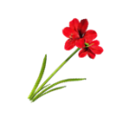  Children will explore the idea that every part of the plant has a job to do. Children will identify and describe the functions of different parts of flowering plants. They will also be performing a scientific enquiry into the requirements of plants for life and growth. |  | 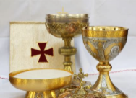  Our R.E. topic this half term is called “Desert to Garden”. We will continue to think about the miracles of Jesus focusing on The Feeding of the 5000 and then we will make links between this miracle and The Last Supper  and Communion.
History |  | D&T
We will be building on the knowledge we learnt in the Stone Age unit by learning about the changes that occurred during the Bronze and Iron Age, including what an iron age fort was like and what life was like. We will know how historians found out about life millions of years ago and compare the different ages. |  | 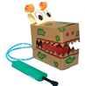  The children will be making their own moving monsters! They will learn and explore what pneumatic systems are before designing, making and evaluating their own pneumatic system, making a monster with moving parts. They will then evaluate their finished product.
Music |  | PHSE
  The children will be using instruments to create different sounds, thinking about tempo, listening to music written  by Kerry Andrew and learning the  song How Far I’ll Go from Moana. |  | We will be learning about our body, and how to keep our body safe. We will also be learning about different substances that aim to help our bodies, like medicine, or harm our bodies.
Computing |  | German
In our coding unit, we will be using word-based code to develop problem solving skills, with persistence and creativity. The children will be sequencing and using loops to repeat sequences. |  |   In German, we will be learning about different traditions and carnival celebrations. We will also be revising numbers and using that to answer mathematical questions.
Snacks
In the Juniors, the children are not provided with a piece of fruit at breaktime. If you would like your child to have a snack, please send in a piece of fruit and they will be able to take it out with them. Thanks.

