

Nursery Newsletter
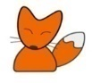
Spring Term 1
Welcome Back!
We hope that you all enjoyed a lovely break over Christmas and we wish you all a very Happy New Year. We are looking forward to a new term with lots more exciting things to learn.

Our learning focus for this half term is ‘Once Upon a Time’
Your child needs to have… | Lending Library |  | Important Dates
*a water bottle containing only water (no juice) each day  *spare clothing including lots of underwear and socks (left on their coat peg.) Where possible, please provide a pack of baby wipes that can be left in your child’s spare clothes bag.  *a waterproof coat with a hood every day  *a pair of wellies in school every day  *no jewellery other than a single stud earring to be worn  Please ensure all items are clearly labelled with your child’s name. | Each week your child chooses a book to take home from our class lending library.  Books are to be returned the following week, so that a new book can be sent home.  Please ensure a suitable book bag is provided. This must be waterproof and large enough not to damage the book being taken home. |  | 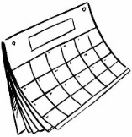  Wednesday 14th January ~ Big Bedtime Read (5pm)  Friday 6th February – school closed for teacher training.  Friday 13th February ~ NSPCC Number Day  Friday 13th February – school closes for half term
What we are learning this half term!
Literacy |  | Maths
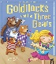  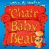  This term our key texts are:  Goldilocks and The Three Bears retold by Mara Alperin  A Chair for Baby Bear by Kaye Umansky  This term we will continue to:  *develop the skills to ask questions about key texts, and make comments and shares our own ideas.  *engage in extended conversations about stories, learning new vocabulary.  *gain an understanding that print has meaning and can have different purposes ~ we will look at print in the environment, logos and packaging.  *use some of our print and letter knowledge in early writing. For example: writing a pretend shopping list that starts at the top of the page.  *(begin to) write letters from our name.  In phonics we will:  *continue to learn to recite nursery rhymes and songs, using actions to help support our recall.  *consolidate our knowledge of the phonemes: s,a,t,p,i, n and m, and learn the phonemes: d g o c and k. We will play games to build up our recognition of initial sounds of words.  *continue to develop oral blending skills.  *build up an awareness of rhyme through sharing rhyming stories and playing rhyming games.  *begin to clap out the syllables in our names. |  | We will be learning to:  *develop fast recognition of up to 3 objects, without having to count them individually(‘subitising’).  *recite numbers past 5.  *say one number for each item in order: 1,2,3,4,5.  *compare quantities using language: ‘more than’, ‘fewer than.’  *link numerals and amounts: for example, showing the right number of objects to match the numeral, up to 5.  *understand position through words alone – for example, “The bag is under the table,” – with no pointing.  *begin to describe a sequence of events, real or fictional using words such as ‘first’, then…’  *select shapes appropriately for building with wooden blocks.
Communication and Language |  | R.E.
We will continue to:  *listen to simple stories and understand what is happening, with the help of the pictures.  *develop our understanding and questions about ‘who’, ‘what’ and ‘where’ and begin to understand ‘why’  *develop a wider vocabulary through our key texts and hands on experiences  *develop our response to simple instructions and then build on this to understand an instruction with two parts. |  | We will continue to learn our nursery prayers and songs to praise God.  We will continue to learn how to make the sign of the cross.  R.E. Topic: Community Celebrating
Understanding the World |  | Expressive Arts and Design
We will:  *continue to develop positive attitudes about the differences between people.  *talk about the differences between materials and changes that we notice ~ looking at how porridge oats change when they are cooked  *continue to discuss seasonal change through our daily weather watcher and observations in the outdoor learning environment  *talk about what we see, using a wide vocabulary ~ on our walk to Asda, we will talk about the print we see in the environment.  *learn about different celebrations ~ the Epiphany and Chinese New Year. We will look at how people celebrate these events. |  | We will:  *make simple models which express their ideas ~ we will make a new chair for Baby Bear.  *join different materials and explore different textures ~ we will decorate the best birthday present ever for Bear’s birthday.  *create closed shapes with continuous lines and begin to use these shapes to represent objects ~ we will create oil pastel pictures of Goldilocks.  *use our imaginations, taking part in simple pretend play, using objects to represent something else even though they are not similar.
Physical Development |  | PSE
We will continue to:  *develop ball skills ~ catching and throwing a large ball.  *develop balancing skills ~ on one leg, hop and hold a pose for a game like musical statues.  *develop our large muscle movements during Wiggle me into Squiggle sessions  *begin to use scissors to make snips in paper  *use a comfortable grip with good control when holding pens and pencils and use dough disco sessions to strengthen our hand and finger muscles.  *use small motor skills to do things independently, for example manage buttons and zips.  *build independently with a range of appropriate large and small construction resources. |  | We will be learning to:  *play with one or more other children, extending and elaborating play ideas.  *increasingly follow rules, understanding why they are important. We will take ownership of our tidy time jobs. We will continue to be: Ready, Respectful and Safe.  *develop appropriate ways of being assertive.  We will continue to use the ‘Zones of Regulation’ to communicating our feelings.
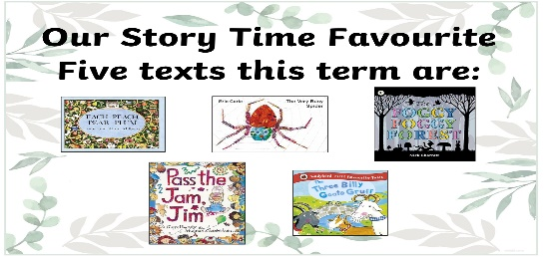 |  | Rhyme/songs we are learning
*When Goldilocks went to the House of the Bears
*On, In, Under
*Incy Wincy Spider
*5 Little Monkeys

At home, please help me…
- to practise putting on my coat and shoes by myself.
- to learn to write my first name. Start with my initial letter and when I know this add a letter at a time.
- by sharing LOTS of stories with me and encourage me to talk about what I can see in the pictures
- by singing the nursery rhymes and counting songs I am learning in nursery
- play eye spy numbers 1-5 when we are out and about,

