

Nursery Newsletter
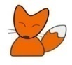
Spring Term 2
Welcome Back!
Our learning focus for this half term is ‘How does your Garden Grow’
Your child needs to have… | Lending Library |  | Important Dates
*a water bottle containing only water (no juice) each day  *spare clothing including lots of underwear and socks (left on their coat peg.) Where possible, please provide a pack of baby wipes that can be left in your child’s spare clothes bag.  *a waterproof coat with a hood every day  *a pair of wellies in school every day  *no jewellery other than a single stud earring to be worn  Please ensure all items are clearly labelled with your child’s name. | Each week your child chooses a book to take home from our class lending library.  Books are to be returned the following week, so that a new book can be sent home.  Please ensure a suitable book bag is provided. This must be waterproof and large enough not to damage the book being taken home. |  |   Thursday 5th March – World book day (dress in Pyjamas or as a book character)  Thursday 19th March – School Class Photo  Wednesday 25th March – Nursery Parents Evening  Thursday 2nd April ~ school closes 1.30pm for Easter Holidays
What we are learning this half term!
Literacy |  | Maths
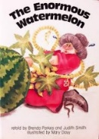  This term our key texts are The Enormous Watermelon by Brenda Parkes and The Very Hungry Caterpillar by Eric Carle. The children are going to enjoy.  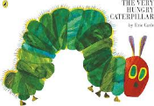  We are going to continue to practise writing our name and begin to think about how to form our letters correctly. We will begin to understand that some books give us information when reading non-fiction books such as ‘Life as a butterfly’.  In phonics we will continue to enjoy learning new rhymes and will use actions to support recall. We will consolidate our knowledge of the phonemes (letter sounds) we have learnt so far. We will be learning the new phonemes e, u, b, f and r.  We will enjoy lots of rhyming and alliteration games. |  | We will continue to develop fast recognition of up to three objects without having to count them. (subitising). We will recite numbers past five. We will compare quantities using language ‘more than’ and ‘less than’. We will link numerals to amounts, for example showing the right number of objects to match the numeral.  We will explore 2d shapes and begin to use mathematical language to describe them. We will compare objects based on their size, length, weight and capacity. We will begin to describe a sequence of events using words such as ‘first and ‘then.
Communication and Language |  | R.E.
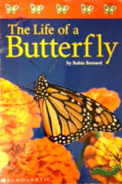  This term the children will develop a wider vocabulary through our non-fiction texts and hands on experiences when learning about growing and looking after sunflower seeds and observing caterpillars. We will continue to develop our understanding of ‘who’, ‘what’ and ‘where’ questions. The children will use talk when describing stories using story maps to support. |  | 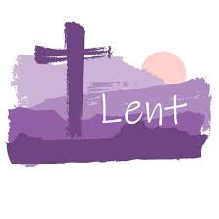  We will be learning about Lent and Easter. We will learn how Lent is a time when we care for others and a time for saying sorry. We will learn about key events of Holy Week and Easter.
Understanding the World |  | Expressive Arts and Design
  This term we have got lots of exciting activities to help children develop their understanding about the world around them. The children will be learning about how to plant sunflower seeds and how we care for plants. We will observe them grow and change. We look forward to seeing them grow into sunflowers when the children take them home. Don’t forget to share pictures on seesaw. The children will learn about the life cycle of a butterfly and we will be observing our own caterpillars. |  | 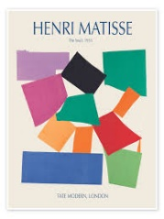  We will be learning to make models using construction kits. We will be exploring paint using fine brushes to paint nursery rhyme characters. We will continue to explore colour and colour mixing when creating our own Easter card patterns. We will be learning about Henri Matisse’s painting with scissors and collage artwork and create our own butterfly versions.
Physical Development |  | PSE
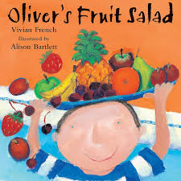  We will continue to develop our gross motor skills when hopping, running and jumping. We will develop our skills when throwing and catching and work together with our peers when playing games. Using our large construction area outside we will work together with our friends to make models. When learning about the story Oliver’s fruit salad we will practise using a knife to cut up fruits to make our own fruit salad. Yummy!! |  |       This term we will be introducing our learning dinosaurs. Our learning dinosaurs help us to understand the different ways we learn- active learning, playing and exploring, creating and thinking critically. We will play with our friends and begin sharing our ideas with each other. We will continue to follow our nursery rules and understand why they are important. We will continue to be: Ready, Respectful and Safe. We will continue to use the ‘Zones of Regulation’ to communicating our feelings.
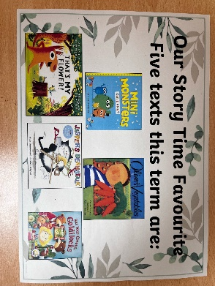 |  | Rhyme/songs we are learning
- Old Mother Hubbard
- Jack and Jill
- Wee Willy Winky
- Little Miss Muffet
- There’s a tiny caterpillar on a leaf
At home, please help me…
- to practise putting on my coat and shoes by myself.
- to learn to write my first name. Start with my initial letter and when I know this add a letter at a time.
- by sharing LOTS of stories with me and encourage me to talk about what I can see in the pictures.
- by singing the nursery rhymes and counting songs I am learning in Nursery.
- play eye spy numbers 1-5 when we are out and about.

