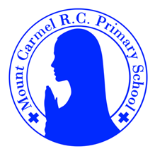
Y1 Newsletter
Autumn Term 2
Welcome to Y1
Please find information below about what your child will be learning this half term. There are also some important dates for your diary.
Year 1DL
Year 1B
PE Days | Homework |  | Important Dates
Our P.E. days are Tuesday & Wednesday Y1DL. Tuesday & Friday Y1B.  Children need the following P.E. kit in school.  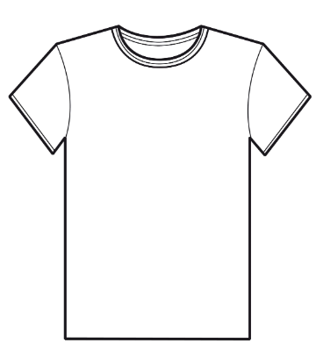  White T-Shirt    Navy blue or black shorts    Trainers or pumps  Please make sure that earrings are removed for P.E. days. |   Spellings are given out on a Monday ready for a test on Friday. One column should be completed each night with the final column completed in class on Friday morning.  Maths homework is set on MyMaths on Friday and is due on the following Thursday. If children cannot complete the homework online, they can use a paper copy.  Reading books are changed every Tuesday. Children are expected to read at home for 10 minutes every day. Reading Diaries must be signed each day. |  | 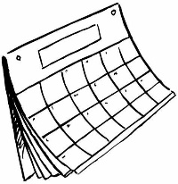  Wednesday 6th November- Infant Parents’ Evening.  Monday 2nd December- Y1 Advent Assembly at 9am for y1 parents.  Wednesday 18th December- Children’s Christmas Dinner  Thursday 19th December- Children’s Christmas Party
What we are learning this half term!
English |  | Maths
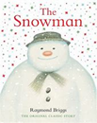  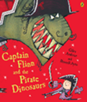  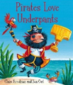  Using these texts, we will be writing simple sentences with capital letters and full stops. The children will write character descriptions, instructions and letters. |  | We will be learning to…  - Make teen numbers (10 and some 1s).  - Compare and order numbers to 20, then 30.  - Understand and use ordinal numbers.  - Number bonds to 5, 6, 7 and 10 and use addition facts to solve subtractions.  - Use number facts for 5, 6 and 10 to solve word problems.  - Describe position and direction; compare lengths and heights; estimate, compare and measure.  - Add 1, 2 and 3 by counting on.  - Subtract 1, 2, 3 or more by counting back.  - Begin to add three small numbers by spotting bonds to 10 or doubles (1-6).  - Recognise coins and know values (up to £2) and begin to make amounts in pence.
Science |  | RE
Seasonal Change- Children will observe and describe changes in the weather and across the four seasons. They will learn that it is unsafe to look directly at the sun, even when wearing dark glasses. |  | 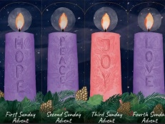  The children will learn that Advent is a time of waiting and preparing for Christmas.
History |  | D&T
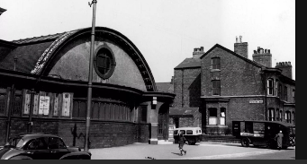  The children will be learning how the local high street has changed since the 1950s. |  | The children will design and make a birdhouse.  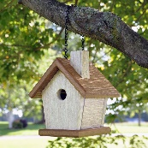
Music |  | PHSE
We will be creating high and low patterns, listening to music by Wolfgang Amadeus Mozart and learning Advent Songs. |  | We will be learning about special people in our lives and how we should treat others.

