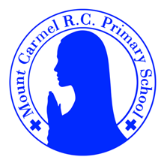
Y1 Newsletter
SpringTerm 1
Welcome to Y1
Please find information below about what your child will be learning this half term.

PE Days | Homework |  | Important Dates
Our P.E. days are Wednesday & Thursday Y1L.  Wednesday & Friday Y1B.  Children need the following P.E. kit in school.  Please make sure that earrings are removed for P.E. days. | Spellings are given out on a Monday ready for a test on Friday. One column should be completed each night with the final column completed in class on Friday morning.  Maths homework is set on MyMaths on Tuesday and is due on the following Tuesday. If children cannot complete the homework online, they can use a paper copy.  Reading books are changed every Tuesday. Children are expected to read at home for 10 minutes every day. Reading Diaries must be signed each day. |  | 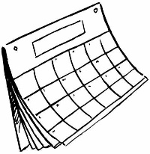  Friday 6th February – school closed for teacher training.  Friday 13th February – school closes for half term
What we are learning this half term!
English |  | Maths
We will be reading the following texts:  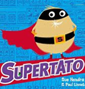  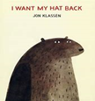  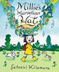  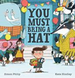  Using these texts we will be writing invitations, information texts, speech bubbles, character descriptions and retelling stories. |  | *Say the number one more or less and two more or less using a number line or a 100 grid; locate 2-digit numbers on a 100 grid and a 1-100 bead string; read, write and say 2-digit numbers and understand them as some tens and some ones  *Revise pairs to 5, 6, 7, 10 and doubles to double 6; derive subtraction facts; understand a symbol being used for an unknown; use number facts to solve simple addition and subtraction word problems; find pairs of numbers with a total of 8  *Add by putting the larger number first and counting on (numbers up to 100), spotting unit patterns; count on from 2-digit numbers; add a 1-digit number to a 2-digit number  *Name, recognise and know the properties of 3D shapes: cube, cuboid, cone, cylinder and sphere; begin to sort 3D shapes according to properties; order and name the days of the week and months of the year; recognise and name the season  *Count on and back in tens from any number; begin to count in 5s and 2s recognising multiples of 5 end in 5 and 0; children begin to count in 2s; estimate a number of objects within a range and count by grouping into 10s or 5s
Science |  | Geography
Science- Everyday Materials  Children will explore, name, discuss, raise, and answer questions about everyday materials so that they become familiar with the names of materials and properties. Children will learn to distinguish between an object and the material from which it is made. They will identify and name a variety of everyday materials, including wood, plastic, glass, metal, water and rock. They will be able to describe the simple physical properties of a variety of everyday materials. They will learn to compare and group together a variety of everyday materials based on their simple, physical properties. In addition, children will further explore and experiment with other materials, including: brick, paper, fabrics, elastic and foil. |  | The Four Seasons and Weather in the UK  Children will learn about the four seasons and identify what the typical weather is like in the seasons. Children will describe daily weather patterns .
RE |  | D&T
Special People People in the parish family  Meals  Mass; Jesus’ special meal  Value & Virtue: Grateful & Generous |  | Making a Hat  - Children will design and make a hat out of recyclable materials.
Music |  | PHSE
We will be starting to notate music and thinking about loud and quiet sounds, listening to Elvis Presley and learning songs about the weather and seasons. |  | Being Safe  Physical Contact  Harmful Substances
Art |  | PE
Colours and Painting  Children will learn about primary and secondary colours and warm and  cool colours. Children will learn how to mix primary colours. Children  will look at Henrie Matisse; Harmony in red to explore colour and  create their own work in the style of Matisse’s work using colour. |  | Gymnastics  Yoga

