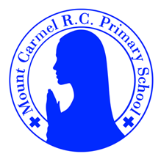
2C Newsletter
Spring Term 1
Welcome back to 2C!
Welcome back to school, everybody! Happy New Year! We hope you have had a lovely Christmas break!

Below you will find lots of important information about this half term, so please read it carefully and if you have any questions then please speak to Mr Conwell. You will also find lots more information about what we will be learning about this year on our class page on the school website. You will receive a new newsletter each half term with updated information.
PE Days | Homework |  | Important Dates
Our P.E. days are Monday and Friday.  Children need the following P.E. kit in school.  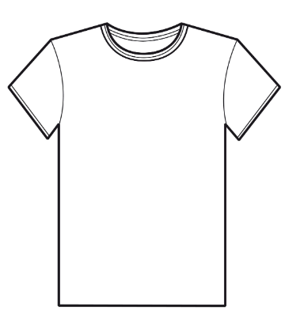  White T-Shirt  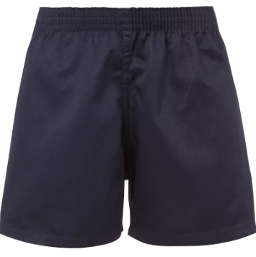  Navy blue or black shorts  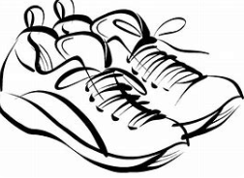  Trainers or pumps  Please make sure that earrings are removed for P.E. days. |   Spellings are given out on a Monday ready for a test on Friday. One column should be completed each night.  Maths homework is set on MyMaths on Tuesday and is due on the following Tuesday. If children cannot complete the homework online, they can use a paper copy. Please speak to Mr Conwell about this.  Reading books are changed every Monday. Children are expected to read at home for 10 minutes every day! Reading Diaries must be signed each day. Children will also be assigned a book on Collins Hub. This is the same book children access in their guided reading sessions in school.  TT Rockstars or Numbots should be used at least weekly to help the children with their learning of the times tables and number fluency. |  | 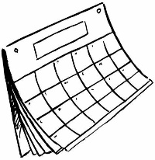  Big Bedtime Read:  Wednesday 14th January - 5pm  School Closed for INSET day:  Friday 6th February  Break up for the half term holidays:  Friday 13th February  School will re-open on Monday 23rd February
What we are learning this half term!
English |  | Maths
In spellings, we will be learning the different rules to follow when we add suffixes to the end of root words.  We will be reading:  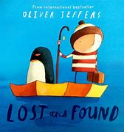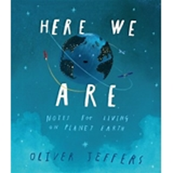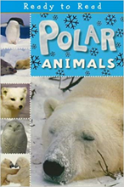  We will use these texts to write postcards, non-chronological reports, postcards, letters, persuasive letters and our own stories. |  | *Place value and ordering 2-digit numbers; place value additions and subtractions; add and begin to subtract 9, 10 and 11  *Revise number bonds to 10; begin to bridge 10; subtract from 10 and 20; use number facts to find the complement to ten; find a difference between two numbers by counting on  *Rehearse complements to multiples of 10; find differences using a number line; find change from 10p and 20p, and from £10 to £20 by counting up and using bonds to 10 and 20; add two 2-digit numbers by counting on  *Recognise and identify properties (including faces and vertices) of 3D shapes; sort according to properties including number of faces; name the 2D shapes of faces of 3D shapes; tell the time to the nearest quarter on analogue and digital clocks  *Order 2-digit numbers and revise the < and > signs; locate 2-digit numbers on a landmarked line and grid; round 2-digit numbers to nearest 10; estimate a quantity <100 within a range.
Science |  | RE
Animals including humans  Children will learn about the basic needs of animals for survival; they will find out about and describe the basic needs of animals, including humans, for survival (water, food and air). They will also learn to describe the importance of exercise and nutrition for humans, as well as eating the right amounts of different types of food and hygiene. Children will also be introduced to the processes of reproduction and growth in animals. They will learn that animals, including humans, have offspring, which grow into adults. |  | Branch 3:  Galilee to Jerusalem – In this unit the children will learn about Jesus’ life, looking at parables and the miracles Jesus performed.  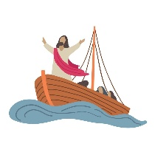
Geography |  | Art
Hot and Cold Places  Children will learn about hot and cold places in relation to the equator. They will be introduced to biomes and climate zones. Children will learn about the weather associated with these areas and they will begin to describe places. |  | 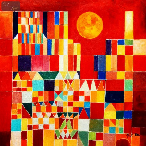  Collage  Children will study the painting ‘Castle and Sun’ by the artist Paul Klee. Children will learn how Klee used simple shapes to make his painting. Children will make their own artwork inspired by a place/ building and then simplify their idea into basic shapes and colours using the collage technique. Children will use printing techniques to make their own painting in Klee’s style.
Music |  | PHSE
We will be starting to notate music and thinking about loud and quiet sounds, listening to music by Duke Ellington Orchestra and learning songs about animals. |  | Feelings: Likes and Dislikes  Feelings: Inside Out  Super Suzie Gets Angry
Computing |  | PE
N/A this half term. |  | 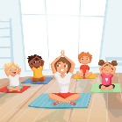  Yoga  Target games.

