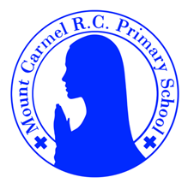
Year 4 Newsletter
Spring 1
Welcome to Year 4
What a fantastic Autumn term we had! We covered so many interesting and exciting topics, produced wonderful pieces of work and (most importantly) had lots of fun. This term promises to be just as exciting and we can not wait to welcome you back and get started on our new topics. Coming back to school after a long break is never easy, but the children have shown a wonderful attitude and an ability to use the skills they have learnt in previous year groups. Happy New Year!
PE Days | Homework |  | Important Dates
Our P.E. day is Thursday, however on a Monday we will be going swimming. A letter has been sent home regarding the correct/appropriate attire for swimming.  For P.E, Children need the following kit in school.  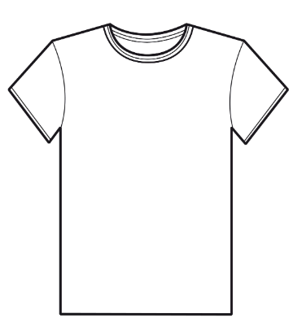  White T-Shirt  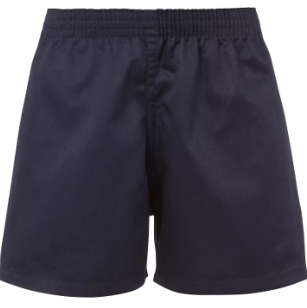  Navy blue or black shorts  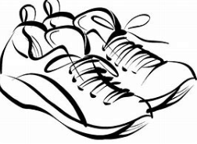  Trainers or pumps  Please make sure that earrings are removed for P.E. days . |   Spellings are given out on a Monday ready for a test on Friday. Children are to complete one column at a time, in order to maximise their learning.  Maths homework is set on MyMaths on Friday and is due on the following Thursday. If children cannot complete the homework online, we would encourage you to ask for a paper copy.  Reading books are changed twice a week. Children are expected to read at home for 20 minutes. Reading Diaries must be signed each day.  TT Rockstars should be used at least weekly to help the children with their learning of the times tables. |  | 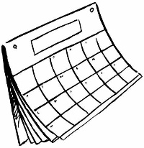  Big Bedtime Read – Wednesday 14th January 2026  INSET day – Friday 6th February 2026  NSPCC Number Day – Friday 13th February 2026  Finish for Half Term break – Friday 13th February 2026
What we are learning this half term!
English |  | Maths
This half term, we are going to be writing non-chronological reports, information texts, postcards and leaflets, centred around our history topic of Ancient Greece. Exciting! |  | 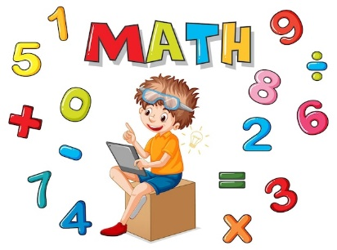  The children will be placing a four-digit number onto a number line, as well as using expanded written subtraction and compact written subtraction with pairs of three-digit numbers. We will also be solving simple money problems and sorting 2D shapes.
Science |  | RE
The children will be exploring states of matter, comparing groups of objects, as well as observing changes of state. In addition to this, the children will identify the parts played by evaporation and condensation within the water cycle.  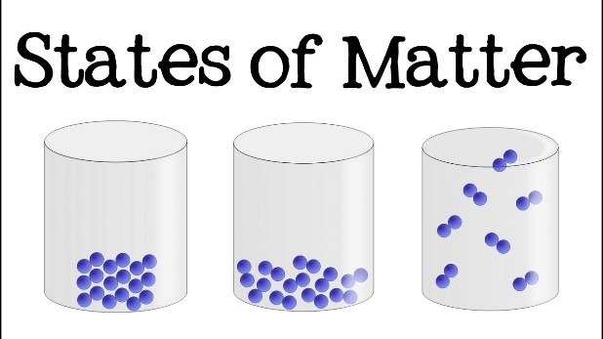 |  | 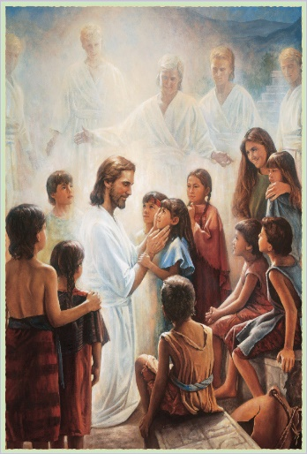  We will be looking at the life of the local community, as well as the importance of the ministry in the parish. The children will also gain a greater understanding of giving and receiving Holy Communion.
History |  | DT
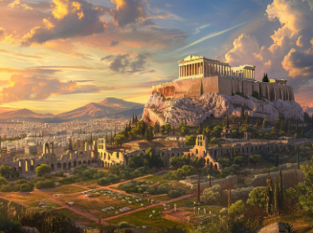  The children will build on their existing knowledge and look at the way in which the Ancient Greeks were governed, looking specifically at the idea of democracy and the introduction of the Olympic Games. |  | 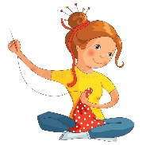  The children will investigate a range of purses and wallets, as well as their features. They will then design and make their own and evaluate their final product. Fun!
Music |  | PHSE
  The children will learn to play the steel pans in the hall. Mrs O will come into school and teach both classes how to play each element of the music. |  | We will be looking at the importance of not being the same and respecting our changing bodies.  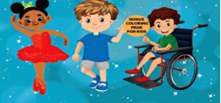
Computing |  | German
We are going to apply our knowledge and understanding of networks to navigate the internet securely and safely. The children will evaluate online content in order to further understand the consequences of false information.   |  |   This half term, the children will be learning to describe their family members or themselves.

