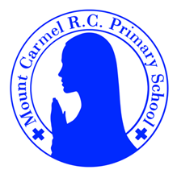
Y6 Newsletter
Spring 1 Term 1
Welcome to Year 6!
Hello everyone!
I hope everybody feels very rested after a wonderful Christmas break spent with their loved ones. It’s a very exciting term next term, including our Robin Wood residential. Please find all the important information about key dates and what we will be learning below and, as always, if you would like to ask a question about anything please come and see us straight away. Thanks for all of your support!
PE Days | Homework |  | Important Dates
Our P.E. days are Tuesday and Friday (Y6C) and Monday and Friday (Y6S).  Children need the following P.E. kit in school.    White T-Shirt    Navy blue or black shorts  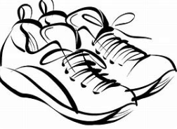  Trainers or pumps  Please make sure that earrings are removed and hair tied back for P.E. days . |   Spellings are given out on a Friday ready for a test on the following Friday. One column should be completed each night with the final column completed in class on Friday morning.  Maths homework is set on MyMaths on Friday and is due on the following Thursday. If children cannot complete the homework online, they can use a paper copy.  Reading books are changed by the children once they have finished their book. Children are expected to read at home for 20 minutes every day. Reading Diaries must be signed and brought to school each day.  Reading comprehension homework is given out on a Friday to be completed by the following Thursday.  TT Rockstars should be used at least three times a week to help the children with their learning of their times tables. |  | 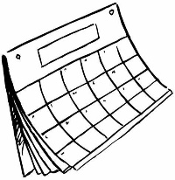  Maths Club starts at 8am and runs Mon-Thurs each week. All children in Year 6 are strongly encouraged to attend. We look forward to seeing you all.  Thursday 8th January - SATS meeting (3pm and 5pm)  Wednesday 14th January – Big Bedtime Read (5pm after school)  Monday 2nd Feb – Wednesday 4th Feb (two night overnight stay) - Robin Wood residential  Inset day – full school closure – Friday 6th Feb  Friday 13th February – NSPCC Number Day
What we are learning this half term!
English |  | RE
We will read the following texts:  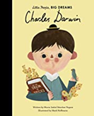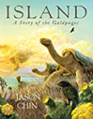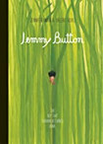  Using these texts, we will write narratives including dialogue, biographies and formal persuasive letters. |  | Topic 4: Sources  The Bible, the special book for the Church  Topic 5: Unity  Eucharist enables people to live in communion
Mathematics |  | Science – Evolution and Inheritance
*Read and write numbers up to 7-digits.  *Multiply and divide by 10, 100 and 1000.  *Multiply numbers with decimal places by whole numbers.  *Name, classify and identify properties of quadrilaterals; understand what an angle is and that it is measured in degrees; know the angles of 2d shapes and use these facts to calculate missing angles; recognise and identify the properties of circles and name their parts.  *Solve addition and subtraction of 7-digit numbers using written column addition.  *Identity common factors and common multiples. *Solve long division to divide 3- and 4-digit numbers by 2-digit numbers, giving remainders as a fraction, simplifying where possible. |  | Investigate how living things have changed over time and that fossils provide evidence about living things that inhabited the Earth millions of years ago. Learn how characteristics are passed from parents to their offspring. Examine how variation in offspring over time can make animals more or less able to survive in particular environments. Identify how animals and plants are adapted to suit their environment and that adaptation may lead to evolution. Research the work of paleontologists including Mary Anning and Charles Darwin.
History – The Peterloo Massacre |  | Art - Gustav Klimt
*Identify when the Peterloo Massacre took place and review what led to the massacre including the impact of the Corn Laws and representation in Parliament.  *Iinvestigate the attitudes and expectations of different groups of people at St. Peter’s Field and detail the sequence of events that led to the massacre.  *Evaluate who was responsible for the Peterloo Massacre. |  | *Learn about the history of Gustav Klimt’s artwork and explore elements of his Golden Period.  *Use photographic portraits to create different images inspired by Adele Bloch Bauer.  *Create their own, “Tree of Life” inspired by their talents and interests.
Music |  | German - Playing and enjoying sport
Use dynamics and notation, listen to music by Gabriela Lena Frank, learn Saturday Afternoon |  | * New year greetings * Introduce sports * Revise opinions
Computing |  | PSHE
Introduced to spreadsheets and begin to organise data into columns and rows. |  | *Body Image *Funny Feelings  *Emotional Changes *Seeing stuff online

