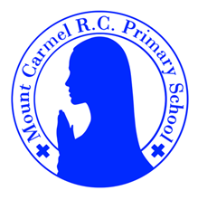
3R Newsletter
Spring Term 1

Welcome Back!

We hope that you all enjoyed a lovely break over Christmas and we wish you all a very Happy New Year. Thank you so much for all the lovely Christmas gifts we received and your kindness. We are looking forward to a new term with lots
more exciting things to learn.
Our school Gospel Value this half term is Curious and Active.
‘Cast all your anxieties on him because he cares for you.’ 1 Peter 5 v7
Miss Ratcliffe and Mrs Du Plessis.
PE Days | Homework |  | Important Dates
Our P.E. days are Wednesday and Thursday.  Children need the following P.E. kit in school.  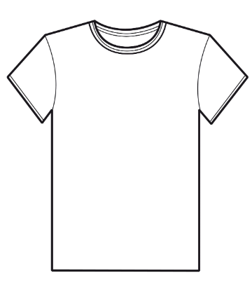  White T-Shirt  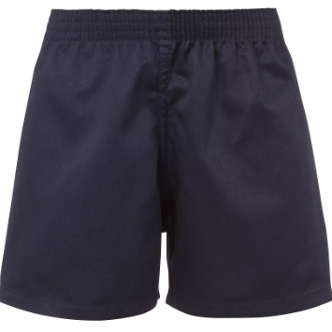  Navy blue or black shorts  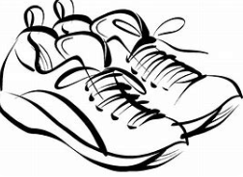  Trainers or pumps  Please make sure that earrings are removed for P.E. days. |   Spellings are given out on a Monday ready for a test on Friday. One column should be completed each night with the final column completed in class on Friday morning.  Maths homework is set on MyMaths on Friday and is due on the following Thursday. If children cannot complete the homework online, they can use a paper copy.  Reading books are changed each week on a daily rota. Children are expected to read at home for 20 minutes every day. Reading Diaries must be signed each day.  TT Rockstars and Numbots should be used for at least 15 minutes each week to help the children with their learning of the times tables. The logins are in the front of the Reading Diary. |  | 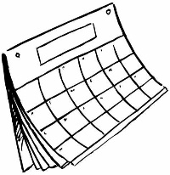  6/1/26  Epiphany Mass at church  7/1/26  Library Visit to meet author Emma Reynolds  14/1/26  Big Bedtime Read Event – starting time 5pm.  6/2/26  School closed for Staff Training
What we are learning this half term!
English |  | Maths
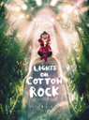  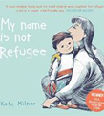  We will be reading the book My Name is not Refugee– following a small boy and his mother on their journey to a new country. We will learn to write a diary entry and will also write a story. We will then read Lights on Cotton Rock,  where we will explore  writing speech. |  | We will be identifying unit fractions, understanding how many make a whole, recognising equivalent fractions, placing them on a number line and finding fractions of amounts. We will recognise right angles and know they are 90°, using ° as the symbol for the measurement of degrees.
Science |  | RE
Children will explore how things move on different surfaces. They will observe how magnets attract or repel each other and attract some materials and not others. They will know that magnets have two poles and predict whether two magnets will attract or repel each other. |  |   In R.E. we will begin our next unit “Galilee to Jerusalem”. We will start by finding out about the visit of the Wise Men and will then then  explore some of the teaching  of Jesus in the parables and  Lord’s Prayer.
Geography |  | Art
Children will learn about earthquakes and the structure of the Earth. They will learn what causes earthquakes. Through an introduction into latitude and longitude children will locate the world’s largest earthquakes. They will learn about the San Francisco earthquake. |  | 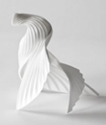  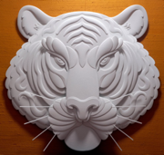  Children will learn about paper sculptures created by Richard Sweeney and Jeff Nishinaka. Children will learn how to make paper sculptures and use  papier mâché to  make monster faces.
Music |  | PHSE
    The children will be taking part in our Opera Project. We will learn what an opera is and then learn a song  from the opera. We will think  about how to perform the song. |  | In PHSE we will be looking at the people around us, including out family and friends. We will also be thinking about when things feel bad, and the need to say sorry.
Computing |  | German
In our coding unit, we will be using word-based code to develop problem solving skills, with persistence and creativity. The children will be sequencing and using loops to repeat sequences. |  |     The children will be learning the German words for different animals, discussing  the animals they like and  dislike.
Snacks
In the Juniors, the children are not provided with a piece of fruit at breaktime. If you would like your child to have a snack, please send in a piece of fruit and they will be able to take it out with them. Thanks.

