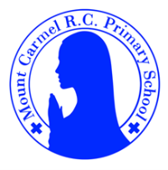
2C Newsletter
Autumn Term 2
Welcome to 2C!
Welcome back to school, everybody! We hope you have had a lovely half term break!

Below you will find lots of important information about this half term, so please read it carefully and if you have any questions then please speak to Mr Conwell. You will also find lots more information about what we will be learning about this year on our class page on the school website. You will receive a new newsletter each half term with updated information.
PE Days | Homework |  | Important Dates
Our P.E. days are Monday and Friday.  Children need the following P.E. kit in school.  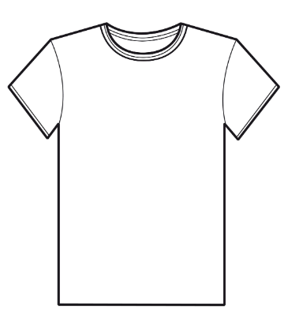  White T-Shirt  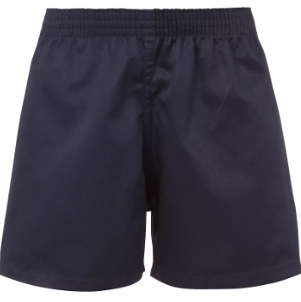  Navy blue or black shorts  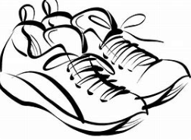  Trainers or pumps  Please make sure that earrings are removed for P.E. days . |   Spellings are given out on a Monday ready for a test on Friday. One column should be completed each night.  Maths homework is set on MyMaths on Tuesday and is due on the following Tuesday. If children cannot complete the homework online, you can request a paper copy.  Reading books are changed every Monday. Children are expected to read at home for 10 minutes every day! Reading Diaries must be signed each day.  TT Rockstars or Numbots should be used at least weekly to help the children with their learning of the times tables and number fluency. |  | 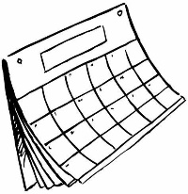  Parents Evening:  Wednesday 12th November  Please remember to book your appointment online.  Christmas Party Day:  Wednesday 17th December 2025 – Children can come to school in their own party clothes  Year 2 Nativity: Friday 19th December – 9:00am  All parents are welcome to attend.  Break up for the Christmas holiday: Friday 19th December – School finishes at 1:30pm
What we are learning this half term!
English |  | Maths
We will be reviewing their phase 5 sounds and they will start to spelling learn rules to help with writing  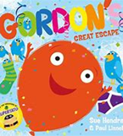  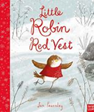  We will be reading:  We will use these texts to write letters, recounts, instructions, diaries and information texts. |  | - Know and use ordinal numbers  - Understand that 2-digit numbers are made from some 10s and some 1s  -Understand place value using 10p and 1p coins  -Add and subtract 10, 20 and 30 to any 2-digit number  -Understand and use terms and vocabulary associated with position, direction and movement  -Begin to measure length in centimetres and meters  -Solving addition and subtraction problems.  -Count in 2s, 5s and 10s from zero.
Science |  | RE
Uses of everyday materials  We will identify and discuss the uses of different everyday materials so that they become familiar with how some materials are used for more than one thing. We will identify and compare the suitability of a variety of materials and we will also find out about John McAdam. |  | Branch 2:  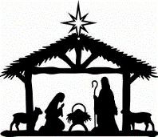  Prophecy and Promise – In this unit the children will think about the Holy Spirit. They will sequence and retell the story of the birth of Jesus
History |  | D&T
History- Remembrance    We will learn who we remember on Remembrance Day and why. We will learn about what happens on Remembrance Day and we will learn about the significance of the poppy. |  | D&T- Puppets  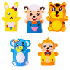  We will investigate a range of puppets and their features. Children will design their own puppet using a design criteria. They will develop and practice their sewing skills (running stitch/ or over stitch) before following their design to make a puppet.
Music |  | PHSE
We will be creating high and low patterns, listening to music by Vaughan Williams and learning Nativity songs in preparation for our Nativity play. |  | I am Unique  Girls and Boys  Clean and Healthy (My Body)
Computing |  | PE
N/A |  |   Dance and fitness

