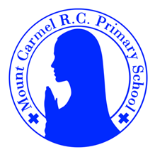
Y6 Newsletter
Autumn Term 2
Welcome to Year 6!
Welcome back everyone to a very busy but wonderfully exciting term. In November we will remember and pray for the Holy Souls. During the season of Advent, we will prepare to welcome Jesus on Christmas Day through prayer and reflection. We will celebrate his birth with plenty of special activities.
PE Days | Homework |  | Important Dates
Our P.E. days are Tuesday and Friday (Y6C) and Monday and Friday (Y6S).  Children need the following P.E. kit in school.  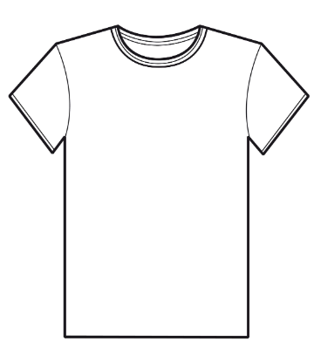  White T-Shirt  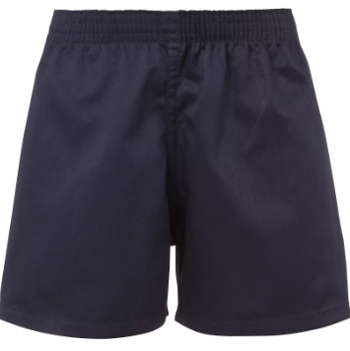  Navy blue or black shorts  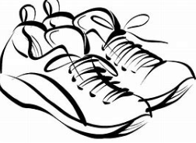  Trainers or pumps  Please make sure that earrings are removed and hair tied back for P.E. days . |   Spellings are given out on a Friday ready for a test on the following Friday. One column should be completed each night with the final column completed in class on Friday morning.  Maths homework is set on MyMaths on Friday and is due on the following Thursday. If children cannot complete the homework online, they can use a paper copy.  Reading books are changed by the children once they have finished their book. Children are expected to read at home for 20 minutes every day. Reading Diaries must be signed and brought to school each day.  Reading comprehension homework is given out on a Friday to be completed by the following Thursday.  Times Tables Rockstars should be used at least three times a week to help the children with their learning of their times tables. |  | Tuesday 11th November – Parents’ Evening  Tuesday 11th November – Remembrance Assembly  10th – 14th November – Anti Bullying Week  10th November – Odd Socks Day  Friday 14th November – School Photographs  15th – 23rd November – Maths Week England (TTRS Maths Rocks Competition)  Wednesday 26th November – visit to Quarry Bank Mill  Monday 15th December – KS2 Christmas Music Performance  Wednesday 17th December – Christmas Party Day
What we are learning this half term!
English |  | Maths
We will be reading the following texts:    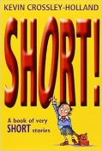  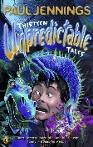  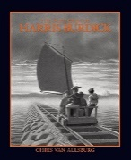  Using these texts children will write an atmospheric short story, a non-chronological report and later in the term they will write a narrative based on the Polar Express. |  | - Understand, add and subtract negative numbers  - Compare fractions and understand what improper fractions and mixed numbers are  - Find non-unit fractions of amounts  - Find simple percentages of amounts, including money.  - Add and subtract fractions including mixed numbers  - Multiply and divide fractions by whole numbers  - Convert improper fractions to whole numbers  - Solve word problems involving fractions.  - Calculate perimeter, area and volume of different shapes including triangles and parallelograms  - Name and describe properties of 3D shapes  - Find and compare nets for different 3D shapes.  - Use short and long division, including those which leave a remainder  - Express a remainder as a fraction
RE |  | Science
Branch 2:  Prophecy and promise  Advent – preparing for the birth of Jesus Christ |  | Animals Including Humans  Children will learn to identify and name the main parts of the human circulatory system. They will recognise the impact of diet, exercise, drugs and lifestyle on the way their bodies function, including how to keep their bodies healthy and how their bodies might be damaged.
History |  | Art
Children will learn about the Industrial Revolution and its impact on Manchester. They will investigate the development of new types of machinery and transport used to improve levels of productivity. |  | Children will research the work of William Morris to understand the arts and craft movement and his approach to the decorative arts. Children will sketch and create own patterns by printing.
Music |  | German
We will be creating pitched melodies, listening to music by Scott Joplin and learning the song Love Shone Down |  | *Revise houses and room in a house  *Christmas traditions
Computing |  | PSHE
Children will learn about the World Wide Web as a communication tool, including different methods of communicating online, and how search engines work. |  | *Gifts and Talents  *Girls Bodies  *Boys Bodies  *Spots and Sleep

