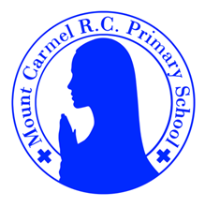
3D Newsletter
Autumn Term 2

Welcome Back!
What a great start to the year! We hope you enjoyed your October holidays and had chance to rest and relax. We have lots of exciting things to learn and explore this half term and we’re looking forward to the build up to Christmas. Our school Gospel Value this half term is “learned and wise”.
Mrs Dennis, Miss Foster and Mrs Lee
PE Days | Homework |  | Important Dates
Our P.E. days are Wednesday and Thursday.  Children need the following P.E. kit in school.    White T-Shirt  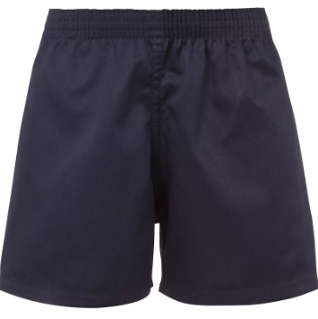  Navy blue or black shorts  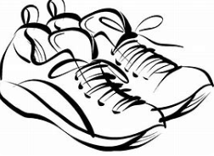  Trainers or pumps  Please make sure that earrings are removed for P.E. days . |   Spellings are given out on a Monday ready for a test on Friday. One column should be completed each night with the final column completed in class on Friday morning.  Maths homework is set on MyMaths on Friday and is due on the following Thursday. If children cannot complete the homework online, they can use a paper copy.  Reading books are changed each week on a daily rota. Children are expected to read at home for 20 minutes every day. Reading Diaries must be signed each day.  TT Rockstars and Numbots should be used to help the children with their learning of the times tables. The children have a weekly challenge to spend 20 minutes on Garage each week. This should be spaced out across the week. The logins are in the front of the Reading Diary. |  | 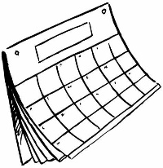  Parents Evening is Tuesday 11th November.  Our music afternoon is on Monday 15th December.  Christmas Party day is Wednesday 17th December.  Schools closes for Christmas at 1.30pm on Friday 19th December.
What we are learning this half term!
English |  | Maths
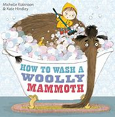  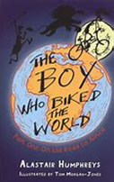  We will be reading the book The Boy Who Biked the World – finding out about Tom’s adventures as he cycles through Africa. We will learn to write a diary entry and also how to write  instructions to wash a  woolly mammoth. |  | We will be doubling and halving numbers up to 100 and will be using partitioning to add and subtract 2 digit numbers. We will be working with money and also measuring length and capacity. We will continue to learn multiplication and division facts.
Science |  | RE
Children will explore different kinds of rocks and soils. They will compare and group together different kinds of rocks. They will describe in simple terms how fossils are formed and will recognise that soils are made from rocks and organic matter. |  | 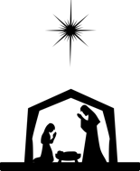  In R.E. we will explore the Celebration of Mass and the different parts of the service. We will also explore Advent as we are getting ready for Christmas.
History |  | D.T.
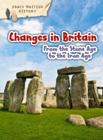  Children will learn about the important aspects of the Stone Age. They will find out how hunter gathers lived, why settlements were formed, why  stone circles were important and  the daily life for people living at  Skara Brae. |  | 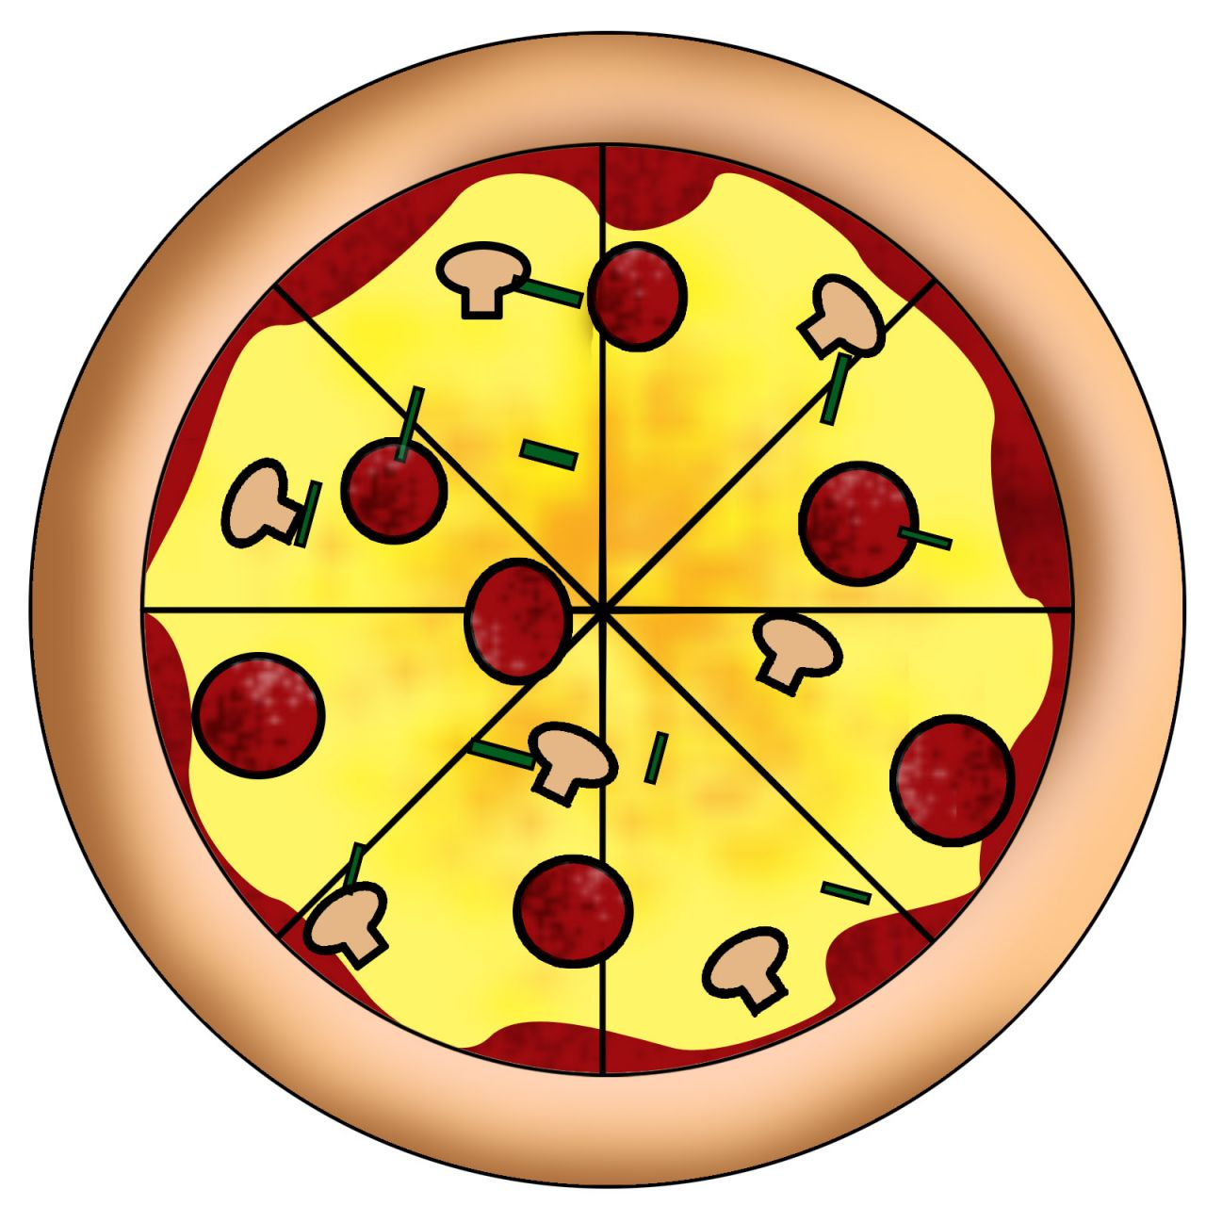  We will be finding out all about pizzas. We will learn about the ingredients and where they come from and think about seasonality. We will plan, create and eat our own pizza. Later in the year,  we will also have a trip to Pizza  Express in Manchester.
Music |  | PHSE
  We will continue to learn  to play the recorder in  whole class ensemble  sessions. A teacher from  One Education is coming in to help us. |  | We will explore the relationships we have we family and friends and find out how we deal when situations and events feel bad.
Computing |  | German
We will continue to learn about digital devices, focussing on inputs, processes and outputs. We will compare digital and non digital devices and learn about computer networks, including our school network. |  |   Children will learn some  classroom commands and  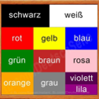  colours. They will learn how to say the Days of the week and  they will listen to the story of St Nikolaus.
Snacks
In the Juniors, the children are not provided with a piece of fruit at breaktime. If you would like your child to have a snack, please send in a piece of fruit and they will be able to take it out with them. Thanks.

