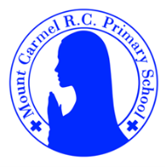

Nursery Newsletter
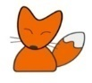
Autumn Term 1
Welcome to Nursery!
Hello and welcome to Nursery! Your teachers are Mrs Flanagan, Mrs Sloan, Miss Marsh and Miss Wrobleska. We are very excited to welcome you and your children to the Mount Carmel family. We have a fantastic EYFS team who are keen to nurture and develop each child as they progress on their learning journey.
Your child will need… | Lending Library |  | Important Dates
*a water bottle containing only water (no juice) each day  *spare clothing including underwear and socks (left on their coat peg.) Where possible, please provide a pack of baby wipes that can be left in your child’s spare clothes bag.  *a waterproof coat with a hood  *a pair of wellies  Please ensure all items are clearly labelled with your child’s name. | Each week your child will get to choose a book to take home from our class lending library.  In due course, your child will be allocated a day on which they will choose a book for pleasure. Books are to be returned the following week, so that a new book can be sent home.  Please ensure a suitable book bag is provided. This must be waterproof and large enough not to damage the book being taken home. |  | 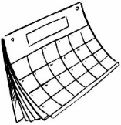  Meet the teacher ~ Wednesday 17th September 3:45pm  Rock star Number day ~ dress as a number or a Rock star  Friday 19th September  Class Saint Day ~ St Francis of Assisi Feast Day ~ dress as an animal  Friday 3rd October  World Mental Health Day ~ wear Yellow  Friday 10th October
What we are learning this half term!
Literacy |  | Maths
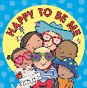  This term our key text is Happy to be Me by Emma Dodd.  This term we will be learning how to hold a book correctly and begin to focus and respond to the pictures or the words in a simple text. We will use a variety of mark making tools to create simple representations of our face.  We will recite nursery rhymes, using actions to help support our recall. We will begin to tune into sounds all around us. |  | We will be learning to  *take part in finger rhymes with numbers.  *compare amounts, saying ‘lots’, ‘more’ or ‘same’  *react to changes of amount in a group of up to three items.  *respond to correctly to directional language (up, down, side to side)  *notice patterns and arrange things in patterns
Communication and Language |  | RE
We will be learning to listen to other peoples talk with interest during snack and chat times and when sharing our news from home.  We will begin to respond positively to visual prompts for good sitting, listening and speaking.  We will begin to use the pictures in simple stories to help us understand what is happening.  We will explore new vocabulary ~ this term we will learn and use the names of main body parts.  We will begin to respond to simple routines. |  | We will begin to learn our nursery prayers and songs to praise God. We will learn how to make the sign of the cross.  R.E. topic: we will be learning all about ‘myself’ and about God knowing and loving each of us.
Understanding the World |  | Expressive Arts and Designs
We will look at baby photographs and think about what I looked like then and what I look like now.  We will talk about and explore differences between each other.  We will also use our senses in hands on exploration of natural materials and use simple words to describe what things feel, look and smell like. |  | We will begin to explore paint, using our fingers and other parts of our bodies as well as brushes and other tools.  We will start to make marks intentionally ~ we will draw a picture of our self using felt tip pens, and use paint to create a self-portrait.  We will begin to join in with simple songs and action rhymes.
Physical Development |  | PSE
We will begin to learn how to:  *kick, throw and catch a large ball.  *use a fork and spoon when eating at lunchtime  *put on and take off outdoor clothing  *use the toilet with help, and then independently. |  | We will be learning to:  *play with one or more children in the setting  *be increasingly independent in meeting our own care needs, e.g. using the toilet, washing and drying their hands thoroughly  We will introduce the children to the ‘Zones of Regulation’ and how to communicate our own feelings.  We will introduce the children to our behaviour motto: Ready, Respectful, Safe.
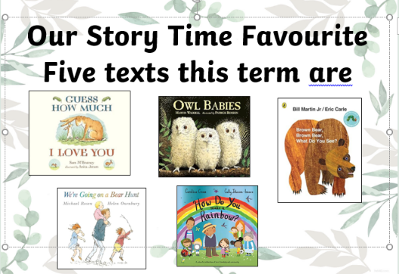 |  | Rhyme/songs we are learning
*Heads, Shoulders, Knees and Toes
*If You’re Happy and You Know It
*1 finger, 1 thumb Keep Moving
*We all need Bones
*1,2,3,4,5 once I Caught a Fish Alive
*Two Little Dickie Birds
At home, please can I…
- Practise putting on and taking off my coat and shoes by myself.
- Working on our pincer grip – using my thumb and forefinger let me pick up small objects.
- share stories with you and talk about what I can see in the pictures
- practice singing nursery rhymes and counting songs

