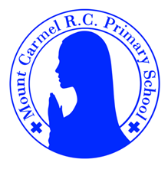
Newsletter
Autumn Term 1
Welcome to Y1
Welcome to Year 1, please find information below about what your child will be learning this half term. There are also some important dates for your diary.
PE Days | Homework |  | Important Dates
Our P.E. days are Tuesday & Wednesday for Y1L. Wednesday & Friday for Y1B. Please send your child’s PE kit into school in a small bag with their name on. This will be sent home at the end of each half term to be washed!  Children need the following P.E. kit in school.  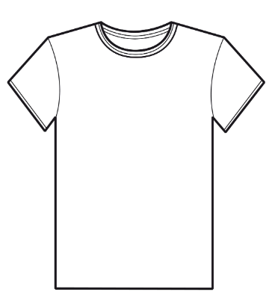  White T-Shirt  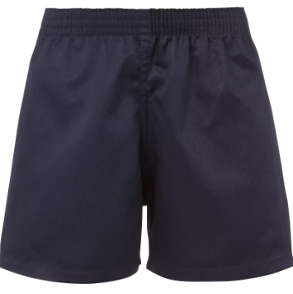  Navy blue or black shorts  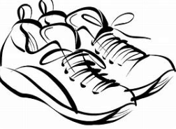  Trainers or pumps  Please make sure that earrings are removed for P.E. days. |   Spellings are given out on a Monday ready for a test on Friday. One column should be completed each night with the final column completed in class on Friday morning.  Maths homework is set on MyMaths on Friday and is due on the following Thursday.  Reading books are changed every Tuesday, children are expected to read at home for 10 minutes every day. Reading Diaries must be signed each day. |  | 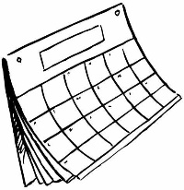  Meet the teacher: Wednesday 17th September.  World mental health day – All children are invited to wear yellow on Friday 10th October.
What we are learning this half term!
English |  | Maths
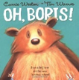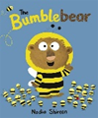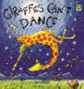  These are the texts we will be reading to help the children write simple sentences capital letters, full stops, write recounts and simple poems. |  | We will be learning to Count up to 20 objects (match number to object).  Find pairs that make 5,6 and 10; match pairs to 5, 6 and 10 to number sentences; find missing numbers in number sentences. Double numbers 1 to 5; find 1 and 2 more; count back 1 and begin to find 1 less. Recognise, name and describe squares, rectangles, circles and triangles. Recognise basic line symmetry; sort 2D shapes according to their properties, using Venn diagrams and Carroll diagrams
Science |  | RE
Using the local environment, we will explore and answer questions about animals in their habitat. |  | The children are learning about God’s love and care for every family and an invitation to baptism.
Geography |  | Art
The children will be learning about the local area and the four countries in the UK.  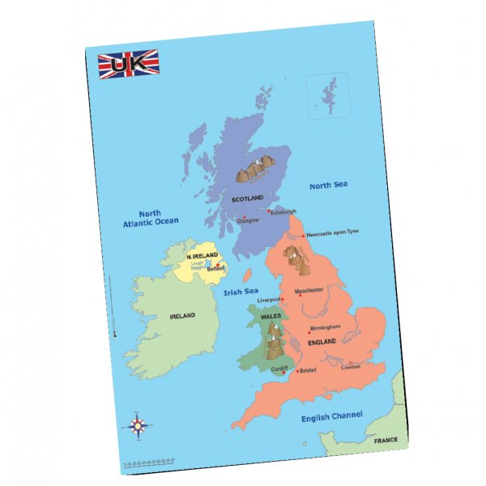 |  | The children will learn about sculpture as an art form and become familiar with the work of Andy Goldsworthy. They will make temporary sculptures using natural forms. They will learn how to sketch natural objects and leaves found in their local environment.
Music |  | PHSE
They will be finding the pulse and creating rhythm patterns, listening to music by Mussorgsky and learning Harvest Songs. |  | Environmental education- road safety.  