
Year 6 Newsletter
Autumn Term 1
Welcome to Year 6!
Welcome to our first newsletter of the year. We will use this newsletter each term to inform you of important dates and what we will be covering in our curriculum for the upcoming term. If you have any questions, concerns or comments, please do not hesitate to speak to an adult either before or after school. We want to work with you to support the children through this exciting year.
PE Days | Homework |  | Important Dates
Y6C P.E. days are Tuesday and Friday. Y6S P.E days are Monday and Friday.  Children need the following P.E. kit in school.  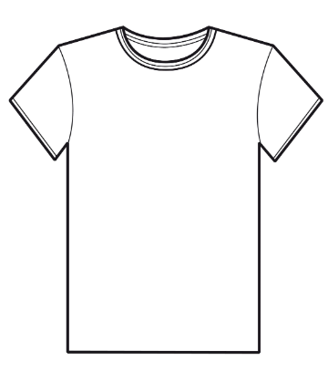  White T-Shirt  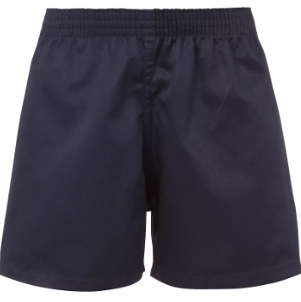  Navy blue or black shorts  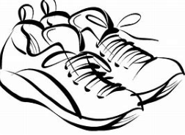  Trainers or pumps  Please make sure that earrings are removed and hair tied back for P.E. days . |   Spellings are given out on a Friday ready for a test on the following Friday. One column should be completed each night with the final column completed in class on Friday morning.  Maths homework is set on MyMaths on Friday and is due on the following Thursday. If children cannot complete the homework online, they can use a paper copy.  Reading books are changed by the children once they have finished their book. Children are expected to read at home for 20 minutes every day. Reading Diaries must be signed and brought to school each day.  Reading comprehension homework is given out on a Friday to be completed by the following Thursday.  TT Rockstars should be used at least four times a week to help the children with their learning of their times tables. |  | 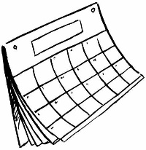  Maths Club starts 8am Monday 8th September and runs Mon-Thurs each week. All children in Year 6 are invited. We look forward to seeing you all.  Times Tables Rock Star Maths Day (dress as a rock star): date to follow  Meet the teacher: Wednesday 18th September 3:45pm or 4:30pm  Wear Yellow 10th October for World Mental Health Day.
What we are learning this half term!
English |  | Maths
We will read the following texts and poems:  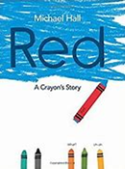  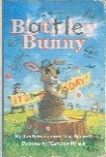    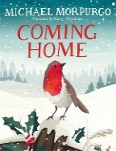    Creator of Unity – Levi Tefari  We will use these texts to write our own poetry, descriptions and informal persuasive texts, and we will revise editing our own work.  . |  | - Read, write and compare 6-digit numbers  - Multiply and divide by 10, 100 and 1000  - Read, write, compare and round decimals  - Convert decimals to fractions  - Solve addition and subtraction questions including decimal numbers  - Solve word problems  - Find missing lengths and angles  - Know the order of operations to carry out calculations involving the four operations  - Convert and read measurements – time, length, weight and capacity  - Use mental multiplication strategies  - Revise short multiplication and  - Use long multiplication
Science |  | RE
Living Things and Their Habitats  Children will build on their learning about grouping living things by looking at the classification system. They will classify all living things and research the life of Carl Linnaeus. |  | Autumn 1: Branch 1 - Creation and Covenant  Harvest Festival
Geography |  | D&T
Children will learn what natural resources are and about the natural resources in the UK (fossil fuels for energy, crops for food, and livestock for food as well as clothes). They will investigate distribution across the world and understand that natural resources vary in different countries. They will study Russia, including its location, physical features and resources. |  | Children will taste a variety of different breads and think about how bread can contribute to a balanced diet. Children will learn how different ingredients are needed to make bread and how ingredients can be altered and mixed to create different effects. Children will then design, make and evaluate their own breads.
Music |  | German
We will be creating our own rhythm patterns, listening to music by Benjamin Britten and learning the song Don’t Look Back in Anger. |  | Revise personal descriptions  Introduce time  Daily routine
PSHE
- Zones of Regulation: green zone, blue zone, yellow zone, red zone
- Calming the Storm: to know we were created individually by God
- Class charter, code of conduct, expectations of behaviour: Ready, Respectful, Safe.

