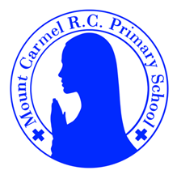
3D Newsletter
Autumn Term 1
Welcome to 3D
Welcome back! We hope you enjoyed your summer holidays. We’re really excited to start the new school year and to get to know you all. We have lots of exciting things to learn and explore this half term.
Mrs Dennis, Miss Foster and Mrs Lee
PE Days | Homework |  | Important Dates
Our P.E. days are Wednesday and Thursday.  Children need the following P.E. kit in school.    White T-Shirt    Navy blue or black shorts  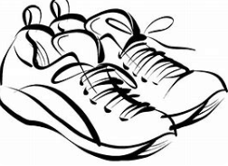  Trainers or pumps  Please make sure that earrings are removed for P.E. days . |   Spellings are given out on a Monday ready for a test on Friday. One column should be completed each night with the final column completed in class on Friday morning.  Maths homework is set on MyMaths on Friday and is due on the following Thursday. If children cannot complete the homework online, they can use a paper copy.  Reading books are changed each week on a daily rota. Children are expected to read at home for 20 minutes every day. Reading Diaries must be signed each day.  TT Rockstars and Numbots should be used at least weekly to help the children with their learning of the times tables. The logins are in the front of the Reading Diary. |  | 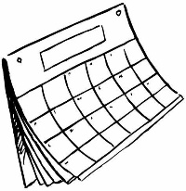
What we are learning this half term!
English |  | Maths
We will be looking at the story “The Search for the Giant Arctic Jellyfish”. We practise writing sentences and write our own version of the story. Then we will focus on the book Journey. We will think about writing a letter.  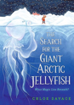  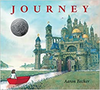 |  | We will be building upon our Year 2 learning, exploring place value with numbers up to 1000. We’ll be thinking about the value of numbers, comparing, ordering, adding and subtracting. We’ll consolidate our knowledge of 2, 5 and 10 times tables and begin to learn the 3s and 4s.
Science |  | RE
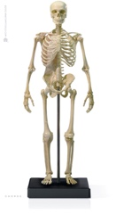  We will find out about the body  This Photo by Unknown Author is licensed under CC BY-NC-ND  – the skeleton and muscles and  their functions. We will learn  about the diet of animals and  humans and how this diet provides  the nutrition to survive. |  | 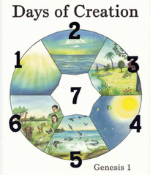  Our first R.E. branch is Creation and Covenant. We will be  exploring the story of God’s  Creation and thinking about  Laudato Si and what it means  for us today.
Geography |  | Art
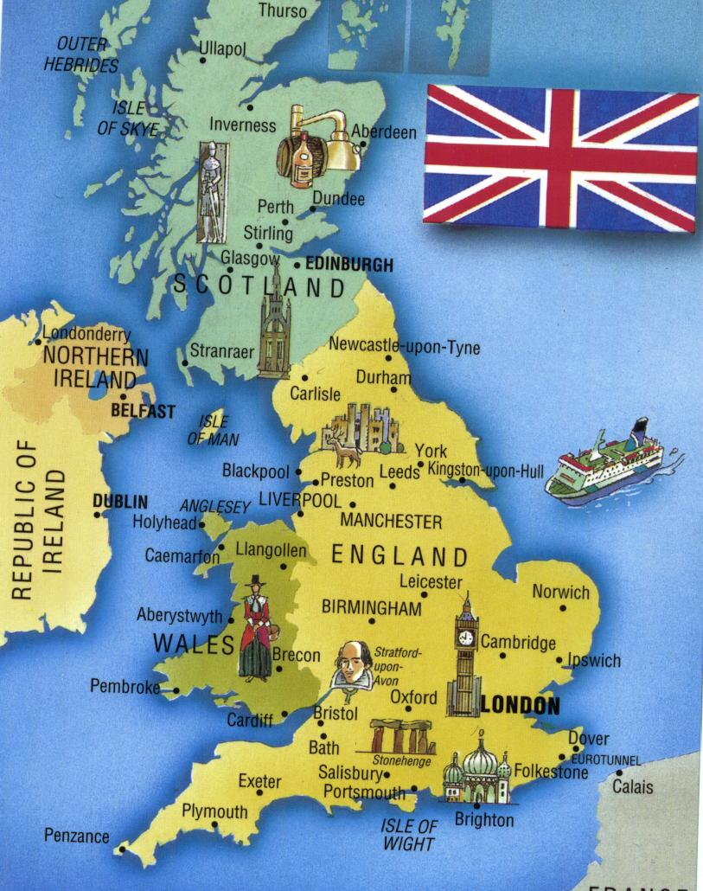  We will be learning about the United Kingdom, building on our knowledge of countries, capitals and seas from Year 1. We will explore landmarks, mountains, rivers, counties and cities in the  UK. We will find out how an area  of Manchester has changed over  time. |  | 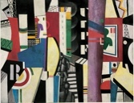  Children will be introduced to the work of Fernand Leger- ‘The City’. They will make sketches of the local area and then use a selection of their own drawings to create their own abstract  art using and mixing similar  colours to Fernard Leger.
Music |  | PHSE
  We will be learning to  play the recorder in  whole class ensemble  sessions. A teacher from  One Education is coming in to help us. |  | We will learn that we are created individually by God, in His own image and likeness. We will explore the Sacraments and know that Jesus is our friend.
Computing |  | German
We will be learning all about digital devices, focussing on inputs, processes and outputs. We will compare digital and non digital devices and learn about computer networks, including our school network. |  |   We are excited to begin learning our new language. We will learn how to greet people, say our names, count  to 10 and name some colours.
Snacks
In the Juniors, the children are not provided with a piece of fruit at breaktime. If you would like your child to have a snack, please send in a piece of fruit and they will be able to take it out with them. Thanks.

