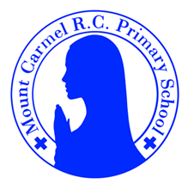
Year 4 Newsletter
Summer 2
Welcome to Year 4
What a busy term Summer 1 was! We have been very busy covering so many interesting topics, produced wonderful pieces of work and (most importantly) had lots of fun. This half term promises to be just as exciting and we have lots planned before we finish for the summer.
Mrs Lyon and Mr Sloan would like to say a very big well done to all of their fantastic year 4 students, especially for working so hard on their times tables. You have all come so far since September!
PE Days | Homework |  | Important Dates
Our P.E. days are Wednesdays for Mr Sloan’s class and Thursdays for Mrs Lyon’s class, however on a Monday we will be going swimming. A letter has been sent home regarding the correct/appropriate attire for swimming.  For P.E, Children need the following kit in school.  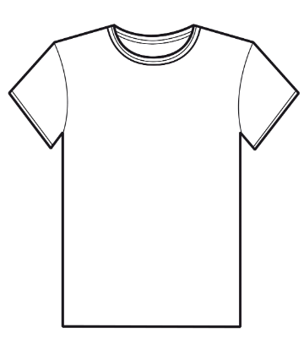  White T-Shirt  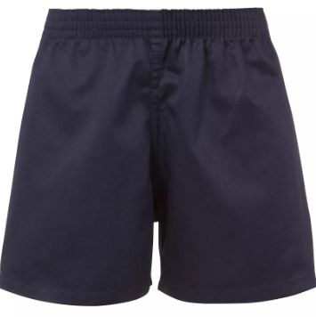  Navy blue or black shorts  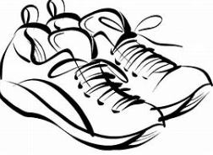  Trainers or pumps  Please make sure that earrings are removed for P.E. days . |   Spellings are given out on a Monday ready for a test on Friday. Children are to complete one column at a time, in order to maximise their learning.  Maths homework is set on MyMaths on Friday and is due on the following Thursday. If children cannot complete the homework online, we would encourage you to ask for a paper copy.  Reading books are changed twice a week. Children are expected to read at home for 20 minutes. Reading Diaries must be signed each day.  TT Rockstars should be used at least weekly to help the children with their learning of the times tables. |  | 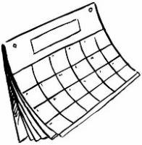  School re-opens – Monday 9th June  Day trip to Bolton Abbey – Monday 30th June  End of half term – Friday 18th July at 1.30pm.
What we are learning this half term!
English |  | Maths
This half term, we are going to be writing newspaper articles, information leaflets, balanced arguments and persuasive letters. As always, we will be encouraging the children to use all of their grammatical knowledge too. |  | 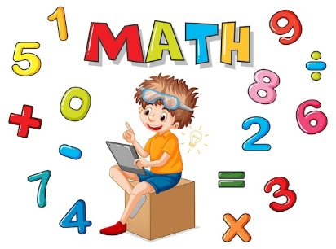  The children will be solving money problems, drawing and interpreting bar charts, pictograms and line graphs. We will be multiplying and dividing by 100, using lots of the mental strategies we have learnt so far.
Science |  | RE
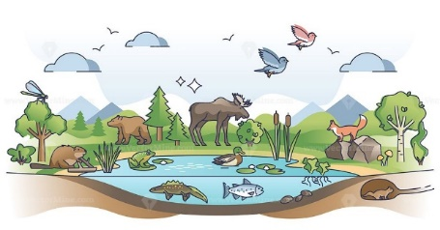  The children will continue to explore the animal world further, looking more closely at habitats and food chains. We will look back at the science work we have done in year 4. |  | 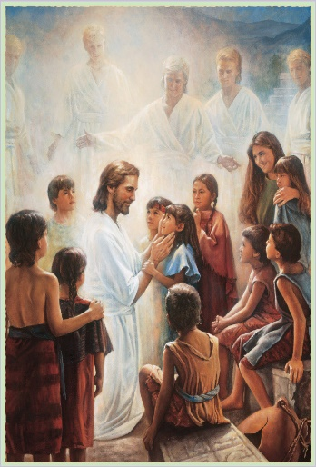  We will be looking at God’s People, specifically, different Saints and how they show what God is like. We will also be exploring Islam, and The Qur’an.
Geography |  | D&T
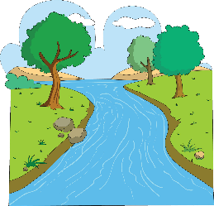  We will be looking at Rivers and the Water Cycle, learning about the distribution of water across the world. The children will learn about the formation of a river and its journey to the sea. We well also conduct a local river study on our trip to Bolton Abbey. |  | 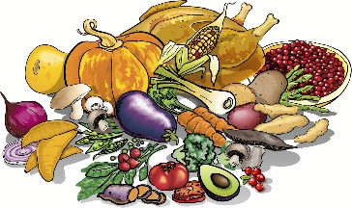  Children will look at seasonal foods in the UK and other parts of the world. We will use their knowledge to make a pasta salad.
Music |  | PHSE
  The children will be using all their knowledge and skills for their final performances. We will also be listening to music by Leonard Bernstein. |  | 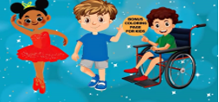  The children will be looking at how we love others in different ways. We will also explore the best ways to manage money, budget and avoid debt.
German

This half term, the children will revise and extend food and drink items and introducing the topic of ‘weather’.

