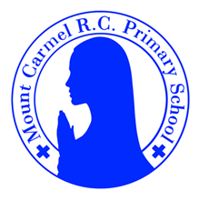
3D Newsletter
Summer Term 2

Welcome Back!
We hope that you all had a lovely break.
We have lots more exciting learning to get through this half term in such a short amount of time – we hope you’re up for the challenge!
Our school Gospel Value this half term is Faith-filled and Hopeful.
Mrs Dennis and Mrs du Plessis
But the Advocate, the Holy Spirit, whom the Father will send in my name, will teach you all things and will remind you of everything I have said to you. John 14 v26
PE Days | Homework |  | Important Dates
Our P.E. days are Wednesday and Thursday.  Children need the following P.E. kit in school.  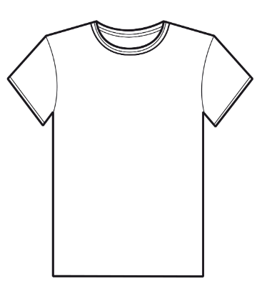  White T-Shirt  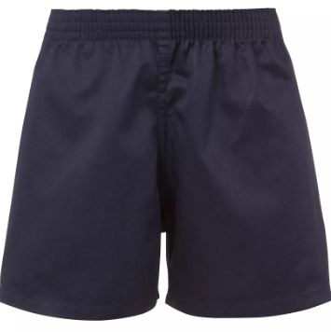  Navy blue or black shorts  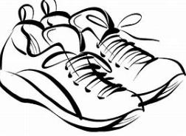  Trainers or pumps  Please make sure that earrings are removed for P.E. days . |   Spellings are given out on a Monday ready for a test on Friday. One column should be completed each night with the final column completed in class on Friday morning.  Maths homework is set on MyMaths on Friday and is due on the following Thursday. If children cannot complete the homework online, they can use a paper copy.  Reading books are changed each week on a daily rota. Children are expected to read at home for 20 minutes every day. Reading Diaries must be signed each day.  TT Rockstars and Numbots should be used at least weekly to help the children with their learning of the times tables. The logins are in the front of the Reading Diary. |  | 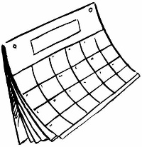  9/6/25  School opens for Summer Term 1  w/b 9/6/25  Art Week  18/6/25  Art Gallery  8/7/25  Create Day  16/7/25  Jewish Museum trip  18/7/25  Finish for summer at 1.30pm
What we are learning this half term!
English |  | Maths
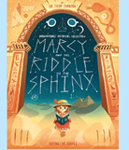  We will continue to read Marcy and the Riddle of the Sphinx where we will revisit dialogue and then create our own adventure story! We will also look at some non fiction writing about Ancient Egypt and will write Instructions to Mummify a Body. |  | We will begin by looking at statistics – pictograms and bar charts - and will revisit shape, learning about different lines and finding perimeters. We will practise adding and subtracting in columns and multiplying bigger numbers using grid multiplication.
Science |  | RE
  We will finish our topic on light and then recap our learning on the Human Body, Rocks, Forces and Magnets and Plants from earlier in the year. |  | In R.E. we will continue to look at our conscience and how we can use our conscience to make right choices, focussing on the Sacrament of Reconciliation. We will learn about special places for Christianity in the World and also learn about special places for Islam.
History |  | Art and DT
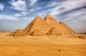  We will learn about the Ancient Civilisations of Sumer, the Indus Valley and the Shang Dynasty. We will then learn in mor detail about Ancient Egypt, finding out about pyramids, Tutankhamun and the River Nile. |  | In Art Week, we will learn about the artist Alma Thomas and will create our own painting based on one of her works. In DT, we will be investigating different structures and will make a garden obelisk for sweet peas to grow up.
Music |  | PHSE
  We will be using all our knowledge and skills in our final performances, listening to music by Tim Minchin and learning the song Tutankhamen. |  | We will be learning about living in a Community of Love and think about the church and the church family. We will find ways of loving and caring for others. We will also find out and different types of jobs and work.
Computing |  | German
We will use a range of techniques to create a stop-frame animation using iPads. Then we will apply those skills to create a story-based animation. adding other types of media, such as music and text. |  |   In German, we will be learning about German towns and cities. We will also revise food items and saying what we would like.
Snacks
In the Juniors, the children are not provided with a piece of fruit at breaktime. If you would like your child to have a snack, please send in a piece of fruit and they will be able to take it out with them. Thanks.

