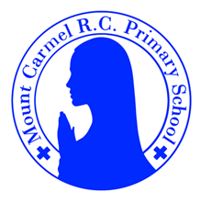
2C Newsletter
Summer Term 2
Welcome back to 2C!
Welcome back to school, everybody! We hope you have had a lovely half term break!

Below you will find lots of important information about this half term, so please read it carefully and if you have any questions then please speak to Mr Conwell. You will also find lots more information about what we will be learning about this year on our class page on the school website. You will receive a new newsletter each half term with updated information.

This half term the children will make visits to the junior school in preparation for their move to year 3 in September. Please use these visits to discuss with your child how their current morning routine may change as they move up to the juniors.

PE Days | Homework |  | Important Dates
Our P.E. days are Monday and Thursday.  Children need the following P.E. kit in school.    White T-Shirt    Navy blue or black shorts  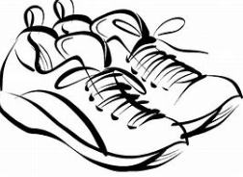  Trainers or pumps  Please make sure that earrings are removed for P.E. days. |   Spellings are given out on a Monday ready for a test on Friday. One column should be completed each night.  Maths homework is set on MyMaths on Friday and is due on the following Thursday. If children cannot complete the homework online, they can use a paper copy. Please speak to Mrs Green or Mrs Grayson about this.  Reading books are changed every Monday. Children are expected to read at home for 10 minutes every day! Reading Diaries must be signed each day. Children will also be assigned a book on Collins Hub. This is the same book children access in their guided reading sessions in school.  TT Rockstars or Numbots should be used at least weekly to help the children with their learning of the times tables and number fluency. |  | 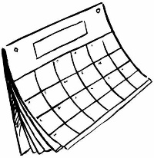  Sports Day –  Monday 23rd June  10:30am – 11:15am Parents are be welcome to Attend  Y2 Trip to the National Football Museum – Monday 14th July - Payment for this trip can be made via ParentPay  Break up for the Summer holidays:  Friday 18th July  1:30pm pick up  Back to school  Wednesday 3rd September 2025
What we are learning this half term!
English |  | Maths
In spellings, we will be learning Why do some longer words have the spelling ‘ti’ for /sh/?  How to use possessive apostrophes for singular possession. When to swap, drop or double? (-ing, -er, -est, -y, -ed)  We will be reading:  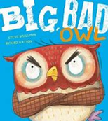  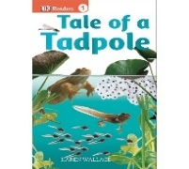  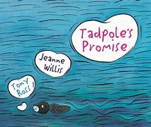  We will be reading the following texts:  We will use these texts to write letters, diaries and our own stories. |  | *Count back in 10s and 1s to solve subtraction (not crossing 10s) and check subtraction using addition, beginning to understand that addition undoes subtraction and vice versa; add three or more small numbers using number facts; record amounts of money using £·p notation including amounts with no 10s or 1s; find more than one way to solve a money problem  *Count in 3s, recognising numbers in the 3 times-table; write multiplications to go with arrays and use arrays to solve multiplication problems; understand that multiplication is commutative and that division and multiplication are inverse operations; solve divisions as multiplications with a missing number; count in 2s, 3s, 5s and 10s to solve divisions and solve division problems in contexts  *Measure and estimate lengths in centimetres; tell the time involving multiples of 5 minutes past the hour and 5 minutes to the hour; tell time to 5 minutes; begin to say the time 10 minutes later  *Partition to add two 2-digit numbers; find the difference between two 2-digit numbers; multiply two numbers using counting in steps of 2, 3, 5 and 10; solve division problems by counting in steps of 2, 3, 5 and 10  *Compare two 2-digit numbers and find bonds to 100 using thermometers; revise place value in 2-digit numbers, numbers between 100 and 200, and 3-digit numbers (including zeros in the 10s and 1s places)
P.E.
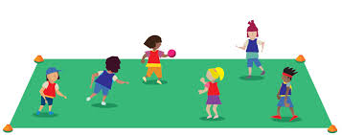
Fundamentals
Invasion Games

Science |  | RE
Revision.  Children will revise units covered throughout the year. |  | Topic 9: Treasures  God’s treasure; the world  Islam: Prayer at home
History |  | Computing
Significant Local Events and People  Children will learn about significant local events and why they are significant to the people of Manchester (Pope John Paul’s visit to Heaton Park). Children will learn about Alan Turing and find out information using different sources. |  | Children will be introduced to using laptops to create content. They will develop their understanding of the various aspects of using a computer. They will begin to familiarise themselves with how to use laptops to create and store content. They will become more familiar with using a keyboard and mouse to enter and remove text, change the look of their text, and consider the differences between using a computer to create text, and writing text on paper.
Art |  | Music
  Artist Study/ Andy Warhol  Children will study the art of Andy Warhol reflect on his style and revise the previous learning on colour. Children will explore how an artist can use repeating lines to create an optical effect for the view. Children will create their own art work using oil pastels. |  |   We will be using all our knowledge and skills in our final performance, listening to music by Dolly Parton and learning songs about the being special.
D&T |  | PSHE
Making a vehicle  Children will investigate a variety of different vehicles before designing, making and evaluating their own vehicle. They will learn all about wheels, axles and chassis. |  | Three in one- God’s love  Who is my neighbour?  The community we live in

