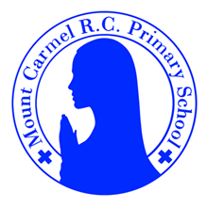
Y6 Newsletter
Summer Term 2
Welcome to Year 6!
Our final term at Mount Carmel together. We hope you had a restful break and enjoy your final weeks at this school!
PE Days | Homework |  | Important Dates
Our P.E. days are either: Tuesday and Friday (Y6C) Monday and Friday (Y6S)  Children need the following P.E. kit in school.  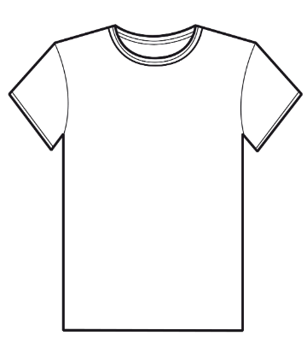  White T-Shirt    Navy blue or black shorts  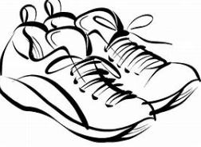  Trainers or pumps  Please make sure that earrings are removed and hair tied back for P.E. days . |   Spellings are given out on a Friday ready for a test on the following Friday. One column should be completed each night with the final column completed in class on Friday morning.  Maths homework is set on MyMaths on Friday and is due on the following Thursday. If children cannot complete the homework online, they can use a paper copy.  Reading books are changed by the children once they have finished their book. Children are expected to read at home for 20 minutes every day. Reading Diaries must be signed and brought to school each day.  Reading comprehension homework is given out on a Friday to be completed by the following Thursday.  TT Rockstars should be used at least three times a week to help the children with their learning of their times tables. |  | Sunday 8th June Pentecost.  Monday 9th June  Art Week across the school.  Wednesday 18th June  Art gallery across the school.  8/7/25  Oliver Twist Performance 6pm  9/7/25  Oliver Twist Performance 6pm  16/7/25  Y6 Leavers Mass 6pm  17/7/25  Y6 Leavers Assembly 1:30pm followed by refreshments in the school  18/7/25 School Finishes 1:30pm for the Summer Holiday  We will also be completing the Fiver Challenges this term so watch out for your children and their money making ideas!
What we are learning this half term!
English |  | RE
We will read the following texts:  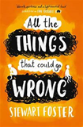  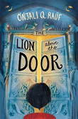  We will use these texts to write from different character perspectives. We will write a guide for staring secondary school and letters to our form tutors. |  | Topic 9: Common good  Work of the worldwide Christian family  Islam: Belonging and values  Guidance for Muslims
Maths |  | Science – Sound and Hearing and Revision
*Revise:  - simplifying fractions  - multiplying and dividing fractions  - solving problems involving ratios  - properties and classification of 2D shapes  - calculating missing angles and use a protractor to measure and draw angles in degrees  - perimeter, area and volume  - interpreting different types of data display.  *Use Mathematical reasoning to investigate and solve problems  *Explore binary numbers; solve mathematical puzzles; including using multiplication facts, find digital roots and look for patterns; explore Fibonacci sequences |  | - Revisit how sounds are made, associating some of them with something vibrating.  - Revise vibrations from sounds that travel through a medium to the ear.  - Revise patterns between the pitch of a sound and features of the object that produced it; revise patterns between the volume of a sound and the strength of the vibrations that produced it; revise that sounds get fainter as the distance from the sound source increases; revise and identify the way sound is made through vibration in a range of different musical instruments from around the world; and investigate how the pitch and volume of sounds can be changed.
History: The Victorians |  | Art- Lowry
Children will identify when the Victorian era was and highlight key features of this period in time. They will review the political reforms which occurred as a result of the Chartist Movement and the impact of the Education Act. They will investigate how leisure time changed and the importance of the Great Exhibition. |  | Through the work of LS Lowry, children will learn how artists make people look as they are moving. They will explore the concept of a ‘vanishing point’ and produce their own playtime Lowry piece of artwork.
Music |  | Computing - Programming
We will be using all our knowledge and skills in our final performances, listening to Elton John and learning the song We are Unstoppable. |  | Learners will learn how to use HTML (Hypertext Markup Language) to create web pages.
PE |  | PSHE
Golf and Football |  | The Trinity, Catholic Social Teaching, Reaching Out, Money and Me
German
Create and perform simple sketches

